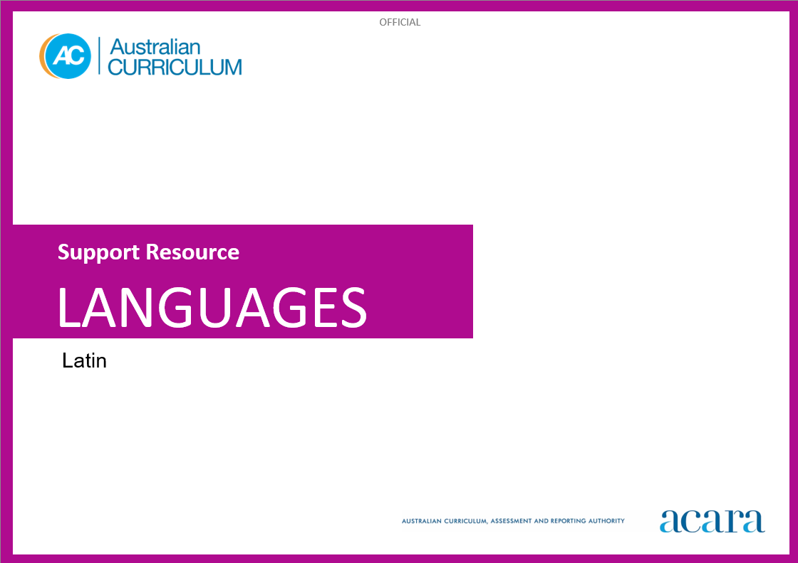

Copyright and Terms of Use Statement
© Australian Curriculum, Assessment and Reporting Authority 2024
The material published in this work is subject to copyright pursuant to the Copyright Act 1968 (Cth) and is owned by the Australian Curriculum, Assessment and Reporting Authority (ACARA) (except to the extent that copyright is held by another party, as indicated).
The viewing, downloading, displaying, printing, reproducing (such as by making photocopies) and distributing of these materials is permitted only to the extent permitted by, and is subject to the conditions imposed by, the terms and conditions of using the ACARA website (see, especially, clauses 2, 3 and 4 of those terms and conditions). The terms and conditions can be viewed at https://www.acara.edu.au/contact-us/copyright

TABLE OF CONTENTS
F–10 AUSTRALIAN CURRICULUM: Latin language support resource 3
Introduction 3
Language structures and features 4

F–10 AUSTRALIAN CURRICULUM: Latin language support resource

Introduction
This Latin Language resource was developed to support teachers as they plan teaching and learning programs to implement the Australian Curriculum: Latin. It is optional and includes illustrative examples and suggestions for a sequential development of language structures and features.
Content is presented in 2 broad levels – beginner/intermediate and intermediate/advanced – and is independent of the year bands and the time spent on task.
Teachers can use suggestions in the resource to assist their planning of programs based on the AC: Latin. The resource may assist teachers to meet the diverse language needs and learning backgrounds of students at different entry points into second-language learning.
For example:
- a Year 9 student is learning Latin for the first time. The teacher can use the cognitive demand of the Years 9 and 10 curriculum achievement standards and content descriptions, supported by the beginner/intermediate language structures and features, to cater for the linguistic needs of the student.
This resource provides language structures and features that are neither exhaustive nor mutually exclusive. The 2 levels demonstrate how a particular structure or feature could be developed at different stages of a continuum of second-language learning.

Language structures and features
Table 1 begins with ‘Conventions of phonological and orthographic systems’ followed by structures and features organised in alphabetical order.
Table 1: Language structures and features
Language structures and features
Conventions of phonological and orthographic systems | Beginner/Intermediate | Intermediate/Advanced
 | letters, sounds and pronunciation  - sound and pronunciation of the 23 letters Roman letters of the alphabet  - pronunciation of c, u/v, g  - pronunciation of short and long vowels, for example, mater, pater  - pronunciation of dipthongs, for example, ae, eu, au, ui, in Caecilius  - i as a vowel and as a consonant, for example, intrat; ianua  - pronunciation of h at the start of words, for example, in horto  - absence of the definite and indefinite article in Latin  - absence of capitalisation, except for proper nouns  - use of enclitics, for example, -que, -ne | reading aloud and performing  - rolled or trilled r  - consonant combinations/clusters as in ingens, magnus, urbs  - elision of words in spoken Latin where there are 2 consecutive vowels such as vowel before final m followed an initial vowel, final vowel followed by an initial h  - absence of punctuation in original Latin  - spoken stress of Latin, for example, spec-tá-tor, compared with péc-tor-a  - variation of Latin word order to create effect, emphasis, tone  for recognition and/or modelled use  - metre of Roman poetry, for example, dactylic hexameter, elegiac couplets
Adjectives | declension forms, agreement and position of adjectives  - use of adjectives to describe nouns, for example, canis est fortis  - placement of adjectives in relation to nouns, for example, puella laeta est in tablino, magnus leo est in pictura  - first, second and third declension forms, for example, bonus, bona, bonum, tristis, triste  - agreement of adjectives and nouns in number, gender and case  - singular and plural adjective forms, for example, iratus, irati  - masculine, feminine and neuter forms, for example, iratus, irata, iratum  - case forms for adjectives, such as nominative, vocative, accusative, genitive, dative, ablative, for example, iratus, iratus, iratum, irati, irato, irato  - degrees of adjectives – positive, comparative and superlative – for example, iratus, iratior, iratissimus, fortis, fortior, fortissimus  - possessive adjectives, for example, meus, tuus, noster, vester  - demonstrative adjectives, for example, hic, ille, is  - numerical adjectives such as cardinal and ordinal numbers, for example, unus, primus | more complex adjectives  - reflexive adjectives, for example, suus, sua, suum  - placement of adjectives in poetry for dramatic effect, for example, media in via  - agreement of first, second and third declension adjective forms with nouns from different declensions, for example, mercator ebrius  - irregular first/second and third declension forms, for example, pulcher pulchra pulchrum; ingens ingentis  - application of first and second declension adjective endings to superlative adjectives and application of third declension adjective endings to comparative adjectives  - possessive adjectives, for example, suus  - irregular comparisons of adjectives, for example, magnus, maior, maximus; parvus minor, minimus; bonus, melior, optimus; malus, peior, pessimus; difficilis difficilior difficillimus
Adverbs | commonly used adverbs  - use of adverbs to modify verbs  - common adverbs, for example, semper, hodie, celeriter  - degrees of adverbs – positive, comparative and superlative – for example, irate, iratius, iratissime; fortiter, fortius, fortissime | more complex use of adverbs  - use of adverbs to modify verbs, adjectives and adverbs, for example, tam dives, Roma est maior multo quam oppidum  - formation of adverbs in different degrees of adverbs – positive, comparative and superlative  - adverbs denoting time, such as tum, deinde  - irregular comparisons of adverbs, for example, magnopere magis maxime; paulum minus, minime; bene melius, optime, male peius pessime, multum plus, plurimum
Affixes | prefixes  - prefixes added to verbs and adjectives, for example, advenit, perterritus  - suffixes/enclitics, for example, estisne, paterque | more specialised use of prefixes  - prefixes can change meaning, for example, venio, invenire  - assimiliation of final consonant of a prefix and first consonant of a verb, for example, ad+loquor=alloquor, ex+fero=effero  - vowel changes when a prefix is added, for example, facere becomes conficere, capere becomes incipere
Case usage | function of cases  - nominative case  - subject of verb, for example, pater in villa dormit  - complement of subject with esse, for example, vir est pater  - in apposition to subject, for example, vir, pater, in villa dormit  - vocative case  - direct address, for example, domine, veni!  - accusative case  - direct object of verb, for example, puella villam intrat  - governed by a preposition, for example, in villam  - genitive case  - possession, for example, villa patris  - descriptive, for example, femina magnae prudentiae  - dative case  - indirect object of verb, for example, femina pecuniam mercatori dat  - dependent on certain verbs, for example, puer patro credit  - ablative case  - governed by a preposition, for example, in villa | more complex case usage  - accusative case  - duration of time, for example, tres dies  - exclamation, for example, me miserum!  - subject of the infinitive in indirect statement, for example, credo iuvenem e villa discedere  - genitive case  - partitive, for example, plus argenti  - dependent on certain verbs and adjectives, for example, memor belli  - dative case  - possession, for example, liber mihi est  - ablative case  - place where, for example, terra  - time when, within which, for example, quarto die, tribus diebus  - comparison, for example, templum est altius villa  - dependent on certain verbs and adjectives, for example,  dignus honore  ablative absolute, for example, urbe deleta  - accompaniment, for example, cum amico  - agent, for example, a domino vocatus  - instrument, for example, ferro interfectus  - means, for example, callidate interfectus  - separation, for example, imperator Roma discessit  - locative case  - place where, for example, Romae, humi
Comparison | simple comparisons  - use of quam to compare, for example, pater est senior quam filius | more complex comparisons  - use ablative case to compare, for example, pater est senior filio
Conjunctions | commonly used conjunctions  - conjunctions to join nouns or clauses in compound sentences, for example, et, et ... et ..., nam, enim, sed, tamen, for example, puellae et feminae sunt in foro; canis e villa currit et in via dormit. | complex sentences  - subordinating conjunctions in complex sentences such as ut, cum, si, postquam, quamquam, for example, si hoc dixit, erravit.
Interrogatives | commonly used interrogatives  - interrogative words, for example, quis? cur? ubi?  - interrogative enclitic, for example, esne contentus? | additional forms of interrogatives  - interrogative words, for example, qualis? quantus? quot? quotiens? quo? Unde? quomodo? quando?  - interrogative pronouns, for example, quis, quis, quid  - interrogative adjectives, for example, qui, quae, quod
Nouns | forms of nouns  - characteristics of nouns in Latin, for example, singular and plural; gender, for example, masculine, feminine, neuter; case, for example, nominative, vocative, accusative, genitive, dative, ablative  - noun inflections for all cases in singular and plural in first, second and third declensions, for example, puella, puella, puellam, puellae, puellae, puella /puellae, puellae, puellas, puellarum, puellis, puellis  - noun inflections for all cases in singular and plural of neuter nouns of the second and third declension, for example, bellum, bella  - rules for determining gender, for example, most nouns in the first declension are feminine, most nouns in the second declension are masculine or neuter | more complex forms of nouns  - locative case, for example, Romae (at Rome), ruri (in the country)  - noun inflections for all cases in singular and plural in fourth and fifth declension nouns, for example, exercitus, exercitus, exercitum, exercitus, exercitui, exercitu/exercitus, exercitus, exercitus, exercituum, exercitibus, exercitibus  - noun inflections for all cases in singular and plural of neuter nouns of the fourth declension, for example, genu, genua  - irregular gender, such as, masculine nouns of the first declension, for example, nauta, poeta, and nouns which can be either gender, for example, canis, parens  - common features of word families of nouns, verbs and adjectives, for example, terror, terreo, territus
Numbers | cardinal and ordinal numbers  - cardinal numbers 1–20, for example, unus, duo, tres  - ordinal numbers, for example, primus, secundus, tertius  - Roman numerals, for example, I, V, X, L, C, M | additional forms and use of numbers  - cardinal numbers 1–100, for example, centum  - ordinal numbers 1st–20th, for example, vicesimum  for recognition and/or modelled use  - numbers in phrases to express distance, capacity, time and price, for example, duo milia passuum  - numeral adverbs, for example, semel, bis, ter, quater  - conventions of Roman calendar
Prepositions | commonly used prepositions  - use of prepositions to govern nouns  - common prepositions, for example, ad, prope, cum  - prepositional phrases, for example, per urbem, e foro | function of prepositions  - with different cases such as the accusative and ablative  - accusative case to denote motion towards with prepositions such as in, sub, super, subter, for example, vir in villam ambulat.  - ablative case to denote rest with prepositions such as in, sub, super, subter, for example, vir in villa manet.  - placement of prepositions within a prepositional phrase, for example, media in via
Pronouns | commonly used pronouns  - personal pronouns and pronominal adjectives, for example, ego, tu, nos, vos, meus, tuus, noster, vester  - interrogative pronouns, for example, quis, quis, quid  - demonstrative pronouns, for example, hic, haec, hoc, ille, illa, illud  - relative pronouns, for example, qui, quae, quod | more complex pronouns  - emphatic pronouns, for example, ipse, ipsa, ipsum; idem, eadem, idem  - personal pronouns, for example, is, ea, id  - reflexive pronoun, for example, se  for recognition and/or modelled use  - indefinite pronouns, for example, quisquam, quisquam, quicquam; quisque, quaeque, quidque
Sentence structures | commonly used sentence structures  - identification of the subject of a verb in a simple sentence  - identification of common word order, for example, subject+direct object+indirect object+verb  - statements, for example, ancilla dominum videt.  - questions, for example, ubi est pater? laboratne hodie?  - commands, for example, ad forum festinate! noli manere!  - compound sentences, for example, puer in horto stat et canem spectat.  - complex sentences involving subordinate clauses, for example, servus est perterritus, ubi dominum audit ormercator, quem heri vidi, navem Syriam habet.  types of clauses  - temporal clauses using postquam, ubi and an indicative verb, for example, postquam femina villam intravit  - concessive clauses using quamquam and an indicative verb, for example, quamquam dominus erat iratus  - causal clauses using quod and an indicative verb, for example, quod puer erat fessus  - relative clauses using the relative pronoun, for example, vir, qui librum mihi dedit | more complex sentence structures  - identification of subordinate clauses in a complex sentence, for example, relative, causal, temporal, concessive and conditional clauses  - periodic sentences involving sophisticated structures, for example, miles, cantans in castra, vestimenta lavabat.  - participial phrases, for example, venalicius, a leone petitus ...  - ablative absolute, for example, te duce  complex clauses  - temporal clauses such as those using cum and a subjunctive verb, for example, cum custodes dormirent  - concessive clauses using cum and a subjunctive verb, for example, cum dominus esset iratus  - causal clauses using cum and a subjunctive verb, for example, quod puer esset fessus  - purpose/final clauses using ut or negative ne and a subjunctive verb, for example, cives ad forum festinaverunt ut nuntium audirent  - purpose/final clauses using the relative pronoun and a subjunctive verb, for example, dominus servum misit qui filium inveniret  - result/consecutive clauses using ut or negative ut ... non and a subjunctive verb, for example, tantus erat clamor ut cives nuntium non audirent  - indirect command using ut or negative ne and a subjunctive verb, for example, imperator militibus imperavit ut redirent  - indirect questions using an interrogative and a subjunctive verb, for example, nemo sciebat quis appropinquaret  - conditional clauses using si, nisi, for example, si hoc fecisset, stultus fuisset  for recognition/modelled use  - indirect statements, for example, magister scivit puerum abesse.
Verbs | tenses and conjugations  - first, second and third person singular and plural present conjugation, for example, laboro, laboras, laborat, laboramus, laboratis, laborant  - regular conjugations, first, second, third, mixed, fourth, for example, laboro, laborare; moneo, monere; traho, trahere; capio, capere; audio, audire  - formation of irregular verbs, for example, sum, esse; possum, posse; volo, velle; nolo, nollo; malo, malle  - tenses in the indicative mood such as present, imperfect, perfect, pluperfect, for example, laborat; laborabat; laboravit; laboraverat  - imperative in the singular and plural in each conjugation, for example, labora, laborate; mone, monete; trahe, trahite; audi, audite  - present infinitives, such as a prolative infinitive, for example, audire non possum  - impersonal expressions, for example, placet mihi | conjugation of more complex tenses and moods  - principal parts of verbs in all conjugations, for example, laboro, laborare, laboravi, laboratus; traho, trahere, traxi, tractus  - tenses in the indicative mood such as future simple for first, second and third, fourth conjugation, future perfect, for example, laborabo, laborabis, laborabit; traham, trahes, trahet; and future perfect, for example, laboravero, laboraveris, laboraverit  - formation of irregular verbs, for example, eo, ire; fero, ferre  - moods such as indicative, subjunctive, imperative  - active and passive voice forms for all tenses, for example, voco, vocor; vocavi, vocatus sumdeponent  - verb forms and principal parts, for example, loquor, loqui, locutus sum  - participles in different tenses and voices, such as present active, future active, perfect passive, perfect active, for example, portans, portaturus, portatus; locutus  - infinitives in different tenses and voices, such as present active, present passive, perfect active, perfect passive, future active, future passive, for example, portare, portari, portavisse, portatus esse, portaturus esseportatum iri  - formation and use of gerunds and gerundives, such as the gerundive of obligation, for example, urbs nobis delenda est  for recognition/modelled use  - tenses of verbs in the subjunctive mood, such as present, perfect  - tenses of verbs in the subjunctive mood, such as imperfect, pluperfect  - use of infinitive in indirect statements, for example, imperator credit hostem advenire

