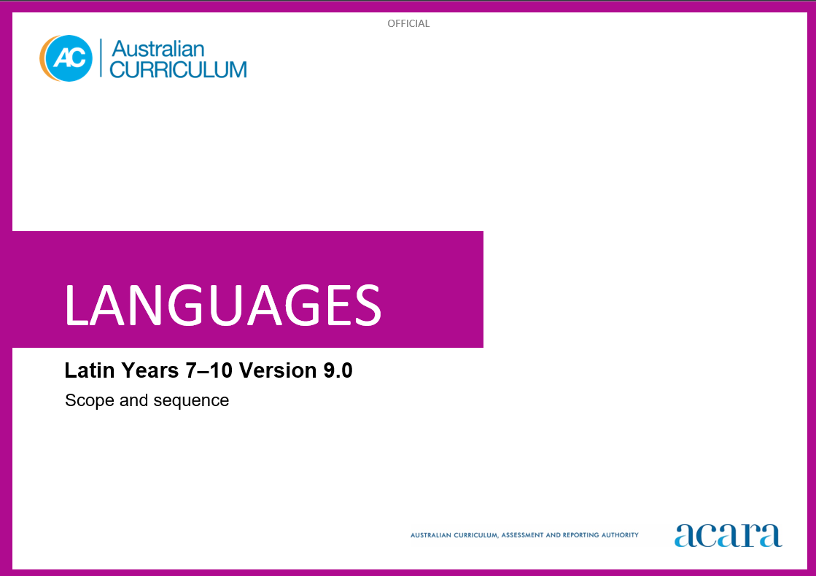

**Copyright and Terms of Use Statement**

**© Australian Curriculum, Assessment and Reporting Authority 2024**

The material published in this work is subject to copyright pursuant to the Copyright Act 1968 (Cth) and is owned by the Australian Curriculum, Assessment and Reporting Authority (ACARA) (except to the extent that copyright is held by another party, as indicated).

The viewing, downloading, displaying, printing, reproducing (such as by making photocopies) and distributing of these materials is permitted only to the extent permitted by, and is subject to the conditions imposed by, the terms and conditions of using the ACARA website (see, especially, clauses 2, 3 and 4 of those terms and conditions). The terms and conditions can be viewed at [https://www.acara.edu.au/contact-us/copyright](https://aus01.safelinks.protection.outlook.com/?url=https%3A%2F%2Fwww.acara.edu.au%2Fcontact-us%2Fcopyright&data=04%7C01%7CSharon.Foster%40acara.edu.au%7C9931e11fa7684c603e6308d98331bbfb%7C6cf76a3aa824427092003d71673ec678%7C0%7C0%7C637685071906340874%7CUnknown%7CTWFpbGZsb3d8eyJWIjoiMC4wLjAwMDAiLCJQIjoiV2luMzIiLCJBTiI6Ik1haWwiLCJXVCI6Mn0%3D%7C1000&sdata=U5O4Vlbpf271IGmGiMh7fDwU4pLzzAiHpCQFylkp6s4%3D&reserved=0)

**LATIN SCOPE AND SEQUENCE**

|  |  |
| --- | --- |
| **Years 7–8 (Year 7 entry)** | **Years 9–10 (Year 7 entry)** |
| **Achievement standard** | |
| By the end of Year 8, students use their knowledge of Latin to interpret texts and sources, and respond to information about ancient Roman society. They develop strategies to translate Latin texts into English, identifying familiar vocabulary and language structures and features to interpret meaning.  Students apply Latin sound-script relationships and use restored pronunciation when reading familiar texts aloud. They demonstrate understanding that Latin has conventions and rules for spoken and written communication. They understand that Latin has influenced English vocabulary and comment on language structures and features, using metalanguage. They demonstrate awareness that language, texts and artefacts from Ancient Rome are connected with culture and identity, and explore the relationships between language(s), culture(s) and identity. | By the end of Year 10, students use their knowledge of Latin to interpret and analyse information from a range of texts and sources about ancient Roman society and culture. They apply strategies to translate and interpret Latin texts into English and demonstrate understanding of how language conveys cultural meaning.  Students apply Latin sound-script relationships and use restored pronunciation, when reading familiar and unfamiliar texts aloud. They select and apply Latin grammatical conventions and rules when translating and responding to texts. They explain how Latin has influenced English vocabulary and analyse language structures and features, using metalanguage. They demonstrate understanding that the language, texts and artefacts from Ancient Rome are connected with culture and identity and reflect on the interrelationship of language(s), culture(s) and identity. |

|  |  |
| --- | --- |
| **Content descriptions** | |
| **Strand: Engaging with the ancient Roman world through texts** | |
| **Sub-strand: Accessing and responding to Latin texts** | |
| access and interpret Latin texts to explore the ancient Roman world  ACL9LL8E01 | interpret Latin texts to analyse the society and culture of the ancient Roman world  ACL9LL10E01 |
| respond to texts and convey information in Latin or English, as appropriate  ACL9LL8E02 | respond to texts and discuss ideas about ancient Roman society in Latin or English, as appropriate  ACL9LL10E02 |
| **Sub-strand: Translating** | |
| develop and apply strategies to interpret and translate Latin texts to convey meaning in English  ACL9LL8E03 | apply strategies to interpret and translate Latin texts to convey meaning and demonstrate understanding of context, purpose and audience  ACL9LL10E03 |

|  |  |
| --- | --- |
| **Strand: Understanding language and culture** | |
| **Sub-strand: Understanding systems of language** | |
| understand and begin to apply the phonological and orthographic systems of Latin  ACL9LL8U01 | apply the phonological and orthographic systems of Latin in a range of contexts  ACL9LL10U01 |
| develop knowledge of the vocabulary, structures and features of Latin grammatical systems to understand, translate and respond to texts  ACL9LL8U02 | select and use vocabulary, grammatical structures and linguistic features of Latin to interpret, translate and respond to texts  ACL9LL10U02 |
| compare Latin vocabulary and language structures and features with English, using metalanguage  ACL9LL8U03 | explain how Latin vocabulary, structures and features extend understanding of English, using metalanguage  ACL9LL10U03 |
| **Sub-strand: Understanding the interrelationship of language and culture** | |
| recognise that language, texts and artefacts provide insights into culture and identity  ACL9LL8U04 | reflect on and explain how language, texts and artefacts provide understanding of culture and identity  ACL9LL10U04 |