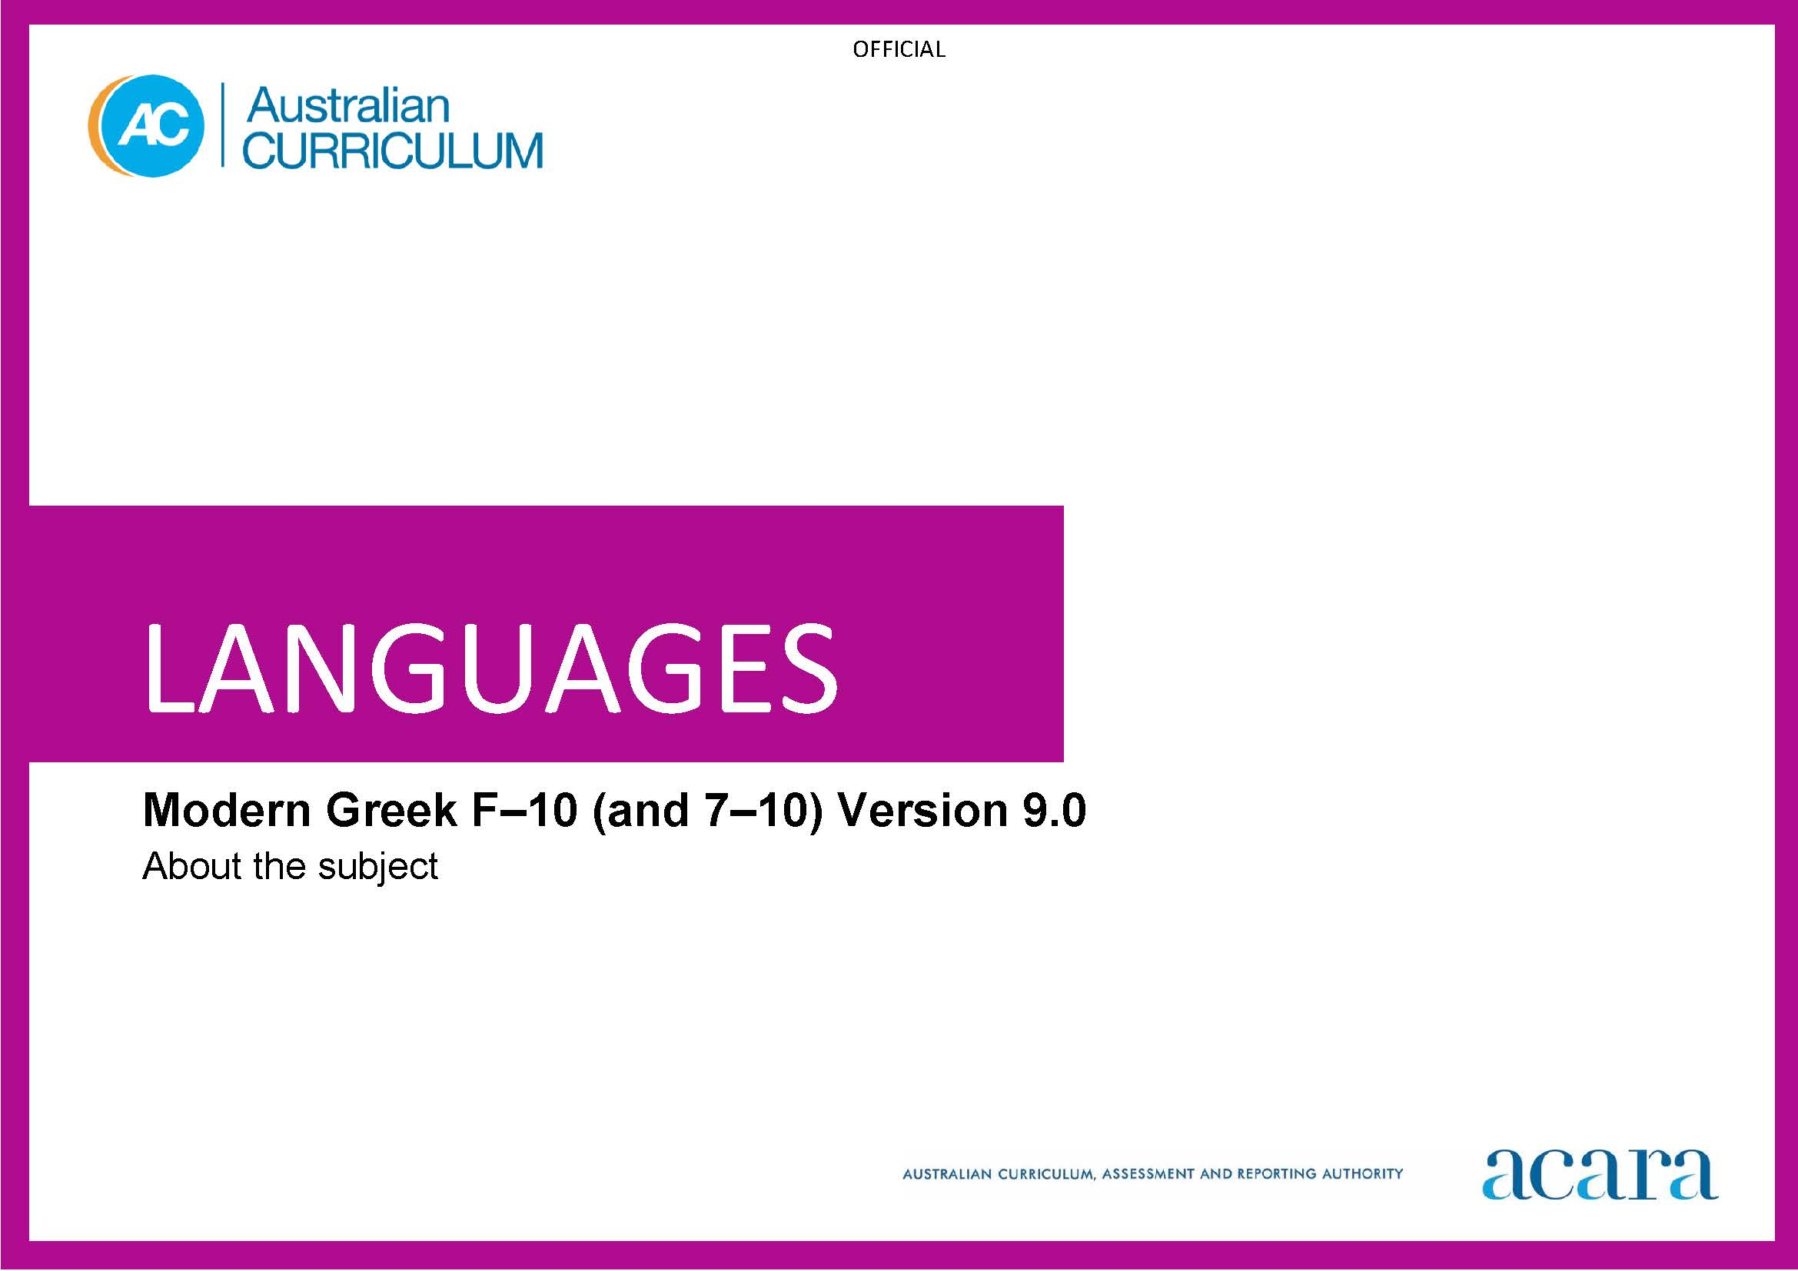

**Copyright and Terms of Use Statement**

**© Australian Curriculum, Assessment and Reporting Authority 2022**

The material published in this work is subject to copyright pursuant to the Copyright Act 1968 (Cth) and is owned by the Australian Curriculum, Assessment and Reporting Authority (ACARA) (except to the extent that copyright is held by another party, as indicated).

The viewing, downloading, displaying, printing, reproducing (such as by making photocopies) and distributing of these materials is permitted only to the extent permitted by, and is subject to the conditions imposed by, the terms and conditions of using the ACARA website (see, especially, clauses 2, 3 and 4 of those terms and conditions). The terms and conditions can be viewed at [https://www.acara.edu.au/contact-us/copyright](https://aus01.safelinks.protection.outlook.com/?url=https%3A%2F%2Fwww.acara.edu.au%2Fcontact-us%2Fcopyright&data=04%7C01%7CSharon.Foster%40acara.edu.au%7C9931e11fa7684c603e6308d98331bbfb%7C6cf76a3aa824427092003d71673ec678%7C0%7C0%7C637685071906340874%7CUnknown%7CTWFpbGZsb3d8eyJWIjoiMC4wLjAwMDAiLCJQIjoiV2luMzIiLCJBTiI6Ik1haWwiLCJXVCI6Mn0%3D%7C1000&sdata=U5O4Vlbpf271IGmGiMh7fDwU4pLzzAiHpCQFylkp6s4%3D&reserved=0)

TABLE OF CONTENTS

**F–10 AUSTRALIAN CURRICULUM: LANGUAGES – MODERN GREEK 3**

**ABOUT MODERN GREEK 3**

Introduction 3

Rationale 3

Structure 4

F–10 AUSTRALIAN CURRICULUM: LANGUAGES – MODERN GREEK

ABOUT MODERN GREEK

Introduction

The Australian Curriculum: Languages: Modern Greek is pitched to second language learners, that is, the dominant group of learners in the current Australian context for whom Modern Greek is an additional language.

Students of Modern Greek (Greek) in Australian schools come from a range of backgrounds. For many students it may be their first experience of learning Greek, while others may have existing connections to Greek as background speakers.

Rationale

Greek is the official language of Greece and an official language of the Republic of Cyprus. It is spoken in communities throughout the world. The modern standard version of Greek is the demotic form of the spoken and written language and is the official language taught worldwide. Greek is one of the official languages of the European Union.

The Hellenic civilisation and language have significantly shaped Western civilisation in the arts, architecture, literature, medicine, mathematics, philosophy, politics and science. The Greek language is still used in many fields to coin new terms.

Greek migration has made a significant contribution to shaping multicultural Australia. The Greek language has been taught in some Australian schools and universities since the 1970s, with extensive networks of community language programs established prior to this time with the first settlement of Greeks in Australia. The influence of Greek-speaking communities is evident in the areas of agriculture, the arts, commerce and trade, cuisine, education, government and politics, industry, law, medicine and scientific research.

Greek belongs to an independent branch of the Indo-European family of languages, to which family of languages English also belongs. Both languages share some similarities such as vocabulary, and language structures and features. Learning Greek enhances students’ understanding of the origins of many English words, and different alphabets and writing systems. It develops an appreciation of the language and cultures of Greek-speaking communities. Knowledge of Greek language and culture enriches travel experiences, increases employment opportunities and promotes understanding of diverse attitudes, beliefs and values.

Structure

Modern Greek has been developed as a Second Language Learner Pathway which caters for students learning Greek as a second or additional language.

The Second Language Learner Pathway includes 2 sequences:

* Foundation to Year 10
* Years 7 to 10.

Teachers use the curriculum to cater for learners of different backgrounds by making appropriate adjustments to differentiate learning experiences.

Content in Modern Greek is organised under 2 interrelated strands, each with a number of sub-strands. The strands and sub-strands are presented in Figure 1.

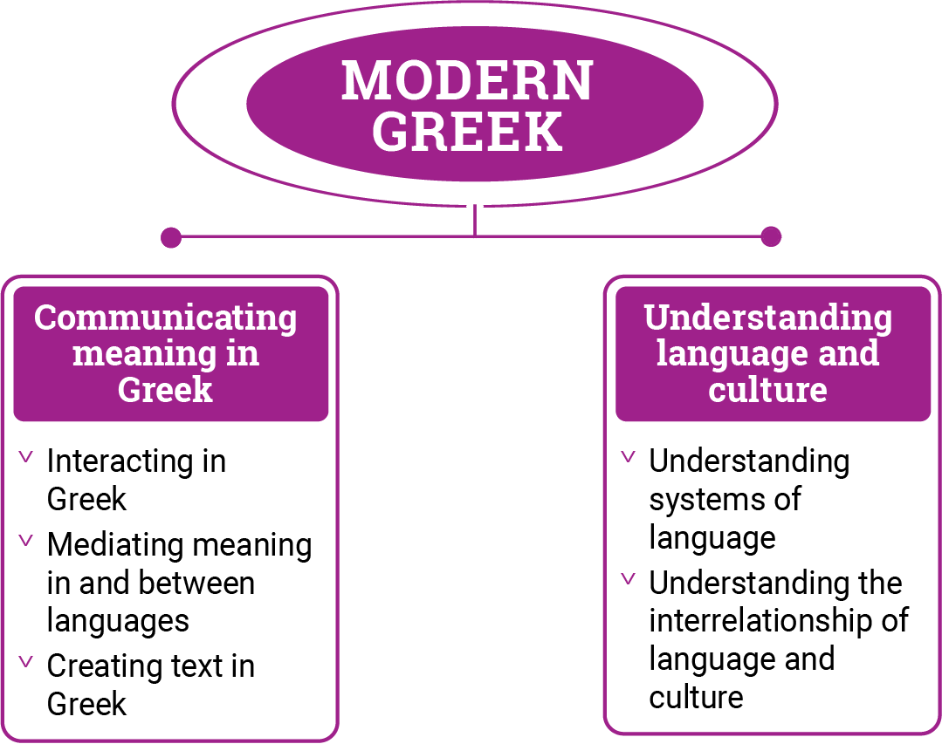

*Figure 1: Modern Greek content structure*

Strand: Communicating meaning in Greek

This involves students learning to use language for communicative purposes in interpreting, creating and exchanging meaning. There are 3 sub-strands.

**Interacting in Greek**

Exchanging ideas, opinions, experiences, thoughts and feelings in non-verbal, spoken and written interactions; participating in planning, negotiating, deciding and taking action.

**Mediating meaning in and between languages**

Obtaining, processing, interpreting and conveying information through a range of spoken, written and multimodal texts; moving between languages and cultures non-verbally, orally and in writing, recognising different interpretations.

**Creating text in Greek**

Creating a range of spoken, written and multimodal texts for specific contexts, purposes and audiences.

Strand: Understanding language and culture

This involves students learning to analyse and understand language and culture as resources for interpreting and shaping meaning in intercultural exchange. There are 2 sub-strands.

**Understanding systems of language**

Understanding the linguistic features of Greek, including sound, writing, grammatical and textual conventions.

**Understanding the interrelationship of language and culture**

Analysing and reflecting on the role of language and culture in shaping meaning and identity.