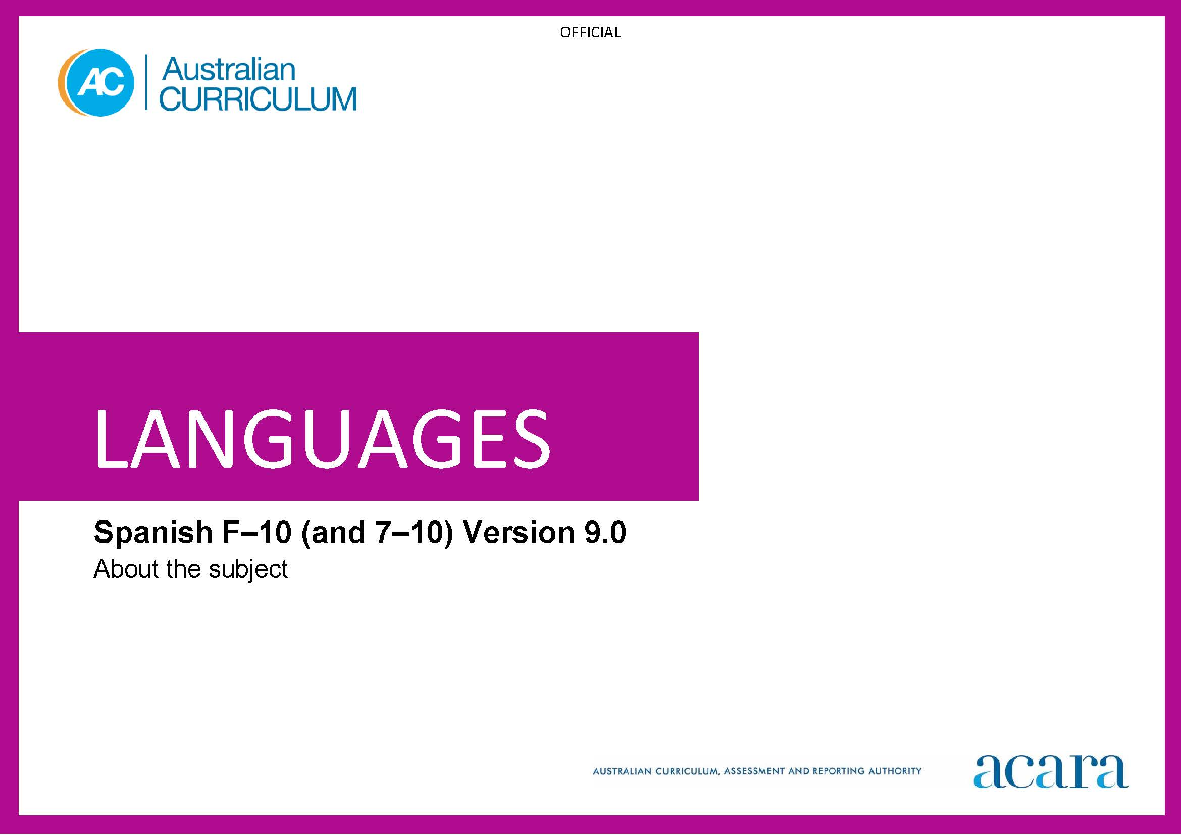

**Copyright and Terms of Use Statement**

**© Australian Curriculum, Assessment and Reporting Authority 2022**

The material published in this work is subject to copyright pursuant to the Copyright Act 1968 (Cth) and is owned by the Australian Curriculum, Assessment and Reporting Authority (ACARA) (except to the extent that copyright is held by another party, as indicated).

The viewing, downloading, displaying, printing, reproducing (such as by making photocopies) and distributing of these materials is permitted only to the extent permitted by, and is subject to the conditions imposed by, the terms and conditions of using the ACARA website (see, especially, clauses 2, 3 and 4 of those terms and conditions). The terms and conditions can be viewed at [https://www.acara.edu.au/contact-us/copyright](https://aus01.safelinks.protection.outlook.com/?url=https%3A%2F%2Fwww.acara.edu.au%2Fcontact-us%2Fcopyright&data=04%7C01%7CSharon.Foster%40acara.edu.au%7C9931e11fa7684c603e6308d98331bbfb%7C6cf76a3aa824427092003d71673ec678%7C0%7C0%7C637685071906340874%7CUnknown%7CTWFpbGZsb3d8eyJWIjoiMC4wLjAwMDAiLCJQIjoiV2luMzIiLCJBTiI6Ik1haWwiLCJXVCI6Mn0%3D%7C1000&sdata=U5O4Vlbpf271IGmGiMh7fDwU4pLzzAiHpCQFylkp6s4%3D&reserved=0)

TABLE OF CONTENTS

F–10 AUSTRALIAN CURRICULUM: LANGUAGES – SPANISH 3

ABOUT SPANISH 3

Introduction 3

Rationale 3

Structure 4

F–10 AUSTRALIAN CURRICULUM: LANGUAGES – SPANISH

ABOUT SPANISH

Introduction

The Australian Curriculum: Spanish is pitched to second language learners, that is, the dominant group of learners in the current Australian context for whom Spanish is an additional language.

Students of Spanish in Australian schools come from a range of backgrounds. For most students it is their first experience of learning Spanish, while others may have existing connections to Spanish as background speakers of the language.

Rationale

Spanish is the official language of Spain and an official language of Argentina, Bolivia, Chile, Colombia, Costa Rica, Cuba, Dominican Republic, Ecuador, El Salvador, Equatorial Guinea, Guatemala, Honduras, Mexico, Nicaragua, Panama, Paraguay, Peru, Puerto Rico, Uruguay and Venezuela. Spanish is a global language and is one of the official languages of the European Union and the United Nations.

The influence of the Spanish language and the cultures of Spanish-speaking communities can be seen globally in past and contemporary achievements in areas such as architecture, art, cuisine, dance, literature and music.

Migration from Spanish-speaking countries to Australia has made a significant contribution to shaping multicultural Australia. Patterns of migration of Spanish speakers to Australia have been influenced by a variety of factors, including economic and political circumstances, interest in tertiary education, and employment opportunities presented by trade agreements in sectors such as agriculture, mining and technology. The Spanish language has been taught in some Australian schools and universities since the 1960s and the influence of and interest in the cuisine, dance, literature and music of Spanish-speaking communities are evident in Australian society.

Spanish, like English, belongs to the Indo-European family of languages, and both share some similarities such as alphabet, vocabulary, language structures and features. Learning Spanish enhances students’ understanding of English and develops an appreciation of the language and cultures of Spanish-speaking communities. Knowledge of Spanish language and cultures enriches travel experiences, increases employment opportunities and promotes understanding of diverse attitudes, beliefs and values.

Structure

Spanish has been developed as a Second Language Learner Pathway which caters for students learning Spanish as a second or additional language.

The Second Language Learner Pathway includes 2 sequences:

* Foundation to Year 10
* Years 7 to 10.

Teachers use the curriculum to cater for learners of different backgrounds by making appropriate adjustments to differentiate learning experiences.

Content in Spanish is organised under 2 interrelated strands, each with a number of sub-strands. The strands and sub-strands are presented in Figure 1.

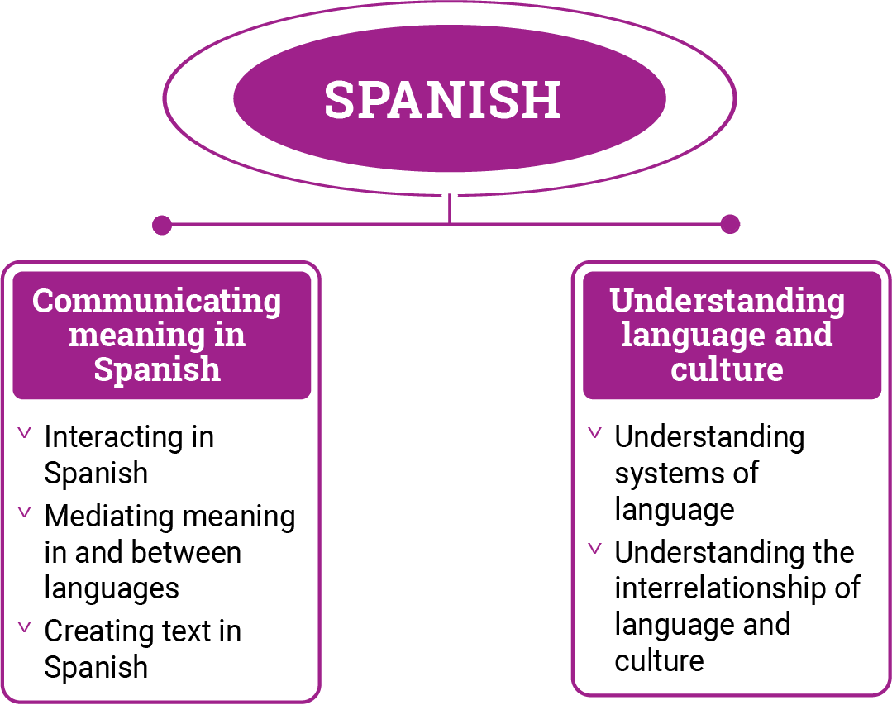

*Figure 1: Spanish content structure*

Strand: Communicating meaning in Spanish

This involves students learning to use language for communicative purposes in interpreting, creating and exchanging meaning. There are 3 sub-strands.

**Interacting in Spanish**

Exchanging ideas, opinions, experiences, thoughts and feelings in non-verbal, spoken and written interactions; participating in planning, negotiating, deciding and taking action.

**Mediating meaning in and between languages**

Obtaining, processing, interpreting and conveying information through a range of spoken, written and multimodal texts; moving between languages and cultures non-verbally, orally and in writing, recognising different interpretations.

**Creating text in Spanish**

Creating a range of spoken, written and multimodal texts for specific contexts, purposes and audiences.

Strand: Understanding language and culture

This involves students learning to analyse and understand language and culture as resources for interpreting and shaping meaning in intercultural exchange. There are 2 sub-strands.

**Understanding systems of language**

Understanding the linguistic features of Spanish, including sound, writing, grammatical and textual conventions.

**Understanding the interrelationship of language and culture**

Analysing and reflecting on the role of language and culture in shaping meaning and identity.