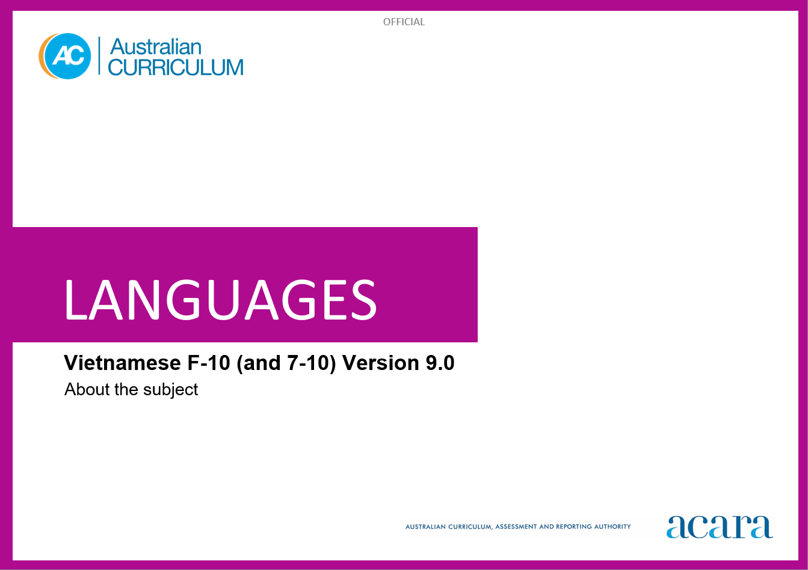

**Copyright and Terms of Use Statement**

**© Australian Curriculum, Assessment and Reporting Authority 2023**

The material published in this work is subject to copyright pursuant to the Copyright Act 1968 (Cth) and is owned by the Australian Curriculum, Assessment and Reporting Authority (ACARA) (except to the extent that copyright is held by another party, as indicated).

The viewing, downloading, displaying, printing, reproducing (such as by making photocopies) and distributing of these materials is permitted only to the extent permitted by, and is subject to the conditions imposed by, the terms and conditions of using the ACARA website (see, especially, clauses 2, 3 and 4 of those terms and conditions). The terms and conditions can be viewed at [https://www.acara.edu.au/contact-us/copyright](https://aus01.safelinks.protection.outlook.com/?url=https%3A%2F%2Fwww.acara.edu.au%2Fcontact-us%2Fcopyright&data=04%7C01%7CSharon.Foster%40acara.edu.au%7C9931e11fa7684c603e6308d98331bbfb%7C6cf76a3aa824427092003d71673ec678%7C0%7C0%7C637685071906340874%7CUnknown%7CTWFpbGZsb3d8eyJWIjoiMC4wLjAwMDAiLCJQIjoiV2luMzIiLCJBTiI6Ik1haWwiLCJXVCI6Mn0%3D%7C1000&sdata=U5O4Vlbpf271IGmGiMh7fDwU4pLzzAiHpCQFylkp6s4%3D&reserved=0)

TABLE OF CONTENTS

ABOUT Vietnamese 4

Introduction 4

Rationale 4

Structure 4

ABOUT Vietnamese

Introduction

The Australian Curriculum: Vietnamese recognises that learners of Vietnamese in Australian schools have a range of cultural backgrounds and language experiences. Learners may have varying degrees of proficiency in Vietnamese as background-language learners or they may be learning Vietnamese as a second or additional language.

Rationale

Modern Standard Vietnamese is the official language of Vietnam. It is a tonal language written in the Roman alphabet with additional diacritics for tones.

Vietnamese speakers have made significant contributions in shaping multicultural Australia. Vietnamese has been taught in some Australian schools and universities since the 1990s as well as in community-run organisations prior to this time. The influence of Vietnamese-speaking communities is evident in areas such as agriculture, the clothing industry, commerce, cuisine and tourism.

Vietnamese is a member of the Mon-Khmer language family. The influence of historical contact and exchanges among Vietnamese, Chinese and French people can be seen in Vietnamese vocabulary. As it uses the Roman alphabet, speakers of English can recognise the script and attempt its pronunciation. Learning Vietnamese develops students’ understanding of the language and culture of Vietnamese-speaking communities. It also enhances students’ awareness of the nature of language learning and promotes an appreciation of diverse attitudes, beliefs and values. Knowledge of the Vietnamese language and culture enriches travel experiences and increases employment opportunities.

Structure

Vietnamese has been developed to cater for learners with different linguistic experiences, those with a background in Vietnamese as well as those learning Vietnamese as a second or additional language.

The Australian Curriculum: Vietnamese includes 2 sequences:

* Foundation to Year 10
* Years 7 to 10.

Teachers can use the curriculum to make appropriate adjustments to differentiate learning. Content elaborations provide differentiated examples of language use and contexts to assist teachers to meet the needs of a range of learners, including background-language learners and second-language learners.

Content in Vietnamese is organised under 2 interrelated strands, each with a number of sub-strands. The strands and sub-strands are presented in Figure 2.

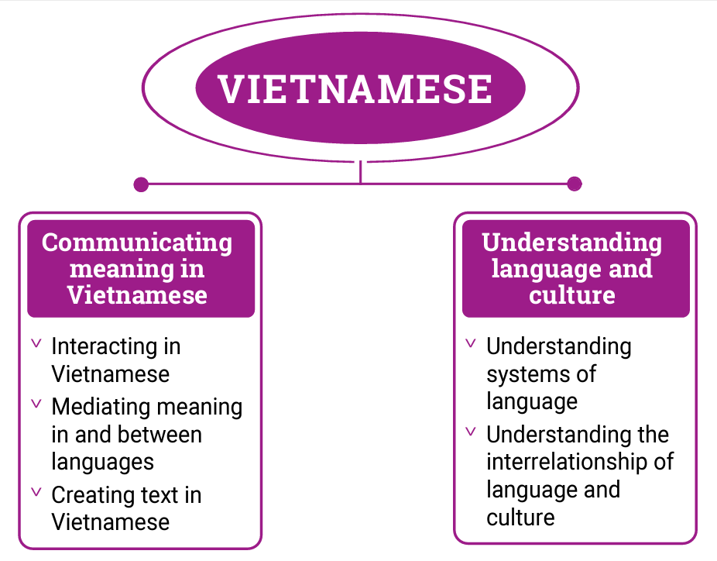

*Figure 2: Vietnamese content structure*

Strand: Communicating meaning in Vietnamese

This involves students learning to use language for communicative purposes in interpreting, creating and exchanging meaning. There are 3 sub-strands.

**Interacting in Vietnamese**

Exchanging ideas, opinions, experiences, thoughts and feelings in non-verbal, spoken and written interactions; participating in planning, negotiating, deciding and taking action.

**Mediating meaning in and between languages**

Obtaining, processing, interpreting and conveying information through a range of spoken, written and multimodal texts; moving between languages and cultures non-verbally, orally and in writing, recognising different interpretations.

**Creating text in Vietnamese**

Creating a range of spoken, written and multimodal texts for specific contexts, purposes and audiences.

Strand: Understanding language and culture

This involves students learning to analyse and understand language and culture as resources for interpreting and shaping meaning in intercultural exchange. There are 2 sub-strands.

**Understanding systems of language**

Understanding the linguistic features of Vietnamese, including sound, writing, grammatical and textual conventions.

**Understanding the interrelationship of language and culture**

Analysing and reflecting on the role of language and culture in shaping meaning and identity.