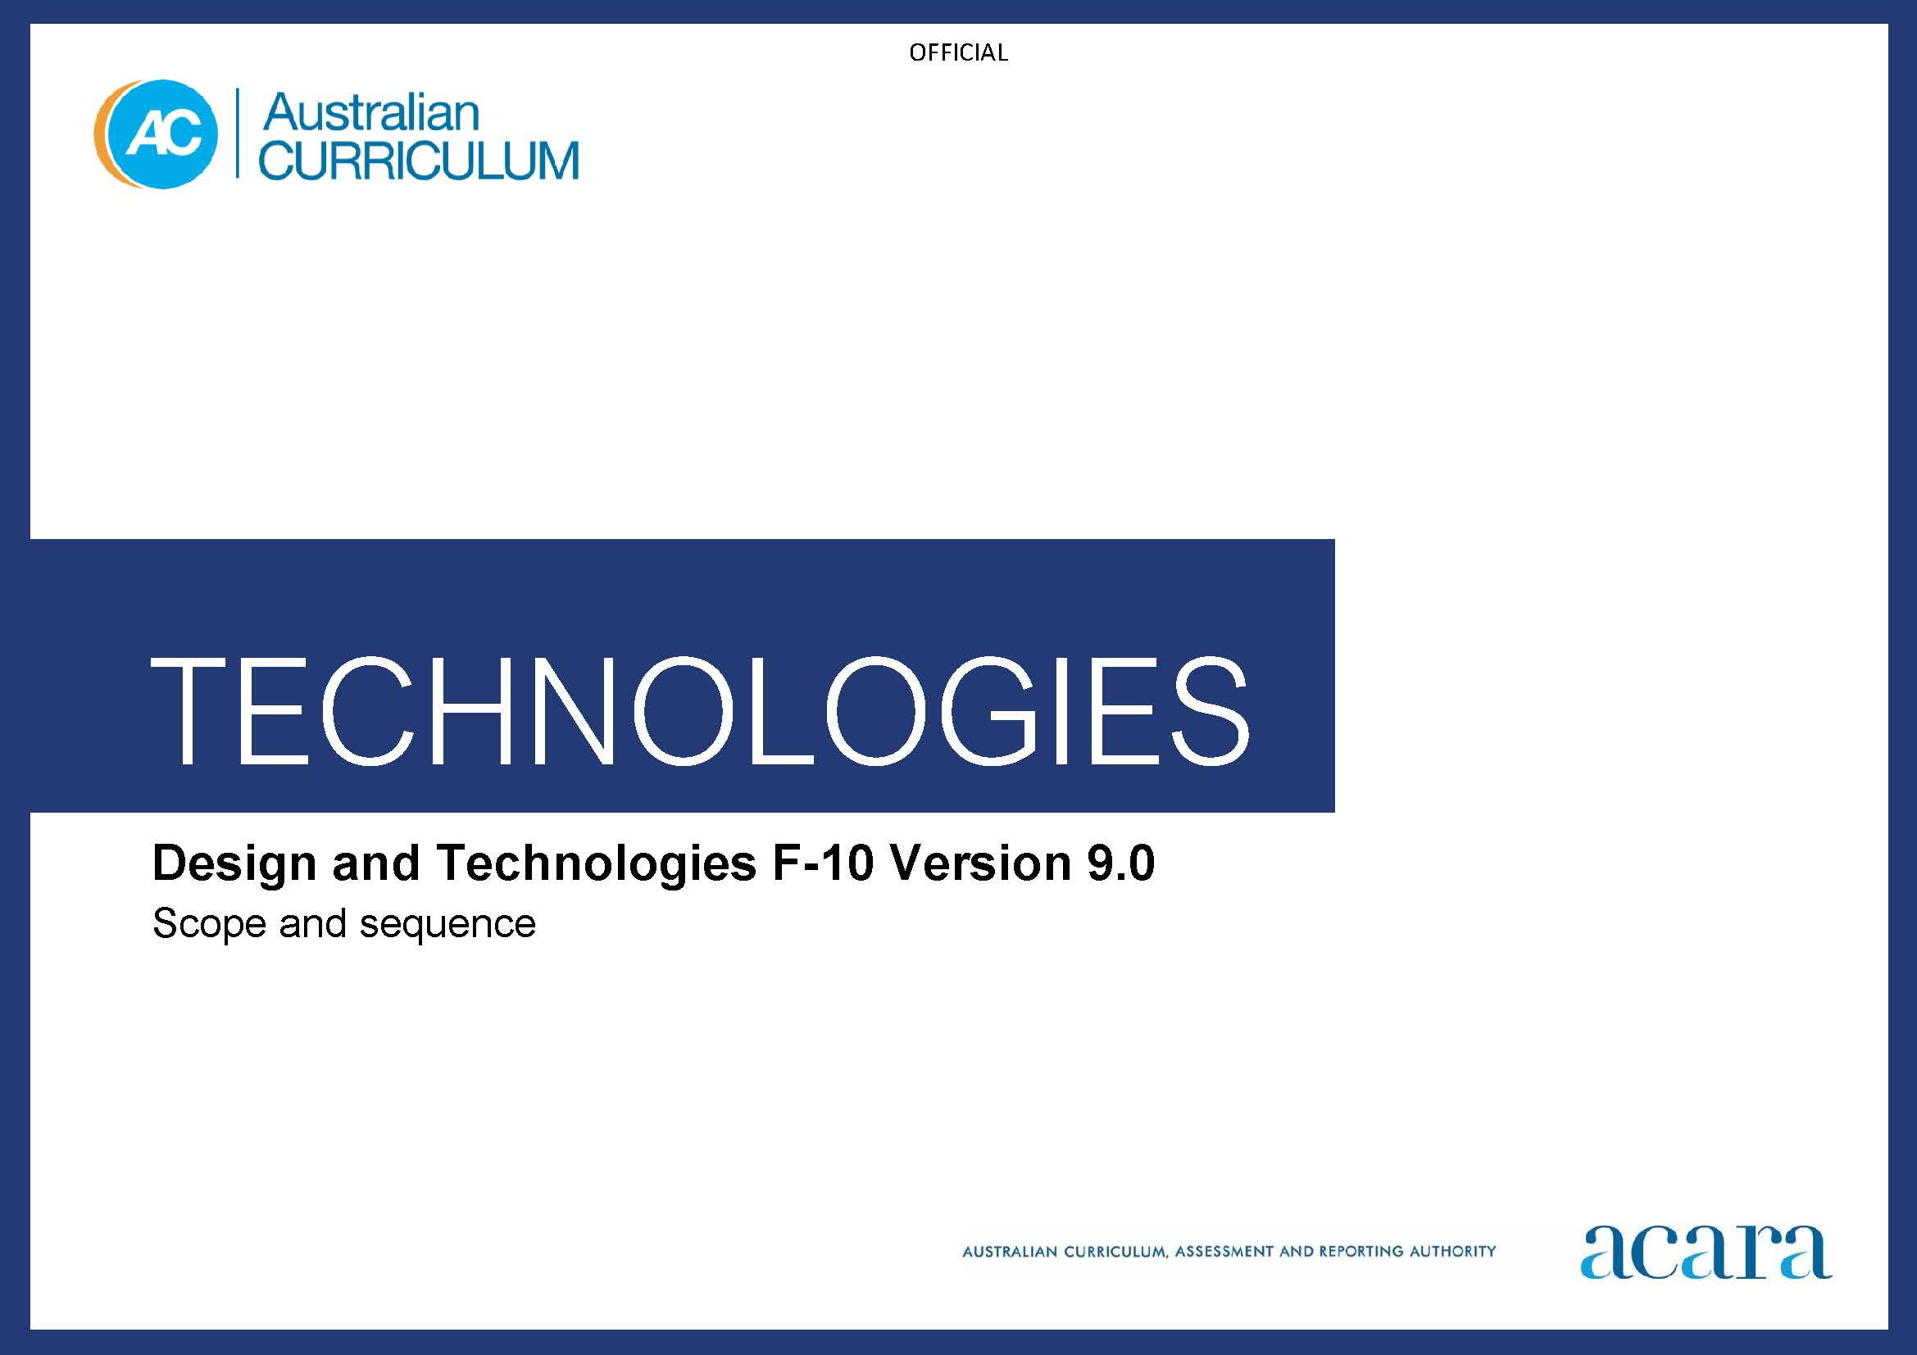

**Copyright and Terms of Use Statement**

**© Australian Curriculum, Assessment and Reporting Authority 2022**

The material published in this work is subject to copyright pursuant to the Copyright Act 1968 (Cth) and is owned by the Australian Curriculum, Assessment and Reporting Authority (ACARA) (except to the extent that copyright is held by another party, as indicated).

The viewing, downloading, displaying, printing, reproducing (such as by making photocopies) and distributing of these materials is permitted only to the extent permitted by, and is subject to the conditions imposed by, the terms and conditions of using the ACARA website (see, especially, clauses 2, 3 and 4 of those terms and conditions). The terms and conditions can be viewed at [https://www.acara.edu.au/contact-us/copyright](https://aus01.safelinks.protection.outlook.com/?url=https%3A%2F%2Fwww.acara.edu.au%2Fcontact-us%2Fcopyright&data=04%7C01%7CSharon.Foster%40acara.edu.au%7C9931e11fa7684c603e6308d98331bbfb%7C6cf76a3aa824427092003d71673ec678%7C0%7C0%7C637685071906340874%7CUnknown%7CTWFpbGZsb3d8eyJWIjoiMC4wLjAwMDAiLCJQIjoiV2luMzIiLCJBTiI6Ik1haWwiLCJXVCI6Mn0%3D%7C1000&sdata=U5O4Vlbpf271IGmGiMh7fDwU4pLzzAiHpCQFylkp6s4%3D&reserved=0)

|  |  |  |
| --- | --- | --- |
| **Foundation** | | **Years 1–2** |
| **Design and Technologies Achievement standard** | | |
| By the end of Foundation students identify familiar products, services and environments. They create a designed solution for a school-selected context. Students create, communicate and choose design ideas. They follow steps and use materials and equipment to safely make a designed solution. | By the end of Year 2 students describe the purpose of familiar products, services and environments. For each of the 2 prescribed technologies contexts they describe the features and uses of technologies and create designed solutions. Students select design ideas based on their personal preferences. They communicate design ideas using models and drawings and follow sequenced steps to safely produce designed solutions. | |
| **Learning area Achievement standard** | | |
| By the end of Foundation students identify familiar products, services and environments and develop familiarity with digital systems, using them for a purpose. They create, communicate and choose design ideas. Students follow steps and use materials and equipment to safely make a designed solution for a school-selected context. They show how to represent data using objects, pictures and symbols and identify examples of data that is owned by them. | By the end of Year 2 students describe the purpose of familiar products, services and environments, including digital systems. They represent and process data in different ways and follow and describe basic algorithms involving a sequence of steps and branching to show how simple digital solutions meet a need for known users. For each of the 2 prescribed technologies contexts they identify the features and uses of technologies and create designed solutions. Students select design ideas based on their personal preferences. They access and use the basic features of common digital tools to create, locate and share content, and collaborate and communicate design ideas using models and drawings. Students safely produce designed or digital solutions and recognise that digital tools may store their personal data online. | |

|  |  |
| --- | --- |
| **Content descriptions** | |
| **Strand: Knowledge and understanding** | |
| **Sub-strand: Technologies and society** | |
| explore how familiar products, services and environments are designed by people  AC9TDEFK01 | identify how familiar products, services and environments are designed and produced by people to meet personal or local community needs and sustainability  AC9TDE2K01 |
| **Sub-strand: Technologies context: Engineering principles and systems; Materials and technologies specialisations** | |
|  | explore how technologies including materials affect movement in products  AC9TDE2K02 |
| **Sub-strand: Technologies context: Food and fibre production; Food specialisations** | |
|  | explore how plants and animals are grown for food, clothing and shelter  AC9TDE2K03 |
|  | explore how food can be selected and prepared for healthy eating  AC9TDE2K04 |

|  |  |
| --- | --- |
|  | |
| **Sub-strand: Designing and making** | |
| generate, communicate and evaluate design ideas, and use materials, equipment and steps to safely make a solution for a purpose  AC9TDEFP01 |  |
|  | **Strand: Processes and production skills** |
| **Sub-strand: Generating and designing** | |
|  | generate and communicate design ideas through describing, drawing or modelling, including using digital tools  AC9TDE2P01 |
| **Sub-strand: Producing and implementing** | |
|  | use materials, components, tools, equipment and techniques to safely make designed solutions  AC9TDE2P02 |
| **Sub-strand: Evaluating** | |
|  | evaluate the success of design ideas and solutions based on personal preferences and including sustainability  AC9TDE2P03 |
| **Sub-strand: Collaborating and managing** | |
|  | sequence steps for making designed solutions cooperatively  AC9TDE2P04 |

|  |  |  |
| --- | --- | --- |
| **Years 3–4** | | **Years 5–6** |
| **Design and Technologies Achievement standard** | | |
| By the end of Year 4 students describe how people design products, services and environments to meet the needs of people, including sustainability. For each of the 2 prescribed technologies contexts they describe the features and uses of technologies and create designed solutions. Students select design ideas against design criteria. They communicate design ideas using models and drawings including annotations and symbols. Students plan and sequence steps and use technologies and techniques to safely produce designed solutions. | By the end of Year 6 students explain how people design products, services and environments to meet the needs of communities, including sustainability. For each of the 3 prescribed technologies contexts they explain how the features of technologies impact on design decisions and they create designed solutions. Students select and justify design ideas and solutions against design criteria that include sustainability. They communicate design ideas to an audience using technical terms and graphical representation techniques. Students develop project plans, including production processes, and select technologies and techniques to safely produce designed solutions. | |
| **Learning area Achievement standard** | | |
| By the end of Year 4 students describe how people design products, services and environments to meet the needs of people, including sustainability. They process and represent data for different purposes, follow and describe simple algorithms involving branching and iteration, and implement them as visual programs. For each of the 2 prescribed technologies contexts they describe the features and uses of technologies and create designed solutions. Students select design ideas against design criteria. Students securely access and use digital systems and their peripherals for a range of purposes, including transmitting data. They communicate design ideas using models and drawings including annotations and symbols. Students plan and sequence steps and use technologies and techniques to safely produce designed solutions. They use the core features of common digital tools to plan, create, locate and share content, and to collaborate, following agreed behaviours. Students identify their personal data stored online and its risks. | By the end of Year 6 students explain how people design products, services and environments to meet the needs of communities, including sustainability. For each of the 3 prescribed technologies contexts students explain how the features of technologies impact on design decisions and they create designed solutions. They process data and show how digital systems represent data, design algorithms involving complex branching and iteration, and implement them as visual programs including variables. They select and justify design ideas and solutions against design criteria. Students share and communicate ideas or content to an audience using technical terms, graphical representation techniques and appropriate digital tools. They develop project plans, including production processes, and select technologies and techniques to safely produce designed or digital solutions. Students securely access and use multiple digital systems and describe their components and how they interact to process and transmit data. They identify their digital footprint and recognise its permanence. | |

|  |  |
| --- | --- |
| **Content descriptions** | |
| **Strand: Knowledge and understanding** | |
| **Sub-strand: Technologies and society** | |
| examine design and technologies occupations and factors including sustainability that impact on the design of products, services and environments to meet community needs  AC9TDE4K01 | explain how people in design and technologies occupations consider competing factors including sustainability in the design of products, services and environments  AC9TDE6K01 |
| **Sub-strand: Technologies context: Engineering principles and systems; Materials and technologies specialisations** | |
| describe how forces and the properties of materials affect function in a product or system  AC9TDE4K02 |  |
| **Sub-strand: Technologies context: Engineering principles and systems** | |
|  | explain how electrical energy can be transformed into movement, sound or light in a product or system  AC9TDE6K02 |
| **Sub-strand: Technologies context: Food and fibre production; Food specialisations** | |
| describe the ways of producing food and fibre  AC9TDE4K03 | explain how and why food and fibre are produced in managed environments  AC9TDE6K03 |
| describe the ways food can be selected and prepared for healthy eating  AC9TDE4K04 | explain how the characteristics of foods influence selection and preparation for healthy eating  AC9TDE6K04 |

|  |  |
| --- | --- |
| **Sub-strand: Technologies context: Materials and technologies specialisations** | |
|  | explain how characteristics and properties of materials, systems, components, tools and equipment affect their use when producing designed solutions  AC9TDE6K05 |

|  |  |
| --- | --- |
| **Strand: Processes and production skills** | |
| **Sub-strand: Investigating and defining** | |
| explore needs or opportunities for designing, and test materials, components, tools, equipment and processes needed to create designed solutions  AC9TDE4P01 | investigate needs or opportunities for designing, and the materials, components, tools, equipment and processes needed to create designed solutions  AC9TDE6P01 |
| **Sub-strand: Generating and designing** | |
| generate and communicate design ideas and decisions using appropriate attributions, technical terms and graphical representation techniques, including using digital tools  AC9TDE4P02 | generate, iterate and communicate design ideas, decisions and processes using technical terms and graphical representation techniques, including using digital tools  AC9TDE6P02 |
| **Sub-strand: Producing and implementing** | |
| select and use materials, components, tools, equipment and techniques to safely make designed solutions  AC9TDE4P03 | select and use suitable materials, components, tools, equipment and techniques to safely make designed solutions  AC9TDE6P03 |

|  |  |
| --- | --- |
| **Sub-strand: Evaluating** | |
| use given or co-developed design criteria including sustainability to evaluate design ideas and solutions  AC9TDE4P04 | negotiate design criteria including sustainability to evaluate design ideas, processes and solutions  AC9TDE6P04 |
| **Sub-strand: Collaborating and managing** | |
| sequence steps to individually and collaboratively make designed solutions  AC9TDE4P05 | develop project plans that include consideration of resources to individually and collaboratively make designed solutions  AC9TDE6P05 |

|  |  |  |
| --- | --- | --- |
| **Year 7–8** | | **Years 9–10** |
| **Design and Technologies Achievement standard** | | |
| By the end of Year 8 students explain how people design, innovate and produce products, services and environments for preferred futures. For each of the 4 prescribed technologies contexts they explain how the features of technologies impact on design decisions, and create designed solutions based on analysis of needs or opportunities. Students create and adapt design ideas, processes and solutions, and justify their decisions against developed design criteria that include sustainability. They communicate design ideas and solutions to audiences using technical terms and graphical representation techniques, including using digital tools. They independently and collaboratively document and manage production processes to safely produce designed solutions. | By the end of Year 10 students explain how people consider factors that impact on design decisions and the technologies used to design and produce products, services and environments for sustainable living. They explain the contribution of innovation, enterprise skills and emerging technologies to global preferred futures. For one or more of the technologies contexts, students explain the features of technologies and their appropriateness for purpose, and create designed solutions based on an analysis of needs or opportunities. Students create, adapt and refine design ideas, processes and solutions and justify their decisions against developed design criteria that include sustainability. They communicate design ideas, processes and solutions to a range of audiences, including using digital tools. Students independently and collaboratively develop and apply production and project management plans, adjusting processes when necessary. They select and use technologies skilfully and safely to produce designed solutions. | |
| **Learning area Achievement standard** | | |
| By the end of Year 8 students explain how people design, innovate and produce products, services and environments for preferred futures. For each of the 4 prescribed technologies contexts students explain how the features of technologies impact on design decisions, and create designed solutions based on analysis of needs or opportunities. They acquire, interpret and model with spreadsheets and represent data with integers and binary. Students design and trace algorithms; and implement them in a general-purpose programming language. Students create and adapt design ideas, processes and solutions, and justify their decisions against developed design criteria that include sustainability. They communicate design ideas and solutions to audiences using technical terms and graphical representation techniques, including using digital tools. They select appropriate hardware for particular tasks, explain how data is transmitted and secured in networks, and identify cyber security threats. They use a range of digital tools to individually and collaboratively document and manage production processes to safely and responsibly produce designed or digital solutions for the intended purpose. Students manage their digital footprint. |  | |

|  |  |
| --- | --- |
| **Content descriptions** | |
| **Strand: Knowledge and understanding** | |
| **Sub-strand: Technologies and society** | |
| analyse how people in design and technologies occupations consider ethical and sustainability factors to design and produce products, services and environments  AC9TDE8K01 | analyse how people in design and technologies occupations consider ethical, security and sustainability factors to innovate and improve products, services and environments  AC9TDE10K01 |
| analyse the impact of innovation and the development of technologies on designed solutions for global preferred futures  AC9TDE8K02 | analyse the impact of innovation, enterprise and emerging technologies on designed solutions for global preferred futures  AC9TDE10K02 |
| **Sub-strand: Technologies context: Engineering principles and systems** | |
| analyse how force, motion and energy are used to manipulate and control engineered systems  AC9TDE8K03 | analyse and make judgements on how the characteristics and properties of materials are combined with force, motion and energy to control engineered systems  AC9TDE10K03 |
| **Sub-strand: Technologies context: Food and fibre production** | |
| analyse how food and fibre are produced in managed environments and how these can become sustainable  AC9TDE8K04 | analyse and make judgements on the ethical, secure and sustainable production and marketing of food and fibre enterprises  AC9TDE10K04 |
| **Sub-strand: Technologies context: Food specialisations** | |
| analyse how properties of foods determine preparation and presentation techniques when designing solutions for healthy eating  AC9TDE8K05 | analyse and make judgements on how the sensory and functional properties of food influence the design and preparation of sustainable food solutions for healthy eating  AC9TDE10K05 |

|  |  |
| --- | --- |
| **Sub-strand: Technologies context: Materials and technologies specialisations** | |
| analyse how characteristics and properties of materials, systems, components, tools and equipment can be combined to create designed solutions  AC9TDE8K06 | analyse and make judgements on how characteristics and properties of materials, systems, components, tools and equipment can be combined to create designed solutions  AC9TDE10K06 |

|  |  |
| --- | --- |
| **Strand: Processes and production skills** | |
| **Sub-strand: Investigating and defining** | |
| analyse needs or opportunities for designing, and investigate and select materials, components, tools, equipment and processes to create designed solutions  AC9TDE8P01 | analyse needs or opportunities for designing; develop design briefs; and investigate, analyse and select materials, systems, components, tools and equipment to create designed solutions  AC9TDE10P01 |
| **Sub-strand: Generating and designing** | |
| generate, test, iterate and communicate design ideas, processes and solutions using technical terms and graphical representation techniques, including using digital tools  AC9TDE8P02 | apply innovation and enterprise skills to generate, test, iterate and communicate design ideas, processes and solutions, including using digital tools  AC9TDE10P02 |
| **Sub-strand: Producing and implementing** | |
| select, justify and use suitable materials, components, tools, equipment, skills and processes to safely make designed solutions  AC9TDE8P03 | select, justify, test and use suitable technologies, skills and processes, and apply safety procedures to safely make designed solutions  AC9TDE10P03 |
| **Sub-strand: Evaluating** | |
| develop design criteria collaboratively including sustainability to evaluate design ideas, processes and solutions  AC9TDE8P04 | develop design criteria independently including sustainability to evaluate design ideas, processes and solutions  AC9TDE10P04 |
| **Sub-strand: Collaborating and managing** | |
| develop project plans to individually and collaboratively manage time, cost and production of designed solutions  AC9TDE8P05 | develop project plans for intended purposes and audiences to individually and collaboratively manage projects, taking into consideration time, cost, risk, processes and production of designed solutions  AC9TDE10P05 |