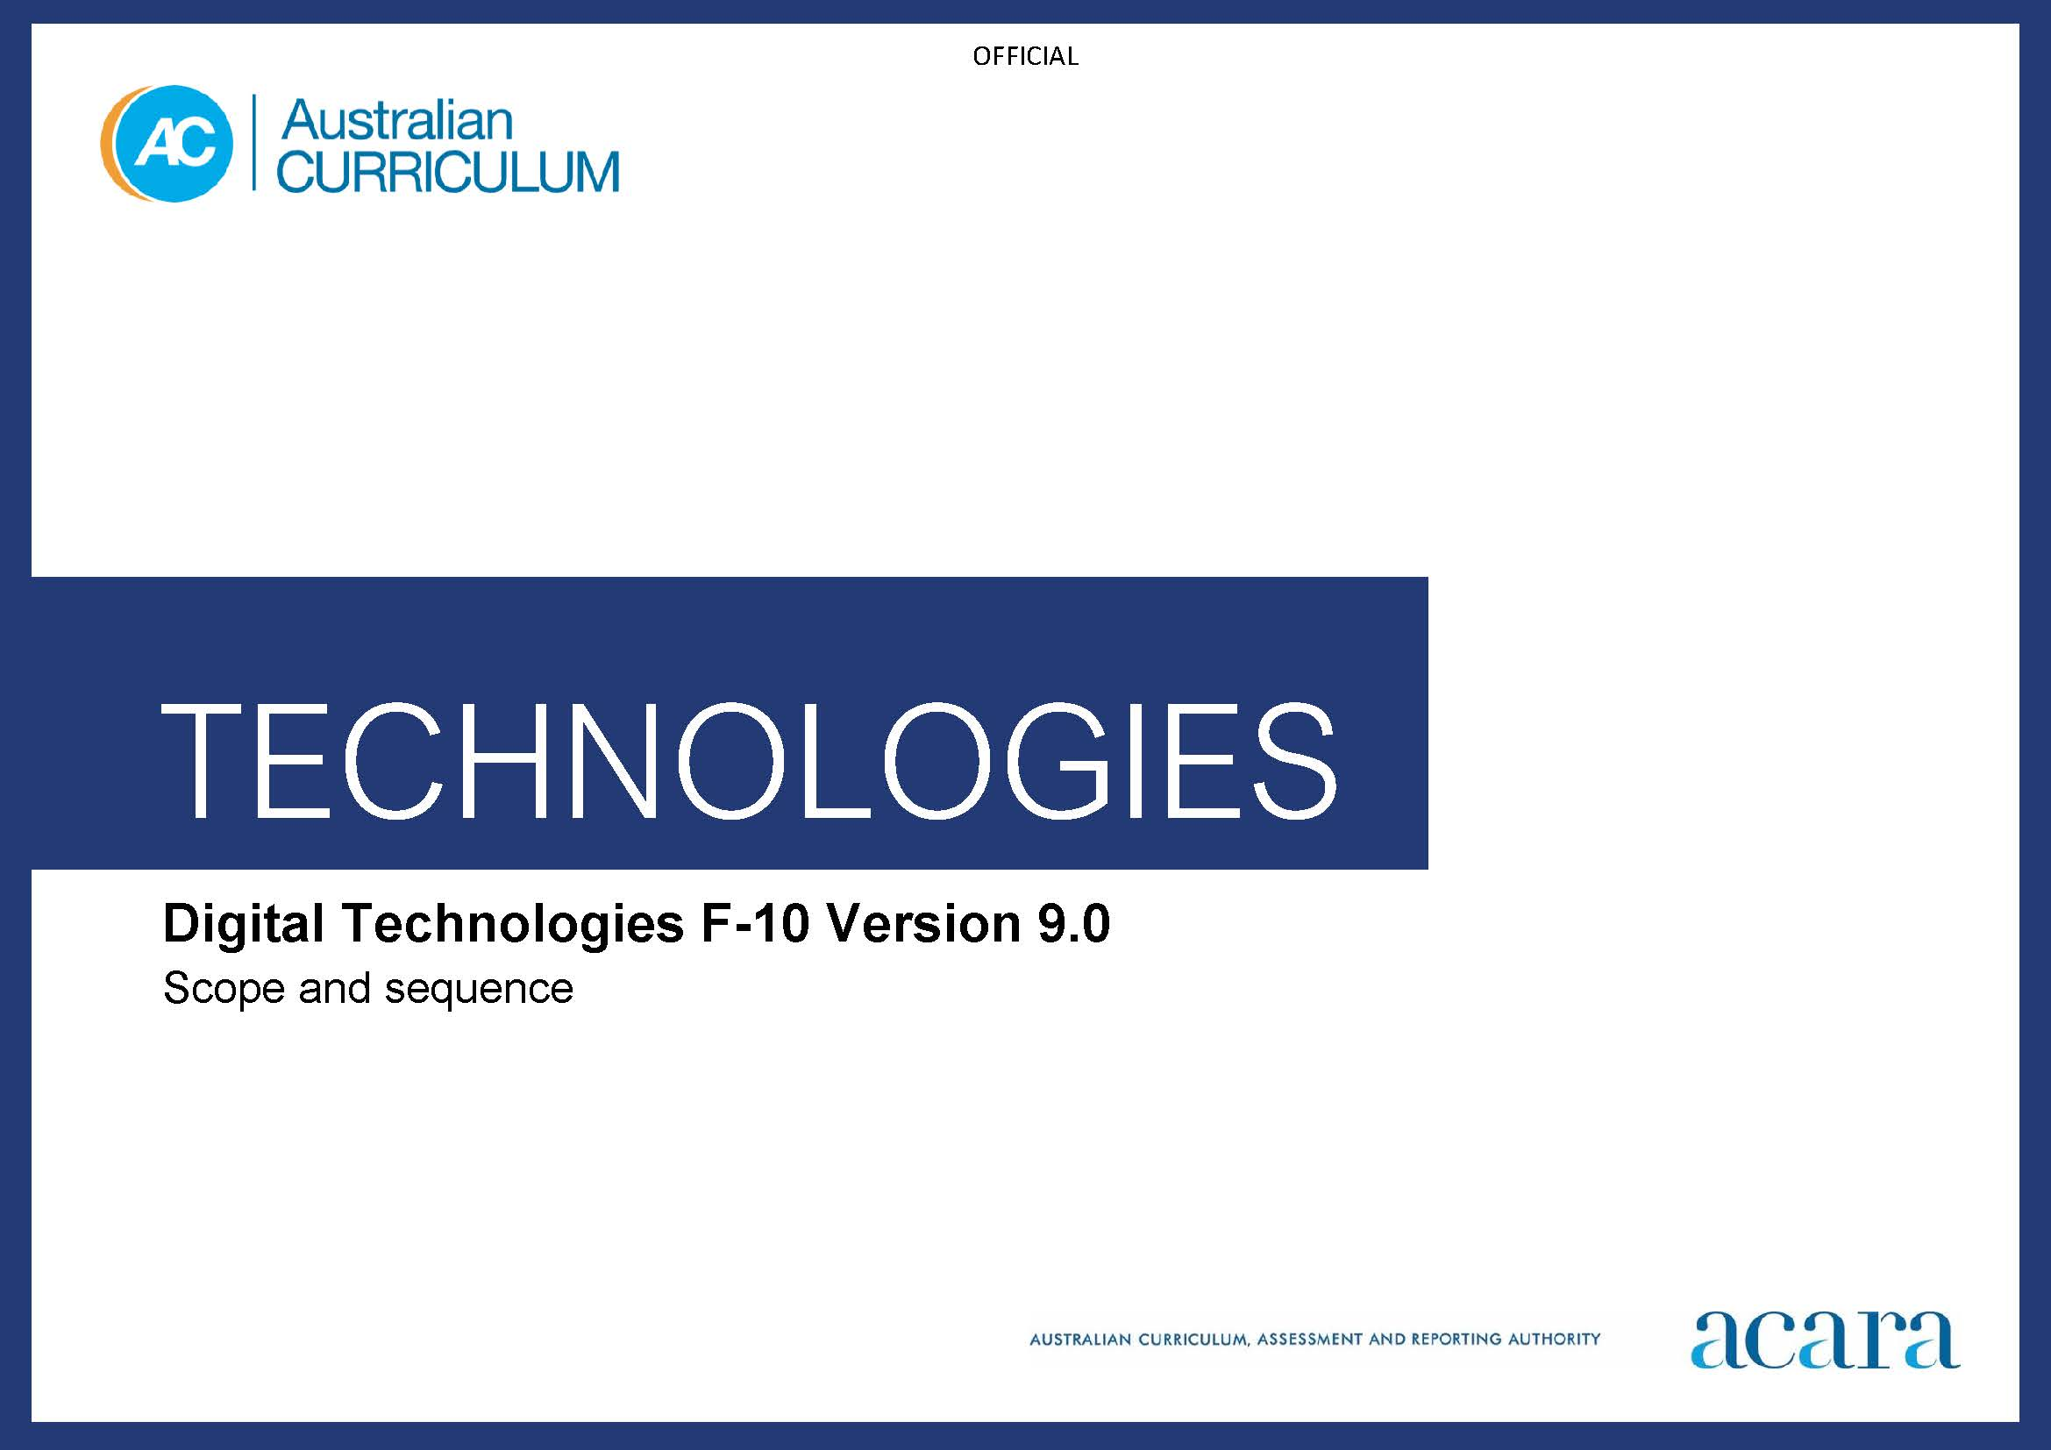

**Copyright and Terms of Use Statement**

**© Australian Curriculum, Assessment and Reporting Authority 2022**

The material published in this work is subject to copyright pursuant to the Copyright Act 1968 (Cth) and is owned by the Australian Curriculum, Assessment and Reporting Authority (ACARA) (except to the extent that copyright is held by another party, as indicated).

The viewing, downloading, displaying, printing, reproducing (such as by making photocopies) and distributing of these materials is permitted only to the extent permitted by, and is subject to the conditions imposed by, the terms and conditions of using the ACARA website (see, especially, clauses 2, 3 and 4 of those terms and conditions). The terms and conditions can be viewed at [https://www.acara.edu.au/contact-us/copyright](https://aus01.safelinks.protection.outlook.com/?url=https%3A%2F%2Fwww.acara.edu.au%2Fcontact-us%2Fcopyright&data=04%7C01%7CSharon.Foster%40acara.edu.au%7C9931e11fa7684c603e6308d98331bbfb%7C6cf76a3aa824427092003d71673ec678%7C0%7C0%7C637685071906340874%7CUnknown%7CTWFpbGZsb3d8eyJWIjoiMC4wLjAwMDAiLCJQIjoiV2luMzIiLCJBTiI6Ik1haWwiLCJXVCI6Mn0%3D%7C1000&sdata=U5O4Vlbpf271IGmGiMh7fDwU4pLzzAiHpCQFylkp6s4%3D&reserved=0)

|  |  |  |
| --- | --- | --- |
| **Foundation** | | **Years 1–2** |
| **Digital Technologies Achievement standard** | | |
| By the end of Foundation students show familiarity with digital systems and use them for a purpose. They represent data using objects, pictures and symbols and identify examples of data that is owned by them. | By the end of Year 2 students show how simple digital solutions meet a need for known users. Students represent and process data in different ways. They follow and describe basic algorithms involving a sequence of steps and branching. With assistance, students access and use digital systems for a purpose. They use the basic features of common digital tools to create, locate and share content, and to collaborate, following agreed behaviours. Students recognise that digital tools may store their personal data online. | |
| **Learning area Achievement standard** | | |
| By the end of Foundation students identify familiar products, services and environments and develop familiarity with digital systems, using them for a purpose. They create, communicate and choose design ideas. Students follow steps and use materials and equipment to safely make a designed solution for a school-selected context. They show how to represent data using objects, pictures and symbols and identify examples of data that is owned by them. | By the end of Year 2 students describe the purpose of familiar products, services and environments, including digital systems. They represent and process data in different ways and follow and describe basic algorithms involving a sequence of steps and branching to show how simple digital solutions meet a need for known users. For each of the 2 prescribed technologies contexts they identify the features and uses of technologies and create designed solutions. Students select design ideas based on their personal preferences. They access and use the basic features of common digital tools to create, locate and share content, and collaborate and communicate design ideas using models and drawings. Students safely produce designed or digital solutions and recognise that digital tools may store their personal data online. | |

|  |  |
| --- | --- |
| **Content descriptions** | |
| **Strand: Knowledge and understanding** | |
| **Sub-strand: Digital systems** | |
| recognise and explore digital systems (hardware and software) for a purpose  AC9TDIFK01 | identify and explore digital systems and their components for a purpose  AC9TDI2K01 |
| **Sub-strand: Data representation** | |
| represent data as objects, pictures and symbols  AC9TDIFK02 | represent data as pictures, symbols, numbers and words  AC9TDI2K02 |

|  |  |
| --- | --- |
| **Strand: Processes and production skills** | |
| **Sub-strand: Investigating and defining** | |
|  | investigate simple problems for known users that can be solved with digital systems  AC9TDI2P01 |
| **Sub-strand: Generating and designing** | |
|  | follow and describe algorithms involving a sequence of steps, branching (decisions) and iteration (repetition)  AC9TDI2P02 |
| **Sub-strand: Evaluating** | |
|  | discuss how existing digital systems satisfy identified needs for known users  AC9TDI2P03 |
| **Sub-strand: Collaborating and managing** | |
|  | use the basic features of common digital tools to create, locate and communicate content  AC9TDI2P04 |
|  | use the basic features of common digital tools to share content and collaborate demonstrating agreed behaviours, guided by trusted adults  AC9TDI2P05 |

|  |  |
| --- | --- |
| **Sub-strand: Privacy and security** | |
| identify some data that is personal and owned by them  AC9TDIFP01 | access their school account with a recorded username and password  AC9TDI2P06 |
|  | discuss that some websites and apps store their personal data online  AC9TDI2P07 |

|  |  |  |
| --- | --- | --- |
| **Years 3–4** | | **Years 5–6** |
| **Digital Technologies Achievement standard** | | |
| By the end of Year 4 students create simple digital solutions and use provided design criteria to check if solutions meet user needs. Students process and represent data for different purposes. They follow and describe simple algorithms involving branching and iteration and implement them as visual programs. Students securely access and use digital systems and their peripherals for a range of purposes, including transmitting data. They use the core features of common digital tools to plan, create, locate and share content, and to collaborate, following agreed behaviours. Students identify their personal data stored online and recognise the risks. | By the end of Year 6 students develop and modify digital solutions, and define problems and evaluate solutions using user stories and design criteria. They process data and show how digital systems represent data. Students design algorithms involving complex branching and iteration and implement them as visual programs including variables. They securely access and use multiple digital systems and describe their components and how they interact to process and transmit data. Students select and use appropriate digital tools effectively to plan, create, locate and share content, and to collaborate, applying agreed conventions and behaviours. They identify their digital footprint and recognise its permanence. | |
| **Learning area achievement standard** | | |
| By the end of Year 4 students describe how people design products, services and environments to meet the needs of people, including sustainability. They process and represent data for different purposes, follow and describe simple algorithms involving branching and iteration, and implement them as visual programs. For each of the 2 prescribed technologies contexts they describe the features and uses of technologies and create designed solutions. Students select design ideas against design criteria. Students securely access and use digital systems and their peripherals for a range of purposes, including transmitting data. They communicate design ideas using models and drawings including annotations and symbols. Students plan and sequence steps and use technologies and techniques to safely produce designed solutions. They use the core features of common digital tools to plan, create, locate and share content, and to collaborate, following agreed behaviours. Students identify their personal data stored online and its risks. | By the end of Year 6 students explain how people design products, services and environments to meet the needs of communities, including sustainability. For each of the 3 prescribed technologies contexts students explain how the features of technologies impact on design decisions and they create designed solutions. They process data and show how digital systems represent data, design algorithms involving complex branching and iteration, and implement them as visual programs including variables. They select and justify design ideas and solutions against design criteria. Students share and communicate ideas or content to an audience using technical terms, graphical representation techniques and appropriate digital tools. They develop project plans, including production processes, and select technologies and techniques to safely produce designed or digital solutions. Students securely access and use multiple digital systems and describe their components and how they interact to process and transmit data. They identify their digital footprint and recognise its permanence. | |

|  |  |
| --- | --- |
| **Content descriptions** | |
| **Strand: Knowledge and understanding** | |
| **Sub-strand: Digital systems** | |
| explore and describe a range of digital systems and their peripherals for a variety of purposes  AC9TDI4K01 | investigate the main internal components of common digital systems and their function  AC9TDI6K01 |
| explore transmitting different types of data between digital systems  AC9TDI4K02 | examine how digital systems form networks to transmit data  AC9TDI6K02 |
| **Sub-strand: Data representation** | |
| recognise different types of data and explore how the same data can be represented differently depending on the purpose  AC9TDI4K03 | explain how digital systems represent all data using numbers  AC9TDI6K03 |
|  | explore how data can be represented by off and on states (zeros and ones in binary)  AC9TDI6K04 |

|  |  |
| --- | --- |
| **Strand: Processes and production skills** | |
| **Sub-strand: Investigating and defining** | |
| define problems with given design criteria and by co-creating user stories  AC9TDI4P01 | define problems with given or co‑developed design criteria and by creating user stories  AC9TDI6P01 |
| **Sub-strand: Generating and designing** | |
| follow and describe algorithms involving sequencing, comparison operators (branching) and iteration  AC9TDI4P02 | design algorithms involving multiple alternatives (branching) and iteration  AC9TDI6P02 |
|  | design a user interface for a digital system  AC9TDI6P03 |
| generate, communicate and compare designs  AC9TDI4P03 | generate, modify, communicate and evaluate designs  AC9TDI6P04 |
| **Sub-strand: Producing and implementing** | |
| implement simple algorithms as visual programs involving control structures and input  AC9TDI4P04 | implement algorithms as visual programs involving control structures, variables and input  AC9TDI6P05 |
| **Sub-strand: Evaluating** | |
| discuss how existing and student solutions satisfy the design criteria and user stories  AC9TDI4P05 | evaluate existing and student solutions against the design criteria and user stories and their broader community impact  AC9TDI6P06 |

|  |  |
| --- | --- |
| **Sub-strand: Collaborating and managing** | |
| use the core features of common digital tools to create, locate and communicate content, following agreed conventions  AC9TDI4P06 | select and use appropriate digital tools effectively to create, locate and communicate content, applying common conventions  AC9TDI6P07 |
| use the core features of common digital tools to share content, plan tasks, and collaborate, following agreed behaviours, supported by trusted adults  AC9TDI4P07 | select and use appropriate digital tools effectively to share content online, plan tasks and collaborate on projects, demonstrating agreed behaviours  AC9TDI6P08 |
| **Sub-strand: Privacy and security** | |
| access their school account using a memorised password and explain why it should be easy to remember, but hard for others to guess  AC9TDI4P08 | access multiple personal accounts using unique passphrases and explain the risks of password re-use  AC9TDI6P09 |
| identify what personal data is stored and shared in their online accounts and discuss any associated risks  AC9TDI4P09 | explain the creation and permanence of their digital footprint and consider privacy when collecting user data  AC9TDI6P10 |

|  |  |  |
| --- | --- | --- |
| **Years 7–8** | | **Years 9–10** |
| **Digital Technologies Achievement standard** | | |
| By the end of Year 8 students develop and modify creative digital solutions, decompose real-world problems, and evaluate alternative solutions against user stories and design criteria. Students acquire, interpret and model data with spreadsheets and represent data with integers and binary. They design and trace algorithms and implement them in a general-purpose programming language. Students select appropriate hardware for particular tasks, explain how data is transmitted and secured in networks, and identify cyber security threats. They select and use a range of digital tools efficiently and responsibly to create, locate and share content; and to plan, collaborate on and manage projects. Students manage their digital footprint. | By the end of Year 10 students develop and modify innovative digital solutions, decompose real-world problems, and critically evaluate alternative solutions against stakeholder elicited user stories. Students acquire, interpret and model complex data with databases and represent documents as content, structure and presentation. They design and validate algorithms and implement them, including in an object-oriented programming language. Students explain how digital systems manage, control and secure access to data; and model cyber security threats and explore a vulnerability. They use advanced features of digital tools to create interactive content, and to plan, collaborate on and manage agile projects. Students apply privacy principles to manage digital footprints. | |
| **Learning area Achievement standard** | | |
| By the end of Year 8 students explain how people design, innovate and produce products, services and environments for preferred futures. For each of the 4 prescribed technologies contexts students explain how the features of technologies impact on design decisions, and create designed solutions based on analysis of needs or opportunities. They acquire, interpret and model with spreadsheets and represent data with integers and binary. Students design and trace algorithms; and implement them in a general-purpose programming language. Students create and adapt design ideas, processes and solutions, and justify their decisions against developed design criteria that include sustainability. They communicate design ideas and solutions to audiences using technical terms and graphical representation techniques, including using digital tools. They select appropriate hardware for particular tasks, explain how data is transmitted and secured in networks, and identify cyber security threats. They use a range of digital tools to individually and collaboratively document and manage production processes to safely and responsibly produce designed or digital solutions for the intended purpose. Students manage their digital footprint. |  | |

|  |  |
| --- | --- |
| **Content descriptions** | |
| **Strand: Knowledge and understanding** | |
| **Sub-strand: Digital systems** | |
| explain how hardware specifications affect performance and select appropriate hardware for particular tasks and workloads  AC9TDI8K01 |  |
| investigate how data is transmitted and secured in wired and wireless networks including the internet  AC9TDI8K02 | investigate how hardware and software manage, control and secure access to data in networked digital systems  AC9TDI10K01 |
| **Sub-strand: Data representation** | |
| investigate how digital systems represent text, image and audio data using integers  AC9TDI8K03 | represent documents online as content (text), structure (markup) and presentation (styling) and explain why such representations are important  AC9TDI10K02 |
| explain how and why digital systems represent integers in binary  AC9TDI8K04 | investigate simple data compression techniques  AC9TDI10K03 |

|  |  |
| --- | --- |
| **Strand: Processes and production skills** | |
| **Sub-strand: Acquiring, managing and analysing data** | |
| acquire, store and validate data from a range of sources using software, including spreadsheets and databases  AC9TDI8P01 | develop techniques to acquire, store and validate data from a range of sources using software, including spreadsheets and databases  AC9TDI10P01 |
| analyse and visualise data using a range of software, including spreadsheets and databases, to draw conclusions and make predictions by identifying trends  AC9TDI8P02 | analyse and visualise data interactively using a range of software, including spreadsheets and databases, to draw conclusions and make predictions by identifying trends and outliers  AC9TDI10P02 |
| model and query the attributes of objects and events using structured data  AC9TDI8P03 | model and query entities and their relationships using structured data  AC9TDI10P03 |
| **Sub-strand: Investigating and defining** | |
| define and decompose real-world problems with design criteria and by creating user stories  AC9TDI8P04 | define and decompose real-world problems with design criteria and by interviewing stakeholders to create user stories  AC9TDI10P04 |
| **Sub-strand: Generating and designing** | |
| design algorithms involving nested control structures and represent them using flowcharts and pseudocode  AC9TDI8P05 | design algorithms involving logical operators and represent them as flowcharts and pseudocode  AC9TDI10P05 |
| trace algorithms to predict output for a given input and to identify errors  AC9TDI8P06 | validate algorithms and programs by comparing their output against a range of test cases  AC9TDI10P06 |
| design the user experience of a digital system  AC9TDI8P07 | design and prototype the user experience of a digital system  AC9TDI10P07 |
| generate, modify, communicate and evaluate alternative designs  AC9TDI8P08 | generate, modify, communicate and critically evaluate alternative designs  AC9TDI10P08 |
| **Sub-strand: Producing and implementing** | |
| implement, modify and debug programs involving control structures and functions in a general-purpose programming language  AC9TDI8P09 | implement, modify and debug modular programs, applying selected algorithms and data structures, including in an object-oriented programming language  AC9TDI10P09 |
| **Sub-strand: Evaluating** | |
| evaluate existing and student solutions against the design criteria, user stories and possible future impact  AC9TDI8P10 | evaluate existing and student solutions against the design criteria, user stories, possible future impact and opportunities for enterprise  AC9TDI10P10 |
| **Sub-strand: Collaborating and managing** | |
| select and use a range of digital tools efficiently, including unfamiliar features, to create, locate and communicate content, consistently applying common conventions  AC9TDI8P11 | select and use emerging digital tools and advanced features to create and communicate interactive content for a diverse audience  AC9TDI10P11 |
| select and use a range of digital tools efficiently and responsibly to share content online, and plan and manage individual and collaborative agile projects  AC9TDI8P12 | use simple project management tools to plan and manage individual and collaborative agile projects, accounting for risks and responsibilities  AC9TDI10P12 |

|  |  |
| --- | --- |
| **Sub-strand: Privacy and security** | |
| explain how multi-factor authentication protects an account when the password is compromised and identify phishing and other cyber security threats  AC9TDI8P13 | develop cyber security threat models, and explore a software, user or software supply chain vulnerability  AC9TDI10P13 |
| investigate and manage the digital footprint existing systems and student solutions collect, and assess if the data is essential to their purpose  AC9TDI8P14 | apply the Australian Privacy Principles to critique and manage the digital footprint that existing systems and student solutions collect  AC9TDI10P14 |