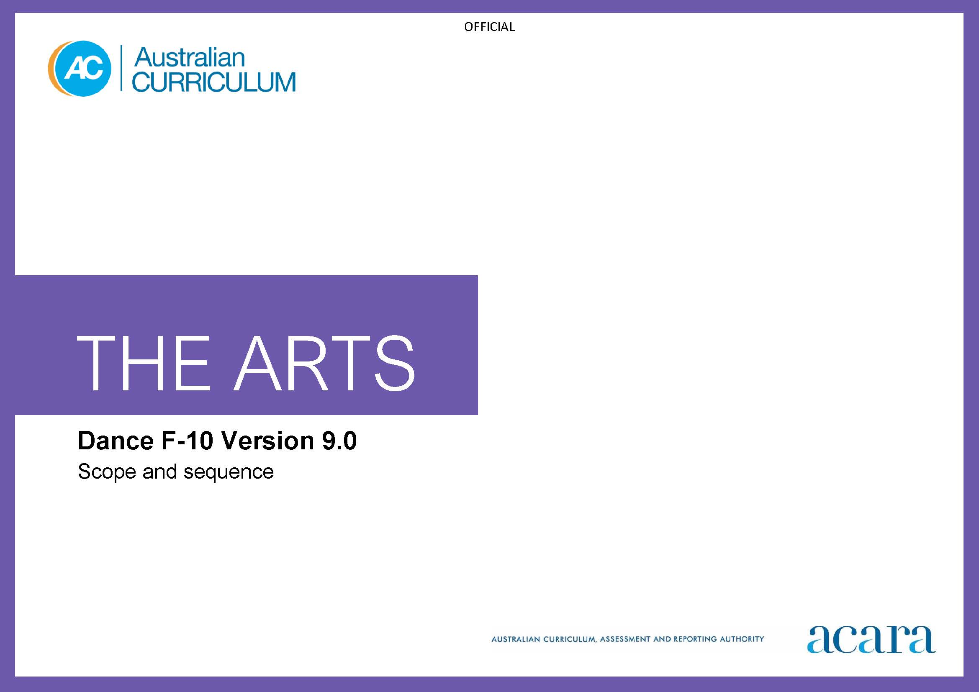

**Copyright and Terms of Use Statement**

**© Australian Curriculum, Assessment and Reporting Authority 2022**

The material published in this work is subject to copyright pursuant to the Copyright Act 1968 (Cth) and is owned by the Australian Curriculum, Assessment and Reporting Authority (ACARA) (except to the extent that copyright is held by another party, as indicated).

The viewing, downloading, displaying, printing, reproducing (such as by making photocopies) and distributing of these materials is permitted only to the extent permitted by, and is subject to the conditions imposed by, the terms and conditions of using the ACARA website (see, especially, clauses 2, 3 and 4 of those terms and conditions). The terms and conditions can be viewed at [https://www.acara.edu.au/contact-us/copyright](https://aus01.safelinks.protection.outlook.com/?url=https%3A%2F%2Fwww.acara.edu.au%2Fcontact-us%2Fcopyright&data=04%7C01%7CSharon.Foster%40acara.edu.au%7C9931e11fa7684c603e6308d98331bbfb%7C6cf76a3aa824427092003d71673ec678%7C0%7C0%7C637685071906340874%7CUnknown%7CTWFpbGZsb3d8eyJWIjoiMC4wLjAwMDAiLCJQIjoiV2luMzIiLCJBTiI6Ik1haWwiLCJXVCI6Mn0%3D%7C1000&sdata=U5O4Vlbpf271IGmGiMh7fDwU4pLzzAiHpCQFylkp6s4%3D&reserved=0)

|  |  |
| --- | --- |
| **Foundation** | **Years 1–2** |
| **Achievement standard** | **Dance Achievement standard** |
| There is no subject specific achievement standard in Foundation | By the end of Year 2, students identify where they experience dance. They describe where, why and/or how people across cultures, communities and/or other contexts experience dance.  Students use the elements of dance to structure dance sequences. They demonstrate fundamental movement skills and safe dance practice. They perform their dance in informal settings. |
| **Learning area Achievement standard** | **Learning area Achievement standard** |
| By the end of the Foundation year, students describe experiences, observations, ideas and/or feelings about arts works they encounter at school, home and/or in the community.  Students use play, imagination, arts knowledge, processes and/or skills to create and share arts works in different forms. | By the end of Year 2, students identify where they experience the arts. They describe where, why and/or how people across cultures, communities and/or other contexts experience the arts.  Students demonstrate arts practices and skills across arts subjects. They create arts works in a range of forms. They share their work in informal settings. |

|  |  |
| --- | --- |
| **Content descriptions** | |
| **Strand: Exploring and responding** | |
| explore how and why the arts are important for people and communities  AC9ADAFE01 | explore where, why and how people across cultures, communities and/or other contexts experience dance  AC9ADA2E01 |
|  | explore examples of dance choreographed and/or performed by First Nations Australians  AC9ADA2E02 |

|  |  |
| --- | --- |
| **Strand: Developing practices and skills** | |
| use play, imagination, arts knowledge, processes and/or skills to discover possibilities and develop ideas  AC9ADAFD01 | experiment with ways to move safely and expressively using fundamental movement skills and the elements of dance  AC9ADA2D01 |

|  |  |
| --- | --- |
| **Strand: Creating and making** | |
| create arts works that communicate ideas  AC9ADAFC01 | use the elements of dance to choreograph dance sequences  AC9ADA2C01 |

|  |  |
| --- | --- |
| **Strand: Presenting and performing** | |
| share their arts works with audiences  AC9ADAFP01 | share dance sequences in informal settings  AC9ADA2P01 |

|  |  |
| --- | --- |
| **Years 3-4** | **Years 5-6** |
| **Dance Achievement standard** | **Dance Achievement standard** |
| By the end of Year 4, students describe use of the elements of dance in dance they experience, create and/or perform. They describe where, why and/or how dance is choreographed and/or performed across cultures, times, places and/or other contexts.  Students use the elements of dance to structure dance sequences that communicate ideas, perspectives and/or meaning. They demonstrate fundamental movement skills and safe dance practice. They perform their dance in informal settings. | By the end of Year 6, students explain how the elements of dance are used in dance that they choreograph, perform and/or experience. They describe how dance from across cultures, times, places and/or other contexts communicates ideas, perspectives and/or meaning. They describe how dance is used to continue and revitalise cultures.  Students use the elements of dance and/or choreographic devices to choreograph dances that communicate ideas, perspectives and/or meaning. They demonstrate safe dance practice and use of technical, and expressive skills. They perform dances in informal and/or formal settings. |
| **Learning area Achievement standard** | **Learning area Achievement standard** |
| By the end of Year 4, students describe use of elements, concepts and/or conventions in arts works they create and/or experience. They describe where, why and/or how arts works are created and presented across cultures, times and/or places and/or other contexts.  Students use arts knowledge and skills to create arts works in a range of forms that communicate ideas, perspectives and/or meaning. They present and/or perform their work in informal settings. | By the end of Year 6, students explain the use of elements, concepts and/or conventions in arts works they create and/or experience. They describe how the arts communicate ideas, perspectives and/or meaning across cultures, times, places and/or other contexts. They describe how the arts are used to continue and revitalise cultures.  Students use subject-specific knowledge, elements, concepts, conventions, materials, skills and/or processes to create arts works that communicate ideas, perspectives and/or meaning. They demonstrate safe practices. They present and perform their arts works in formal and/or informal settings. |

|  |  |
| --- | --- |
| **Content descriptions** | |
| **Strand: Exploring and responding** | |
| explore where, why and how dance is choreographed and/or performed across cultures, times, places and/or other contexts  AC9ADA4E01 | explore ways that the elements of dance are combined to communicate ideas, perspectives and/or meaning in dance across cultures, times, places and/or other contexts  AC9ADA6E01 |
| explore how First Nations Australians use dance to communicate their connection to and responsibility for Country/Place  AC9ADA4E02 | explore the ways that First Nations Australians use dance to continue and revitalise cultures  AC9ADA6E02 |

|  |  |
| --- | --- |
| **Strand: Developing practices and skills** | |
| experiment with and practise skills for moving safely and expressively using fundamental movement skills and the elements of dance  AC9ADA4D01 | develop and practise technical and expressive skills using safe dance practice and the elements of dance  AC9ADA6D01 |

|  |  |
| --- | --- |
| **Strand: Creating and making** | |
| use the elements of dance to choreograph dance that communicates ideas, perspectives and/or meaning  AC9ADA4C01 | manipulate the elements of dance and/or choreographic devices to choreograph dances that communicate ideas, perspectives and/or meaning  AC9ADA6C01 |

|  |  |
| --- | --- |
| **Strand: Presenting and performing** | |
| practise and perform dances in informal settings  AC9ADA4P01 | practise and perform dances using technical and expressive skills in informal and/or formal settings  AC9ADA6P01 |

|  |  |
| --- | --- |
| **Years 7-8** | **Years 9-10** |
| **Achievement standard** | **Achievement standard** |
| By the end of Year 8, students analyse how the elements of dance, choreographic devices and/or production elements are manipulated in dance they create and/or experience. They evaluate the ways that dance works and/or performances in a range of styles and/or from across cultures, times, places and/or other contexts communicate ideas, perspectives and/or meaning. They describe respectful approaches to creating, performing and/or responding to dance.  Students manipulate the elements of dance and choreographic devices to choreograph dance that communicate ideas, perspectives and/or meaning. They demonstrate safe dance practice when choreographing and performing dance. They employ technical and expressive skills and, as appropriate, genre- or style-specific techniques when performing dances for audiences. | By the end of Year 10, students analyse how and/or why the elements of dance, choreographic devices, genre- or style-specific techniques, production elements, and/or technical and expressive skills are manipulated in dance they create and/or experience. They evaluate how dance works and/or performances in a range of styles and/or from across cultures, times, places and/or other contexts communicate ideas, perspectives and/or meaning. They evaluate how dance is used to celebrate and challenge perspectives of Australian identity.  Students select and manipulate the elements of dance, choreographic devices and/or structure to choreograph dances. They demonstrate safe dance practice when choreographing and performing dance. They employ technical and expressive skills and genre- or style-specific techniques to enhance communication of ideas, perspectives and/or meaning when performing dance for audiences. |

|  |  |
| --- | --- |
| **Content descriptions** | |
| **Strand: Exploring and responding** | |
| investigate ways that dance works, performers and/or choreographers across cultures, times, places and/or other contexts use the elements of dance, choreographic devices and/or production elements to communicate ideas, perspectives and/or meaning  AC9ADA8E01 | investigate performers’ and/or choreographers’ use of elements of dance, choreographic devices, genre- or style-specific techniques, conventions and/or production elements to communicate and/or challenge ideas, perspectives and/or meaning in dance across cultures, times, places and/or other contexts  AC9ADA10E01 |
| investigate the diversity of dance choreographed and/or performed by First Nations Australians considering culturally responsive approaches to Indigenous Cultural and Intellectual Property rights  AC9ADA8E02 | investigate the ways First Nations Australian choreographers and/or performers celebrate and challenge multiple perspectives of Australian identity through dance  AC9ADA10E02 |

|  |  |
| --- | --- |
| **Strand: Developing practices and skills** | |
| develop safe dance practice and use of expressive and technical skills and, as appropriate, genre- or style-specific techniques  AC9ADA8D01 | develop and refine safe dance practice, expressive and technical skills and genre- or style-specific techniques  AC9ADA10D01 |
| reflect on own and others’ dance works and/or practices to inform choreographic choices and use of technical and expressive skills  AC9ADA8D02 | reflect on own and others’ use of the elements of dance, choreographic devices, structure, genre- or style-specific techniques and/or technical and expressive skills to inform their choreographic or performance choices  AC9ADA10D02 |

|  |  |
| --- | --- |
| **Strand: Creating and making** | |
| choreograph dance by selecting and manipulating elements of dance and choreographic devices to communicate ideas, perspectives and/or meaning  AC9ADA8C01 | choreograph dance that communicates ideas, perspectives and/or meaning by selecting and manipulating elements of dance, choreographic devices and/or structure  AC9ADA10C01 |
| apply technical and expressive skills and/or genre- or style-specific techniques to communicate ideas, perspectives and/or meaning  AC9ADA8C02 | apply technical and expressive skills and genre- or style-specific techniques to enhance communication of ideas, perspectives and/or meaning  AC9ADA10C02 |

|  |  |
| --- | --- |
| **Strand: Presenting and performing** | |
| rehearse and perform dance for audiences, using technical and expressive skills and, as appropriate genre- or style-specific techniques  AC9ADA8P01 | rehearse and perform dance for audiences, using technical and expressive skills and genre- or style-specific techniques  AC9ADA10P01 |