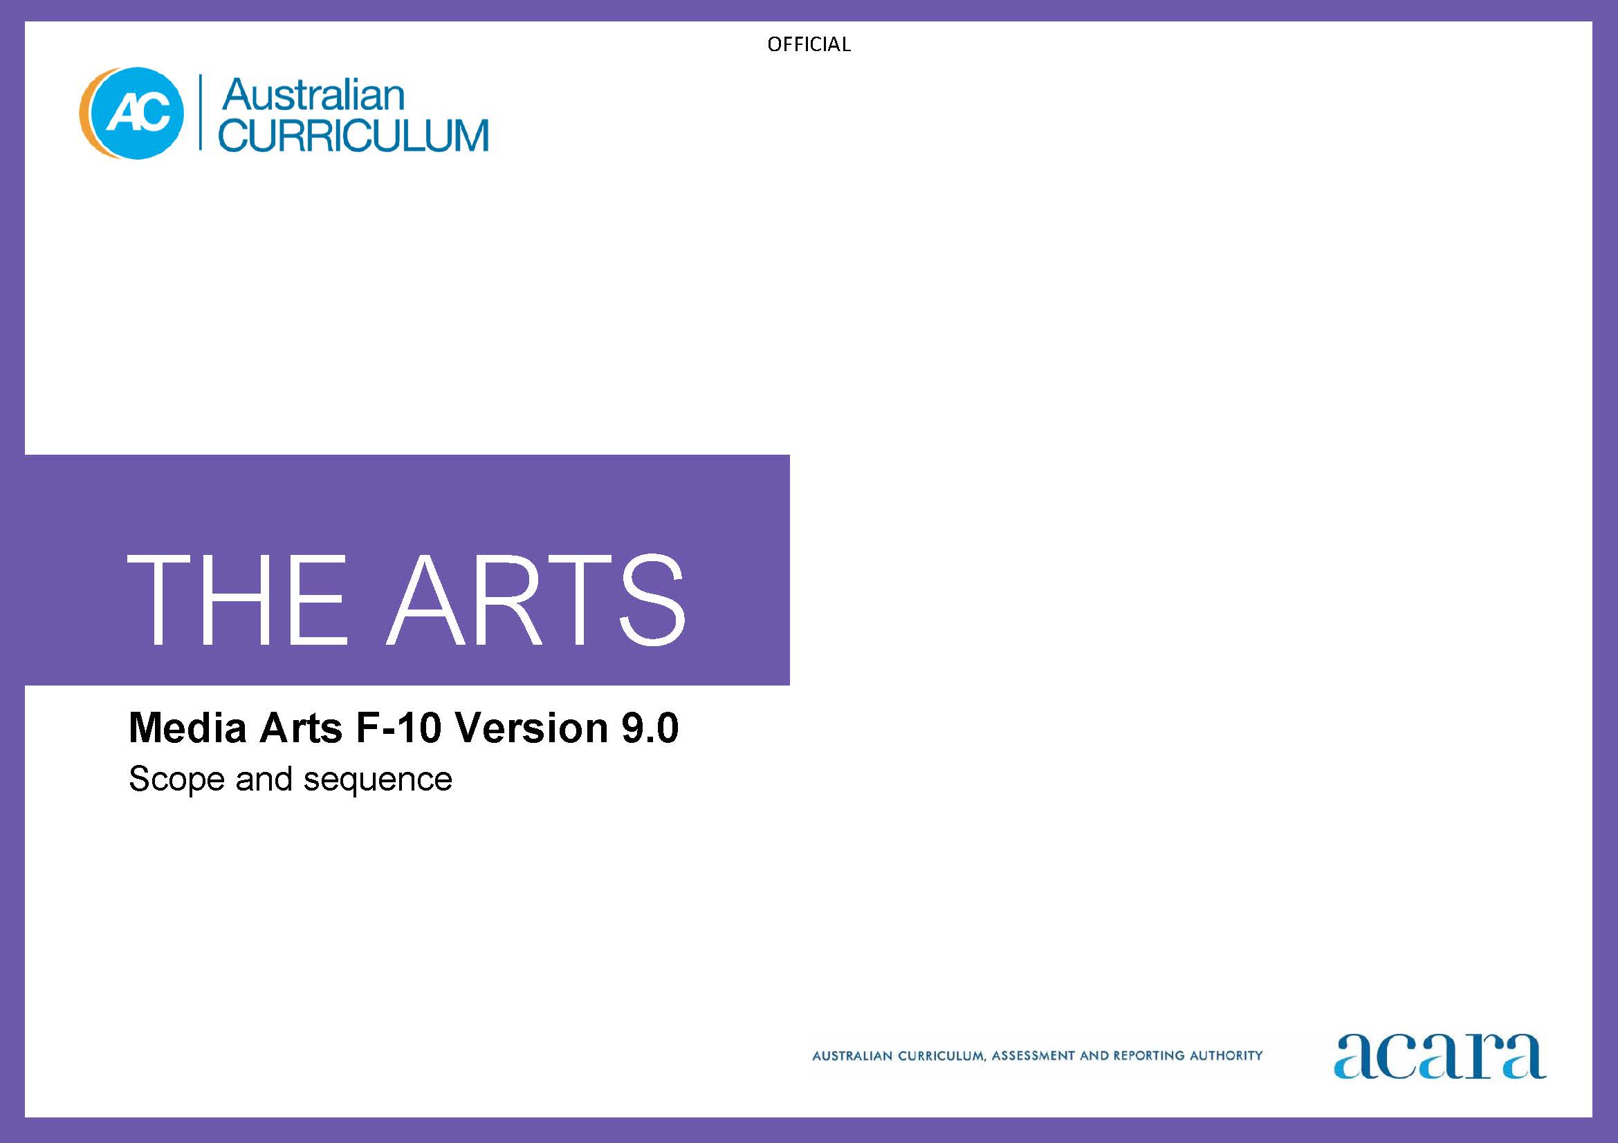

**Copyright and Terms of Use Statement**

**© Australian Curriculum, Assessment and Reporting Authority 2022**

The material published in this work is subject to copyright pursuant to the Copyright Act 1968 (Cth) and is owned by the Australian Curriculum, Assessment and Reporting Authority (ACARA) (except to the extent that copyright is held by another party, as indicated).

The viewing, downloading, displaying, printing, reproducing (such as by making photocopies) and distributing of these materials is permitted only to the extent permitted by, and is subject to the conditions imposed by, the terms and conditions of using the ACARA website (see, especially, clauses 2, 3 and 4 of those terms and conditions). The terms and conditions can be viewed at [https://www.acara.edu.au/contact-us/copyright](https://aus01.safelinks.protection.outlook.com/?url=https%3A%2F%2Fwww.acara.edu.au%2Fcontact-us%2Fcopyright&data=04%7C01%7CSharon.Foster%40acara.edu.au%7C9931e11fa7684c603e6308d98331bbfb%7C6cf76a3aa824427092003d71673ec678%7C0%7C0%7C637685071906340874%7CUnknown%7CTWFpbGZsb3d8eyJWIjoiMC4wLjAwMDAiLCJQIjoiV2luMzIiLCJBTiI6Ik1haWwiLCJXVCI6Mn0%3D%7C1000&sdata=U5O4Vlbpf271IGmGiMh7fDwU4pLzzAiHpCQFylkp6s4%3D&reserved=0)

|  |  |
| --- | --- |
| **Foundation** | **Years 1–2** |
| **Achievement standard** | **Media Arts Achievement standard** |
| There is no subject specific achievement standard in Foundation. | By the end of Year 2, students identify where they experience media arts. They describe where, why and/or how people across cultures, communities and/or other contexts experience media arts.  Students use media languages and media technologies to construct representations in media arts works. They share their work with audiences safely and in informal ways. |
| **Learning area Achievement standard** | **Learning area Achievement standard** |
| By the end of the Foundation year, students describe experiences, observations, ideas and/or feelings about arts works they encounter at school, home and/or in the community.  Students use play, imagination, arts knowledge, processes and/or skills to create and share arts works in different forms. | By the end of Year 2, students identify where they experience the arts. They describe where, why and/or how people across cultures, communities and/or other contexts experience the arts.  Students demonstrate arts practices and skills across arts subjects. They create arts works in a range of forms. They share their work in informal settings. |

|  |  |
| --- | --- |
| **Content descriptions** | |
| **Strand: Exploring and responding** | |
| explore how and why the arts are important for people and communities  AC9AMAFE01 | explore where, why and how people across cultures, communities and/or other contexts experience media arts  AC9AMA2E01 |
|  | explore examples of media arts produced and/or distributed by First Nations Australians  AC9AMA2E02 |

|  |  |
| --- | --- |
| **Strand: Developing practices and skills** | |
| use play, imagination, arts knowledge, processes and/or skills to discover possibilities and develop ideas  AC9AMAFD01 | explore ways of using media technologies responsibly to capture and organise images, sounds, text and/or interactive elements  AC9AMA2D01 |

|  |  |
| --- | --- |
| **Strand: Creating and making** | |
| create arts works that communicate ideas  AC9AMAFC01 | use media languages and media technologies to construct representations  AC9AMA2C01 |

|  |  |
| --- | --- |
| **Strand: Presenting and performing** | |
| share their arts works with audiences  AC9AMAFP01 | share media arts works with audiences in informal settings  AC9AMA2P01 |

|  |  |
| --- | --- |
| **Years 3–4** | **Years 5–6** |
| **Media Arts Achievement standard** | **Media Arts Achievement standard** |
| By the end of Year 4, students describe the use of media languages and media technologies to construct representations in media arts works they experience and/or produce. They describe where, why and/or how media arts works are created and/or distributed across cultures, times, places and/or other contexts.  Students use media languages, and media technologies and production processes to construct representations in media arts works. They share their work in informal settings using responsible media practice. | By the end of Year 6, students explain how media languages and media technologies are used in media arts works they construct and/or experience. They describe how media arts works created across cultures, times, places and/or other contexts communicate ideas, perspectives and/or meaning. They describe how media arts are used to continue and revitalise cultures.  Students use media languages, and media technologies and production processes to construct representations in media arts works for specific purposes and audiences. They present their work in informal and/or formal settings using responsible media practice. |
| **Learning area Achievement standard** | **Learning area Achievement standard** |
| By the end of Year 4, students describe use of elements, concepts and/or conventions in arts works they create and/or experience. They describe where, why and/or how arts works are created and presented across cultures, times, places and/or other contexts.  Students use arts knowledge and skills to create arts works in a range of forms that communicate ideas, perspectives and/or meaning. They present and/or perform their work in informal settings. | By the end of Year 6, students explain the use of elements, concepts and conventions in arts works they create and/or experience. They describe how the arts communicate ideas, perspectives and/or meaning across cultures, times, places and/or other contexts. They describe how the arts are used to continue and revitalise cultures.  Students use subject-specific knowledge, elements, concepts, conventions, materials, skills and/or processes to create arts works that communicate ideas, perspectives and/or meaning. They demonstrate safe practices. They present and perform their arts works in formal and/or informal settings. |

|  |  |
| --- | --- |
| **Content descriptions** | |
| **Strand: Exploring and responding** | |
| explore where, why and how media arts is created and/or distributed across cultures, times, places and/or other contexts  AC9AMA4E01 | explore ways that media languages and media technologies are used in media arts works and practices across cultures, times, places and/or other contexts  AC9AMA6E01 |
| explore how First Nations Australians use media arts to communicate their connection to and responsibility for Country/Place  AC9AMA4E02 | explore ways First Nations Australians use media arts to continue and revitalise cultures  AC9AMA6E02 |

|  |  |
| --- | --- |
| **Strand: Developing practices and skills** | |
| develop media production skills by exploring ways of shaping ideas using media technologies, images, sounds, text and/or interactive elements  AC9AMA4D01 | develop media production skills to communicate ideas, perspectives and/or meaning through manipulation of media languages, including images, sounds, texts and/or interactive elements, and media technologies  AC9AMA6D01 |

|  |  |
| --- | --- |
| **Strand: Creating and making** | |
| use media languages, media technologies and production processes to construct representations that communicate ideas, perspectives and/or meaning  AC9AMA4C01 | use media languages, media technologies and production processes to construct media arts works that communicate ideas, perspectives and/or meaning for specific audiences  AC9AMA6C01 |

|  |  |
| --- | --- |
| **Strand: Presenting and performing** | |
| share media arts works in informal settings considering responsible media practice  AC9AMA4P01 | present media arts works in informal and/or formal settings using responsible media practice  AC9AMA6P01 |

|  |  |
| --- | --- |
| **Years 7–8** | **Years 9–10** |
| **Achievement standard** | **Achievement standard** |
| By the end of Year 8, students analyse the use of media arts concepts to construct representations that communicate ideas, perspectives and/or meaning in media arts works they produce and/or experience. They evaluate use of media arts concepts in media arts works from across cultures, times, places and/or other contexts. They describe respectful approaches to creating and/or responding to media arts works.  Students select and manipulate media languages and media technologies, and use production processes to construct representations. They produce media arts works that communicate ideas, perspectives and/or meaning. They present their work to an audience. They plan where and how they could distribute their work using responsible media practice. | By the end of Year 10, students analyse how and why media arts concepts are manipulated to construct representations in media arts works they produce and/or experience. They evaluate how and why media artists across cultures, times, places and/or other contexts use media arts concepts to represent and/or challenge ideas, perspectives and/or meaning. They evaluate how media arts are used to celebrate and challenge perspectives of Australian identity.  Students use media arts concepts to construct representations and communicate ideas, perspectives and/or meaning. They use responsible media practice and production processes to create media arts works in a range of genres/styles and/or forms, for specific audiences. They present their work to an audience. They plan where and how they could distribute their work and the relationships they could develop with their audiences, using responsible media practice. |

|  |  |
| --- | --- |
| **Content descriptions** | |
| **Strand: Exploring and responding** | |
| investigate the ways that media arts concepts are used in media arts works and practices across cultures, times, places and/or other contexts  AC9AMA8E01 | investigate the ways that media artists use media arts concepts to construct representations in media arts works and practices from across cultures, times, places and/or other contexts  AC9AMA10E01 |
| investigate the diversity of First Nations Australians’ media arts works and practices, considering culturally responsive approaches to Indigenous Cultural and Intellectual Property rights  AC9AMA8E02 | investigate the ways First Nations Australian media artists celebrate and challenge multiple perspectives of Australian identity through media arts  AC9AMA10E02 |

|  |  |
| --- | --- |
| **Strand: Developing practices and skills** | |
| develop media production skills throughout the production process to construct representations using media languages and media technologies  AC9AMA8D01 | experiment with ways to construct representations that reflect ideas, perspectives and/or meaning, and/or use of media conventions, media languages and media technologies  AC9AMA10D01 |
| reflect on their own and others’ media arts works and practices to inform choices they make during the production process  AC9AMA8D02 | reflect on their own or others’ media arts works and/or practices to refine and inform choices they make during stages of the production process  AC9AMA10D02 |

|  |  |
| --- | --- |
| **Strand: Creating and making** | |
| design and structure media arts works to communicate ideas, perspectives and meaning for an intended audience  AC9AMA8C01 | design and structure media arts works that examine and communicate ideas, perspectives and/or meaning  AC9AMA10C01 |
| apply production processes and use media arts concepts to construct representations and produce media arts works that communicate ideas, perspectives and/or meaning for specific audiences using responsible media practice  AC9AMA8C02 | apply production processes and use media arts concepts to construct representations and produce media arts works that communicate ideas, perspectives and/or meaning, and confirm or challenge the expectations of specific audiences  AC9AMA10C02 |

|  |  |
| --- | --- |
| **Strand: Presenting and performing** | |
| present media arts works, using responsible media practices and considering potential relationships the work could create with audiences  AC9AMA8P01 | present media arts works to audiences and plan approaches for creating relationships with audiences if/when media arts works are distributed in selected personal, community and/or institutional contexts using responsible media practice  AC9AMA10P01 |