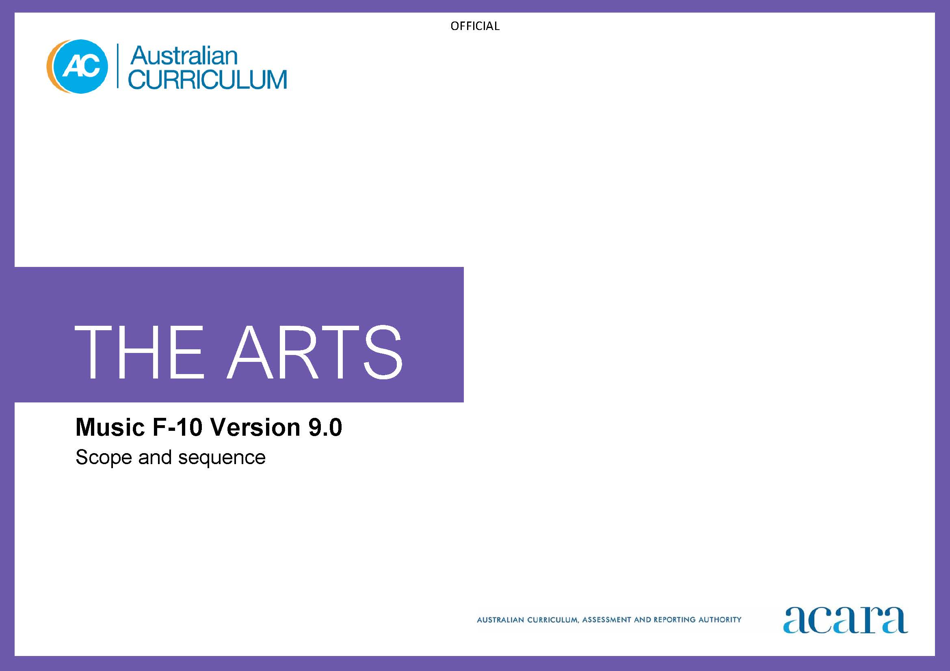

**Copyright and Terms of Use Statement**

**© Australian Curriculum, Assessment and Reporting Authority 2022**

The material published in this work is subject to copyright pursuant to the Copyright Act 1968 (Cth) and is owned by the Australian Curriculum, Assessment and Reporting Authority (ACARA) (except to the extent that copyright is held by another party, as indicated).

The viewing, downloading, displaying, printing, reproducing (such as by making photocopies) and distributing of these materials is permitted only to the extent permitted by, and is subject to the conditions imposed by, the terms and conditions of using the ACARA website (see, especially, clauses 2, 3 and 4 of those terms and conditions). The terms and conditions can be viewed at [https://www.acara.edu.au/contact-us/copyright](https://aus01.safelinks.protection.outlook.com/?url=https%3A%2F%2Fwww.acara.edu.au%2Fcontact-us%2Fcopyright&data=04%7C01%7CSharon.Foster%40acara.edu.au%7C9931e11fa7684c603e6308d98331bbfb%7C6cf76a3aa824427092003d71673ec678%7C0%7C0%7C637685071906340874%7CUnknown%7CTWFpbGZsb3d8eyJWIjoiMC4wLjAwMDAiLCJQIjoiV2luMzIiLCJBTiI6Ik1haWwiLCJXVCI6Mn0%3D%7C1000&sdata=U5O4Vlbpf271IGmGiMh7fDwU4pLzzAiHpCQFylkp6s4%3D&reserved=0)

|  |  |
| --- | --- |
| **Foundation** | **Years 1–2** |
| **Achievement standard** | **Music Achievement standard** |
| There is no subject specific achievement standard in Foundation. | By the end of Year 2, students identify where they experience music. They describe where, why and/or how people across cultures, communities and/or other contexts experience music.  Students demonstrate listening skills. They use the elements of music to improvise and/or compose music. They sing and play music in informal settings. |
| **Learning area Achievement standard** | **Learning area Achievement standard** |
| By the end of the Foundation year, students describe experiences, observations, ideas and/or feelings about arts works they encounter at school, home and/or in the community.  Students use play, imagination, arts knowledge, processes and/or skills to create and share arts works in different forms | By the end of Year 2, students identify where they experience the arts. They describe where, why and/or how people across cultures, communities and/or other contexts experience the arts.  Students demonstrate arts practices and skills across arts subjects. They create arts works in a range of forms. They share their work in informal settings. |

|  |  |
| --- | --- |
| **Content descriptions** | |
| **Strand: Exploring and responding** | |
| explore how and why the arts are important for people and communities  AC9AMUFE01 | explore where, why and how people across cultures, communities and/or othercontexts experience music  AC9AMU2E01 |
|  | explore examples of music composed and/or performed by First Nations Australians  AC9AMU2E02 |

|  |  |
| --- | --- |
| **Strand: Developing practices and skills** | |
| use play, imagination, arts knowledge, processes and/or skills to discover possibilities and develop ideas  AC9AMUFD01 | develop listening skills and skills for singing and playing instruments  AC9AMU2D01 |

|  |  |
| --- | --- |
| **Strand: Creating and making** | |
| create arts works that communicate ideas  AC9AMUFC01 | select and combine elements of music when composing and practising music for performance  AC9AMU2C01 |

|  |  |
| --- | --- |
| **Strand: Presenting and performing** | |
| share their arts works with audiences  AC9AMUFP01 | sing and play music in informal settings  AC9AMU2P01 |

|  |  |
| --- | --- |
| **Years 3–4** | **Years 5–6** |
| **Music Achievement standard** | **Music Achievement standard** |
| By the end of Year 4, students describe the use of elements of music in music they compose, perform and/or experience. They describe where, why and/or how music is composed and/or performed across cultures, times, places and/or other contexts.  Students demonstrate listening skills when performing and composing. They combine the elements of music to compose music that communicates ideas. They sing and play music they have learnt and/or composed in informal settings. | By the end of Year 6, students explain how elements of music are manipulated in music they compose, perform and/or experience. They describe how music composed and/or performed across contexts, cultures, times and/or places communicates ideas, perspectives and/or meaning. They describe how music is used to continue and revitalise cultures.  Students demonstrate listening and aural skills when composing and performing. They use elements of music and compositional devices to compose music that communicates ideas, and when practising music for performance. They notate, document and/or record the music they compose. They perform music in formal and/or informal settings. |
| **Learning area Achievement standard** | **Learning area Achievement standard** |
| By the end of Year 4, students describe use of elements, concepts and/or conventions in arts works they create and/or experience. They describe where, why and/or how arts works are created and presented across cultures, times and/or places, and/or other contexts.  Students use arts knowledge and skills to create arts works in a range of forms that communicate ideas, perspectives and/or meaning. They present and/or perform their work in informal settings. | By the end of Year 6, students explain the use of elements, concepts and/or conventions in arts works they create and/or experience. They describe how the arts communicate ideas, perspectives and/or meaning across cultures, times, places and/or other contexts. They describe how the arts are used to continue and revitalise cultures.  Students use subject-specific knowledge, elements, concepts, conventions, materials, skills and/or processes to create arts works that communicate ideas, perspectives and/or meaning. They demonstrate safe practices. They present and perform their arts works in formal and/or informal settings. |

|  |  |
| --- | --- |
| **Content descriptions** | |
| **Strand: Exploring and responding** | |
| explore where, why and how music is composed and/or performed across cultures, times, places and/or other contexts  AC9AMU4E01 | explore ways that the elements of music are combined in music across cultures, times, places and/or other contexts  AC9AMU6E01 |
| explore how First Nations Australians use music to communicate their connection to and responsibility for Country/Place  AC9AMU4E02 | explore ways First Nations Australians use music to continue and revitalise culture  AC9AMU6E02 |

|  |  |
| --- | --- |
| **Strand: Developing practices and skills** | |
| develop listening skills and skills for manipulating elements of music when singing and playing instruments  AC9AMU4D01 | develop listening/aural skills and skills for manipulating elements of music to achieve expressive effects when composing, singing and playing instruments  AC9AMU6D01 |

|  |  |
| --- | --- |
| **Strand: Creating and making** | |
| manipulate elements of music to communicate ideas, perspectives and/or meaning when composing and practising for performance  AC9AMU4C01 | manipulate elements of music and use compositional devices to communicate ideas, perspectives and/or meaning when composing and practising music for performance, and notate, document and/or record the music they compose  AC9AMU6C01 |

|  |  |
| --- | --- |
| **Strand: Presenting and performing** | |
| sing and play music they have learnt and/or composed in informal settings  AC9AMU4P01 | perform music in a range of forms they have learnt and/or composed in informal and/or formal settings  AC9AMU6P01 |

|  |  |
| --- | --- |
| **Years 7-8** | **Years 9-10** |
| **Achievement standard** | **Achievement standard** |
| By the end of Year 8, students analyse how the elements of music and/or compositional devices are manipulated in music they compose, perform and/or experience. They evaluate the ways music from across cultures, times, places and/or other contexts communicates ideas, perspectives and/or meaning. They describe respectful approaches to composing, performing and/or responding to music.  Students demonstrate listening and aural skills when composing and performing. They manipulate elements of music and compositional devices to compose music that communicates ideas, perspectives and/or meaning. They notate, document and/or record the music they compose. They manipulate elements of music when performing their own and/or others’ music. They demonstrate performance skills when performing music for audiences. | By the end of Year 10, students analyse ways composers and/or performers use the elements of music and compositional devices to engage audiences. They evaluate how music and/or performances in a range of styles and/or from across cultures, times, places and/or other contexts communicate ideas, perspectives and/or meaning. They evaluate how music is used to celebrate and challenge perspectives of Australian identity.  Students demonstrate listening and aural skills relevant to the styles and/or contexts in which they are working. Students manipulate elements of music and use compositional devices to communicate ideas, perspectives and/or meaning in compositions in selected style/s, form/s and/or using selected instrumentation. They notate, document and/or record their music. They apply knowledge of styles and/or forms when performing their own and/or others’ music. They demonstrate appropriate vocal and/or instrumental techniques and performance skills when performing music for audiences. |

|  |  |
| --- | --- |
| **Content descriptions** | |
| **Strand: Exploring and responding** | |
| investigate the ways that composers and/or performers use the elements of music and/or compositional devices in music composed across cultures, times, places and/or other contexts  AC9AMU8E01 | investigate composers’ and/or performers’ use of elements of music, compositional devices and/or vocal/instrumental techniques in music from a range of cultures, times, places and/or other contexts  AC9AMU10E01 |
| investigate the diversity of music composed and/or performed by First Nations Australians, considering culturally responsive approaches to Indigenous Cultural and Intellectual Property rights  AC9AMU8E02 | investigate the ways that First Nations Australian performers and/or composers celebrate and challenge multiple perspectives of Australian identity through music  AC9AMU10E02 |

|  |  |
| --- | --- |
| **Strand: Developing practices and skills** | |
| develop and practise listening/aural skills and vocal and/or instrumental skills/techniques for manipulating elements of music to achieve expressive effects  AC9AMU8D01 | develop, practise and refine the use of listening/aural skills and style-specific vocal instrumental skills/techniques to interpret music and communicate expressive effects  AC9AMU10D01 |
| reflect on their own and others’ music to inform choices they make as composers and performers about how they will manipulate elements of music and/or compositional devices  AC9AMU8D02 | reflect on their own and others’ music to inform choices they make as composers and performers about how they will interpret and/or manipulate elements of music and/or compositional devices  AC9AMU10D02 |

|  |  |
| --- | --- |
| **Strand: Creating and making** | |
| interpret music in a variety of forms and/or styles, manipulating elements of music and employing relevant vocal/instrumental techniques  AC9AMU8C01 | interpret music in a variety of forms and styles, manipulating the elements of music and/or compositional devices, and using style-specific vocal/instrumental techniques to communicate ideas, perspectives and/or meaning  AC9AMU10C01 |
| compose using the elements of music and compositional devices to communicate ideas, perspectives and/or meaning, and notate, document and/or record the music  AC9AMU8C02 | compose music, manipulating and combining elements of music and compositional devices relevant to chosen styles and/or forms to communicate ideas, perspectives and/or meaning and notate, document and/or record the music  AC9AMU10C02 |

|  |  |
| --- | --- |
| **Strand: Presenting and performing** | |
| perform music using relevant vocal and/or instrumental techniques and performance skills  AC9AMU8P01 | rehearse and present planned performances of music they have learnt and/or composed, using relevant vocal/instrumental techniques and performance skills  AC9AMU10P01 |