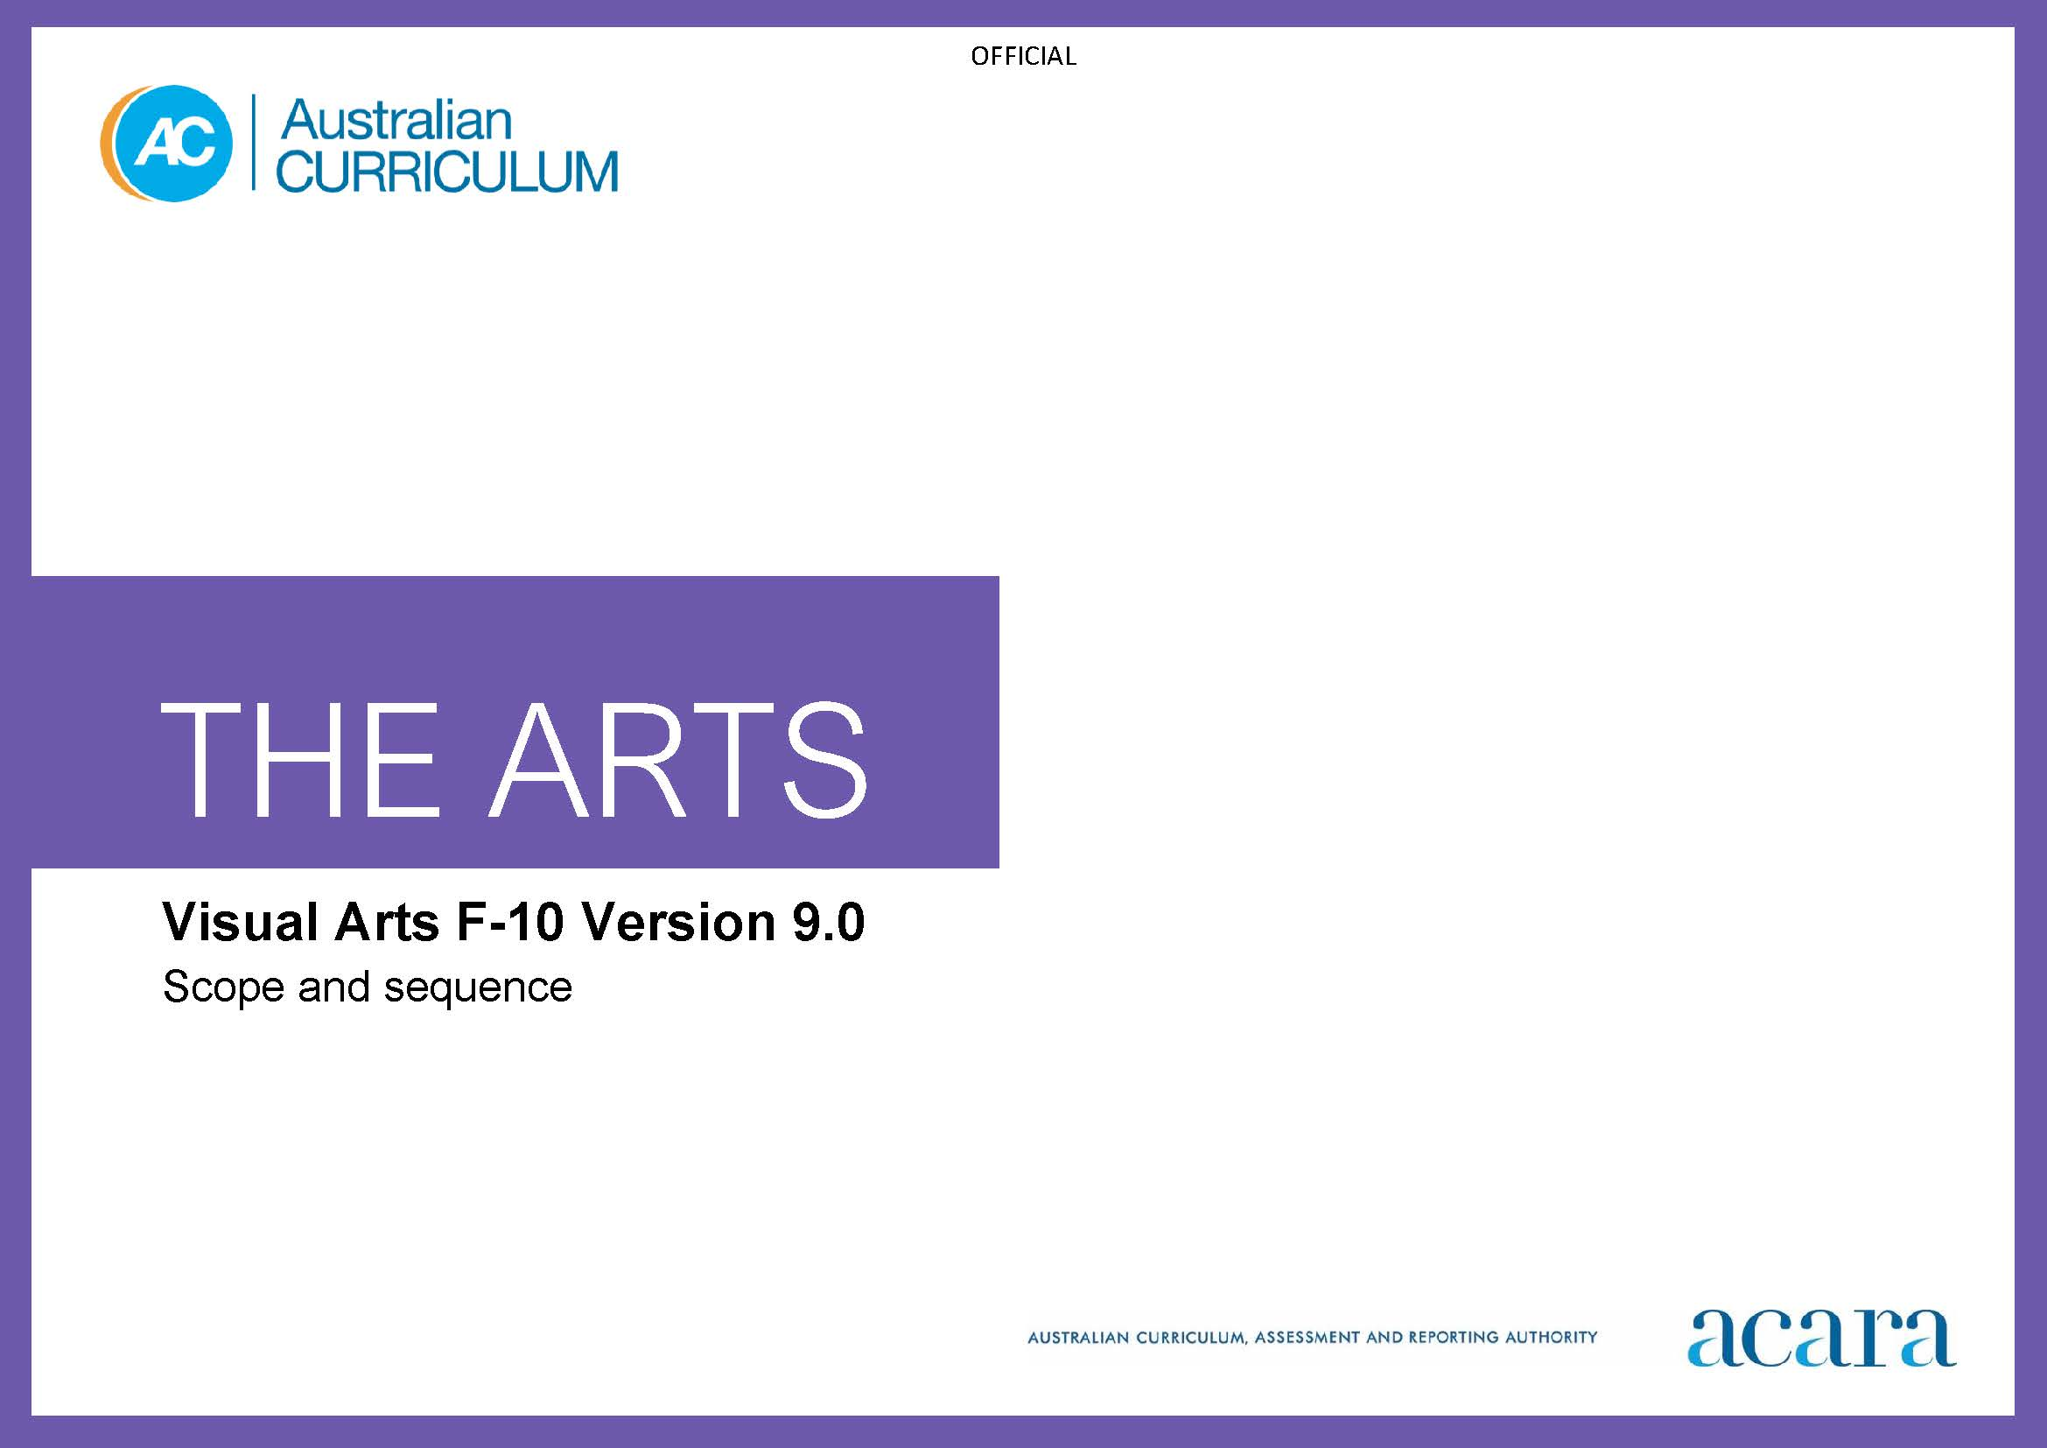

**Copyright and Terms of Use Statement**

**© Australian Curriculum, Assessment and Reporting Authority 2022**

The material published in this work is subject to copyright pursuant to the Copyright Act 1968 (Cth) and is owned by the Australian Curriculum, Assessment and Reporting Authority (ACARA) (except to the extent that copyright is held by another party, as indicated).

The viewing, downloading, displaying, printing, reproducing (such as by making photocopies) and distributing of these materials is permitted only to the extent permitted by, and is subject to the conditions imposed by, the terms and conditions of using the ACARA website (see, especially, clauses 2, 3 and 4 of those terms and conditions). The terms and conditions can be viewed at [https://www.acara.edu.au/contact-us/copyright](https://aus01.safelinks.protection.outlook.com/?url=https%3A%2F%2Fwww.acara.edu.au%2Fcontact-us%2Fcopyright&data=04%7C01%7CSharon.Foster%40acara.edu.au%7C9931e11fa7684c603e6308d98331bbfb%7C6cf76a3aa824427092003d71673ec678%7C0%7C0%7C637685071906340874%7CUnknown%7CTWFpbGZsb3d8eyJWIjoiMC4wLjAwMDAiLCJQIjoiV2luMzIiLCJBTiI6Ik1haWwiLCJXVCI6Mn0%3D%7C1000&sdata=U5O4Vlbpf271IGmGiMh7fDwU4pLzzAiHpCQFylkp6s4%3D&reserved=0)

|  |  |
| --- | --- |
| **Foundation** | **Years 1–2** |
| **Achievement standard** | **Visual Arts Achievement standard** |
| There is no subject specific achievement standard in Foundation. | By the end of Year 2, students identify where they experience visual arts. They describe where, why and/or how people across cultures, communities and/or other contexts experience visual arts.  Students experiment with visual conventions, visual arts processes and materials. They make and share artworks in informal settings. |
| **Learning area Achievement standard** | **Learning area Achievement standard** |
| By the end of the Foundation year, students describe experiences, observations, ideas and/or feelings about arts works they encounter at school, home and/or in the community.  Students use play, imagination, arts knowledge, processes and/or skills to create and share arts works in different forms. | By the end of Year 2, students identify where they experience the arts. They describe where, why and/or how people across cultures, communities and/or other contexts experience the arts.  Students demonstrate arts practices and skills across arts subjects. They create arts works in a range of forms. They share their work in informal settings. |

|  |  |
| --- | --- |
| **Content descriptions** | |
| **Strand: Exploring and responding** | |
| explore how and why the arts are important for people and communities  AC9AVAFE01 | explore where, why and how people across cultures, communities and/or other contexts experience visual arts  AC9AVA2E01 |
|  | explore examples of visual arts created by First Nations Australians  AC9AVA2E02 |

|  |  |
| --- | --- |
| **Strand: Developing practices and skills** | |
| use play, imagination, arts knowledge, processes and/or skills to discover possibilities and develop ideas  AC9AVAFD01 | experiment and play with visual conventions, visual arts processes and materials  AC9AVA2D01 |

|  |  |
| --- | --- |
| **Strand: Creating and making** | |
| create arts works that communicate ideas  AC9AVAFC01 | use visual conventions, visual arts processes and materials to create artworks  AC9AVA2C01 |

|  |  |
| --- | --- |
| **Strand: Presenting and performing** | |
| share their arts works with audiences  AC9AVAFP01 | share artworks and/or visual arts practice in informal settings  AC9AVA2P01 |

|  |  |
| --- | --- |
| **Years 3–4** | **Years 5–6** |
| **Visual Arts Achievement standard** | **Visual Arts Achievement standard** |
| By the end of Year 4, students describe the use of visual conventions, visual arts processes and materials in artworks they create and/or experience. They describe where, why and/or how visual artists create and/or display artworks across cultures, times, places and/or other contexts.  Students use visual conventions, visual arts processes and materials to create artworks that communicate ideas, perspectives and/or meaning. They share or display their artworks and/or visual arts practice in informal settings. | By the end of Year 6, students explain the ways that visual conventions, visual arts processes, and materials are used in artworks they create and/or experience. They describe how artworks created across cultures, times, places and/or other contexts communicate ideas, perspectives and/or meaning. They describe how visual arts are used to continue and revitalise cultures.  Students develop and document ideas for their own artworks. They select and use visual conventions, visual arts processes, and materials to create artworks that communicate ideas, perspectives and/or meaning. They present documentation and artworks that communicate ideas, perspectives or meaning in informal and/or formal settings. |
| **Learning area Achievement standard** | **Learning area Achievement standard** |
| By the end of Year 4, students describe use of elements, concepts and/or conventions in arts works they create and/or experience. They describe where, why and/or how arts works are created and presented across cultures, times and/or places and/or other contexts.  Students use arts knowledge and skills to create arts works in a range of forms that communicate ideas, perspectives and/or meaning. They present and/or perform their work in informal settings. | By the end of Year 6, students explain the use of elements, concepts and/or conventions in arts works they create and/or experience. They describe how the arts communicate ideas, perspectives and/or meaning across cultures, times, places and/or other contexts. They describe how the arts are used to continue and revitalise cultures.  Students use subject-specific knowledge, elements, concepts, conventions, materials, skills and/or processes to create arts works that communicate ideas, perspectives and/or meaning. They demonstrate safe practices. They present and perform their arts works in formal and/or informal settings. |

|  |  |
| --- | --- |
| **Content descriptions** | |
| **Strand: Exploring and responding** | |
| explore where, why and how visual arts are created and/or presented across cultures, times, places and/or othercontexts  AC9AVA4E01 | explore ways that visual conventions, visual arts processes and materials are combined to communicate ideas, perspectives and/or meaning in visual arts across cultures, times, places and/or other contexts  AC9AVA6E01 |
| explore how First Nations Australians use visual arts to communicate their connection to and responsibility for Country/Place  AC9AVA4E02 | explore ways that First Nations Australians use visual arts to continue and revitalise cultures  AC9AVA6E02 |

|  |  |
| --- | --- |
| **Strand: Developing practices and skills** | |
| experiment with a range of ways to use visual conventions, visual arts processes and materials  AC9AVA4D01 | experiment with, document and reflect on ways to use a range of visual conventions, visual arts processes and materials  AC9AVA6D01 |

|  |  |
| --- | --- |
| **Strand: Creating and making** | |
| use visual conventions, visual arts processes and materials to create artworks that communicate ideas, perspectives and/or meaning  AC9AVA4C01 | use visual conventions, visual arts processes and materials to plan and create artworks that communicate ideas, perspectives and/or meaning  AC9AVA6C01 |

|  |  |
| --- | --- |
| **Strand: Presenting and performing** | |
| share and/or display artworks and/or visual arts practice in informal settings  AC9AVA4P01 | select and present documentation of visual arts practice and display artworks in informal and/or formal settings  AC9AVA6P01 |

|  |  |
| --- | --- |
| **Years 7–8** | **Years 9–10** |
| **Achievement standard** | **Achievement standard** |
| By the end of Year 8, students analyse how visual conventions, visual arts processes and materials are manipulated in artworks they create and/or experience. They evaluate the ways that visual artists across cultures, times, places and/or other contexts communicate ideas, perspectives and/or meaning through their visual arts practice. They describe respectful approaches to creating and/or responding to artworks.  Students generate, document and develop ideas for artworks. They reflect on their visual arts practice. They select and manipulate visual conventions, visual arts processes and/or materials to create artworks that represent ideas, perspectives and/or meaning. They curate and present exhibits and/or displays of their own and/or others’ artworks and/or visual arts practice for audiences. | By the end of Year 10, students analyse how and why visual conventions, visual arts processes and materials are manipulated in artworks they create and/or experience. They evaluate how and why artists from across cultures, times, places and/or other contexts use visual conventions, visual arts processes and materials in their visual arts practice and/or artworks to represent and/or challenge ideas, perspectives and/or meaning. They evaluate how visual arts are used to celebrate and challenge perspectives of Australian identity.  Students draw on inspiration from multiple sources to generate and develop ideas for artworks. They document and reflect on their own visual arts practice. They use knowledge of visual conventions, visual arts processes and materials to create artworks that represent and/or communicate ideas, perspectives and/or meaning. They curate and present exhibitions of their own and or/others’ artworks and visual arts practice to engage audiences. |

|  |  |
| --- | --- |
| **Content descriptions** | |
| **Strand: Exploring and responding** | |
| investigate ways that visual conventions, visual arts processes and materials are manipulated to represent ideas, perspectives and/or meaning in artworks created across cultures, times, places and/or other contexts  AC9AVA8E01 | investigate the ways that artists across cultures, times, places and/or other contexts, develop personal expression in their visual arts practice to represent, communicate and/or challenge ideas, perspectives and/or meaning  AC9AVA10E01 |
| investigate the diversity of First Nations Australians’ artworks and arts practices, considering culturally responsive approaches to Indigenous Cultural and Intellectual Property rights  AC9AVA8E02 | investigate the ways that First Nations Australian artists celebrate and challenge multiple perspectives of Australian identity through their artworks and visual arts practice  AC9AVA10E02 |

|  |  |
| --- | --- |
| **Strand: Developing practices and skills** | |
| experiment with visual conventions, visual arts processes and materials to develop skills  AC9AVA8D01 | experiment with visual conventions, visual arts processes and materials to refine skills and develop personal expression  AC9AVA10D01 |
| reflect on the ways that they and other artists respond to influences to inform choices they make in their own visual arts practice  AC9AVA8D02 | reflect on the way they and other visual artists respond to influences to inspire, develop and resolve choices they make in their own visual arts practice  AC9AVA10D02 |

|  |  |
| --- | --- |
| **Strand: Creating and making** | |
| generate, document and develop ideas for artworks  AC9AVA8C01 | evaluate critical feedback when planning, developing and refining their visual arts practice  AC9AVA10C01 |
| select and manipulate visual conventions, visual arts processes and/or materials to create artworks that represent ideas, perspectives and/or meaning  AC9AVA8C02 | select and manipulate visual conventions, visual arts processes and/or materials to create artworks that reflect personal expression, and represent and/or challenge, ideas, perspectives and/or meaning  AC9AVA10C02 |

|  |  |
| --- | --- |
| **Strand: Presenting and performing** | |
| curate and present examples of their visual arts practice to accompany exhibits of their artworks to communicate ideas, perspectives and/or meaning to audiences  AC9AVA8P01 | evaluate art exhibits to inform the curation and exhibition of their own and/or others’ artworks and/or visual arts practice  AC9AVA10P01 |