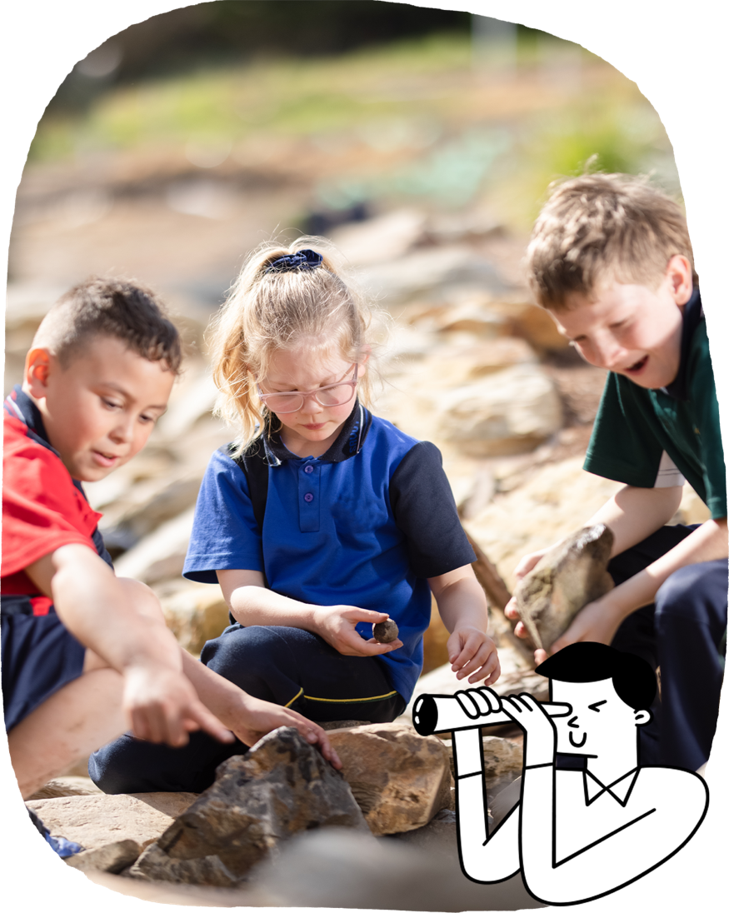

In their first year of school, students learn from their teachers and through their interactions with others. They experiment, practise and play in the classroom and school community. Priority is given to literacy and numeracy development as these are the foundations upon which further learning is built. There are opportunities to develop literacy and numeracy in all subjects and particularly in English and Mathematics. Learning in a classroom and belonging to a school community are key to the first year at school.

Each state and territory has a different name for the first formal year of schooling, such as Reception, Kindergarten, Pre-Primary or Prep.

**English**

Students engage with texts that entertain and inform, such as picture books and rhymes. They begin learning to read and create texts.

Students learn to:

* communicate with others in familiar situations
* retell stories and personal experiences
* report on topics they have learnt
* read and talk about texts, including stories, information texts and texts by First Nations Australian, Australian and world authors and illustrators
* recognise rhyming words, syllables and sounds
* name letters and the most common sounds the letters make
* listen to, read and view picture books
* write some words and phrases
* recognise some common words
* create texts both orally and in writing.

**Foundation**

The Australian Curriculum is designed to develop successful learners; confident and creative individuals; and active and informed young people who are ready to take their place in society.

It sets the goals for what all students should learn as they progress through schooling – wherever they live in Australia and whatever school they attend.

There are 8 learning areas, which provide a modern curriculum for every student in Australia.   
The curriculum includes 7 general capabilities intended to help prepare young Australians to learn, live and work in the 21st century.

There are 3 cross-curriculum priorities that also enrich the learning areas.

The Australian Curriculum is used flexibly by schools and teachers, who plan the learning for all their students while taking into account their local school community.

For more information about your child and their educational progress, talk to your school.

Information for parents and carers

**The Australian Curriculum**

**Mathematics**

Students develop a sense of shape, size, number, order, sequence, pattern and position in relation to familiar settings.

Students learn to:

* connect numbers, their names and quantities up to 20
* count numbers in sequences up to 20
* recognise repeating patterns
* compare different attributes of objects
* use materials to represent problems, compare and sort objects, and discuss answers
* group, sort and name familiar shapes
* connect events with times of the day and days of the week
* use location words such as above, below, outside, next to, underneath.

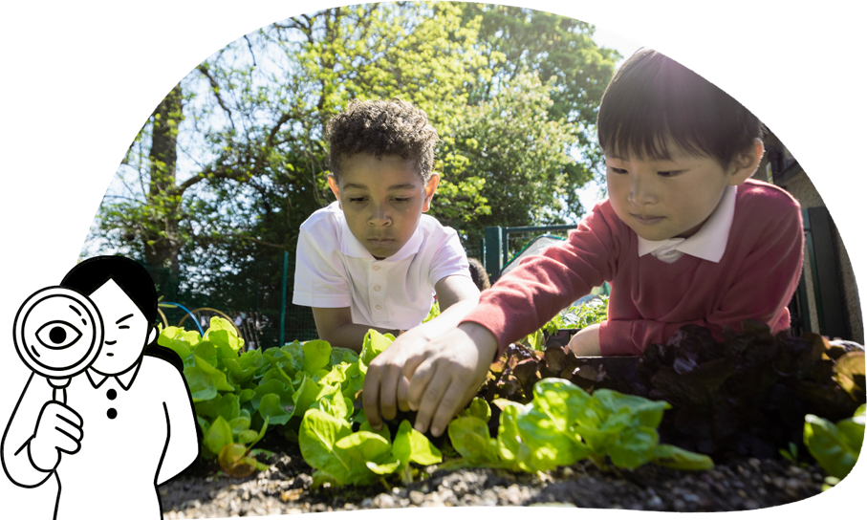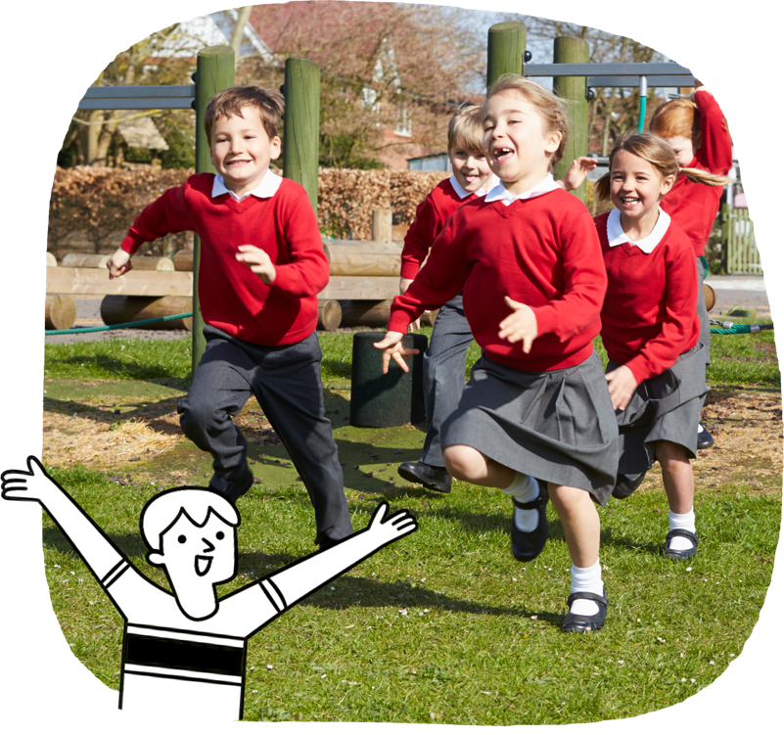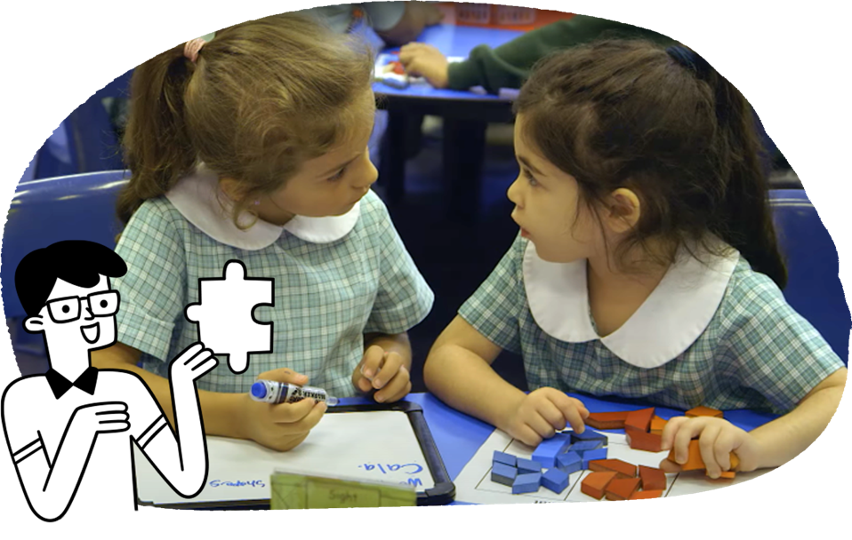

**Science**

Students learn how science works through exploration and observation, building wonder and curiosity by observing everyday objects.

Students learn to:

* observe external features of plants and animals
* investigate the properties of everyday materials
* explore how things move.

**Health and Physical Education**

Students learn through exploration and play. They practise movement skills, learn about their body, and how to be healthy, safe and active. They learn about respectful relationships.

Students learn to:

* discuss who they are, where they come from and people in their lives
* describe emotions of people who are happy, sad, excited, tired, angry, scared or confused
* ask for permission when sharing possessions or personal space
* move in different ways, speeds, directions and environments
* identify and demonstrate actions that ensure fair play.

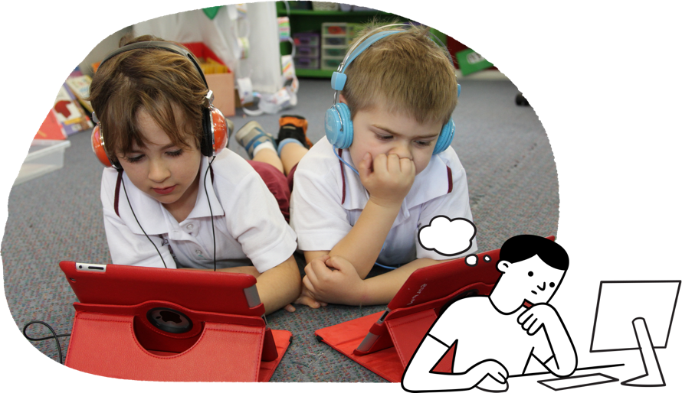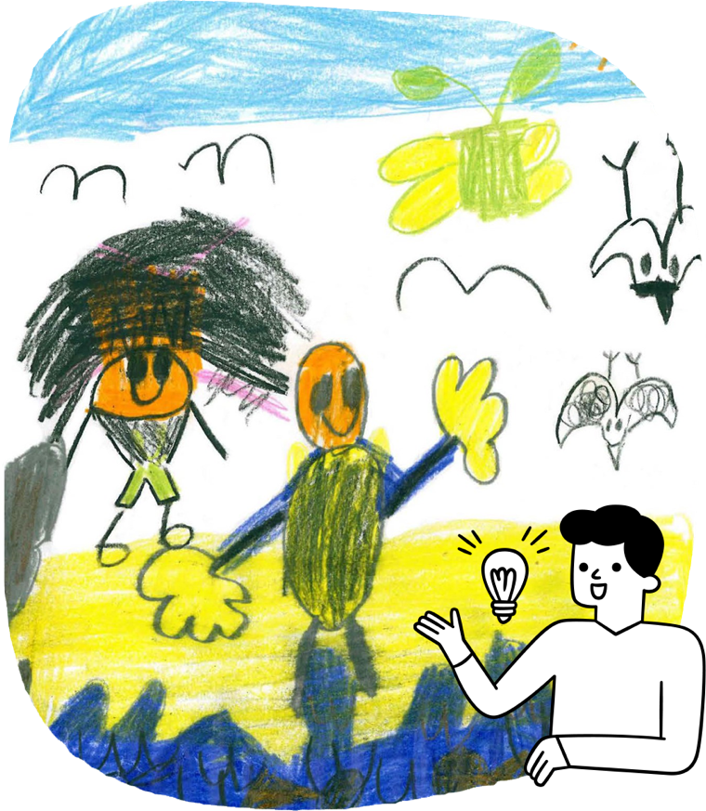

**Languages**

Students learn a language other than English through play and imagination.

Students learn to:

* imitate sounds, gestures and expressions
* listen to songs, picture books and stories in the language
* appreciate that language and culture are related.

**Humanities and Social Sciences**

Students use their natural curiosity to make sense of their world. They develop historical and geographical knowledge and skills about people and places.

Students learn to:

* explore their personal world, including personal and family histories
* investigate places they and their families live in and belong to
* find out about other places through stories told in books or by family members and other people
* find out how people feel about places
* explore why places are special
* explore how students and other people can care for places
* recognise the importance of Country/Place to First Nations Australians
* name the Country/Place where their school is located.

**The Arts**

Students use purposeful and creative play as a basis for creating and sharing arts works.

Students learn to:

* in Dance, use play, imagination and skills to develop ideas
* in Drama, create small scenes based on dramatic play
* in Media Arts, use a camera to record images that communicate ideas
* in Music, explore sounds when listening, singing and making music
* in Visual Arts, respond to and create a variety of artworks by drawing and painting.

**Technologies**

Students discover how technologies work through exploration, design and guided play.

Students learn to:

* follow steps, and use materials and equipment to safely make a designed solution
* become familiar with digital systems and how people use them in their everyday lives
* represent data as objects, pictures and symbols
* recognise their personal data including their name and birth date.