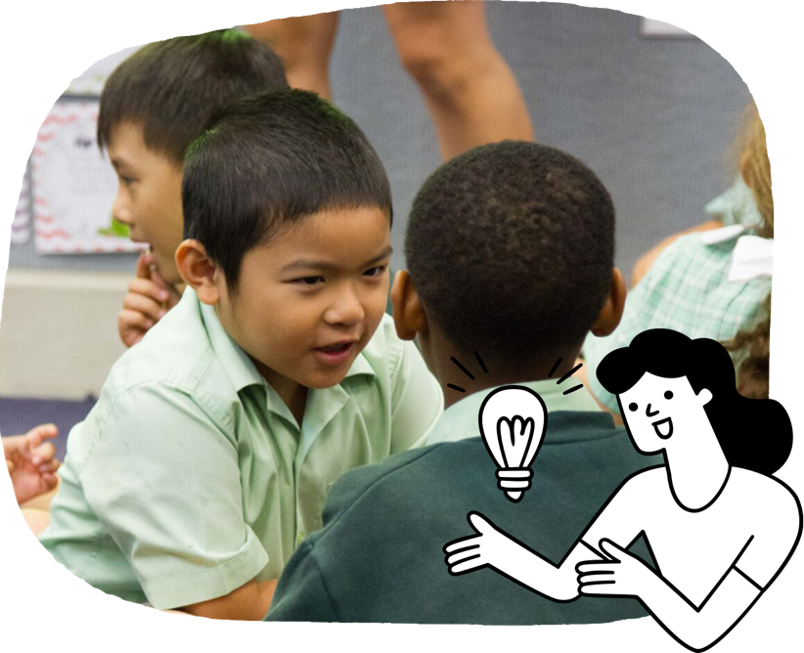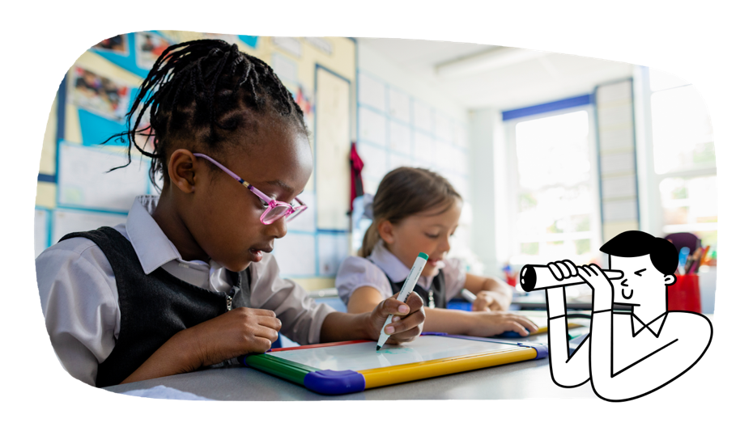A group of pens and pencils.

In Years 1 and 2, priority is given to the important areas of literacy and numeracy development. English and Mathematics are the core subjects for this, but literacy and numeracy are found in all subjects. By the end of Year 2, students have a much stronger understanding of themselves and have begun to connect with the wider community.

Students learn to:

* listen to and discuss information books, stories, films and digital texts
* independently read simple books and discuss what they have read
* discuss the characters and events in texts written by First Nations Australian and wide-ranging Australian and world authors
* decode words
* write to express thoughts and ideas
* tell a story or talk about topics they have learnt in class
* use simple punctuation, such as capital letters and full stops
* spell common words and write in sentences
* create texts using digital tools
* give short oral presentations on topics of interest
* develop legible handwriting.

The Australian Curriculum is designed to develop successful learners; confident and creative individuals; and active and informed young people who are ready to take their place in society.

It sets the goals for what all students should learn as they progress through schooling – wherever they live in Australia and whatever school they attend.

There are 8 learning areas, which provide a modern curriculum for every student in Australia.   
The curriculum includes 7 general capabilities intended to help prepare young Australians to learn, live and work in the 21st century.

There are 3 cross-curriculum priorities that also enrich the learning areas.

The Australian Curriculum is used flexibly by schools and teachers, who plan the learning for all their students while taking into account their local school community.

For more information about your child and their educational progress, talk to your school.

**English**

Students develop literacy using texts that entertain, inform and persuade, such as picture books,   
non-fiction books and films. Students grow into more independent readers, learn to create a range of different texts and become more confident when they communicate.

**Years 1 and 2**

Information for parents and carers

**The Australian Curriculum**

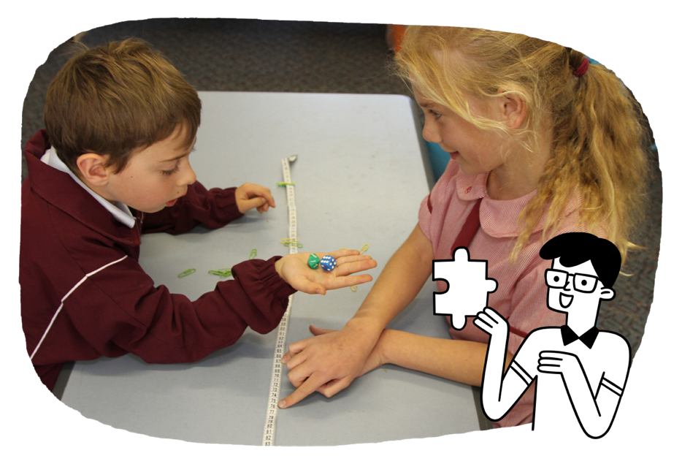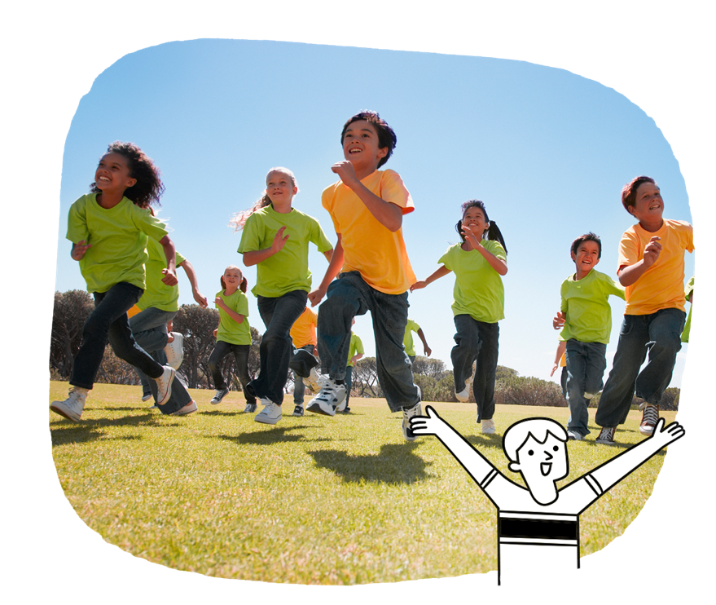

Students learn to:

* describe number sequences and locate numbers on a number line
* begin to use number sentences with mathematical symbols to represent simple additive situations
* represent simple fractions using pictures, words, objects and events
* describe and draw shapes and objects
* use informal units to measure length, capacity and mass
* tell the time from both analog and digital clocks
* use a calendar to determine the date
* position and locate objects using directions and pathways
* investigate data collected through surveys, observations and experiments.

**Humanities and Social Sciences**

Students continue to make sense of their world in personal and familiar situations that tap into students’ curiosity about people, places and how things work. They develop historical and geographical knowledge and skills.

Students learn to:

* investigate family life now and in past generations
* Investigate how families are diverse
* investigate the natural, managed and human-made features of places
* recognise how the world is represented on maps
* explore peoples’ connections to places, including Australian First Nations Peoples
* explore changes in their lives
* explore why people and places are significant
* explore how technology affects people’s lives, now and in the past.

**Health and Physical Education**

Students start to learn more about themselves and explore their personal qualities. Through exploration and play, they investigate how health and movement impact their lives and the lives of others. They become more confident and cooperative.

Students learn to:

* explore how groups and communities they belong to are part of their identity
* recognise their emotions and explore strategies to manage their emotions
* practise ways to interact with others in a fair and respectful way
* practise what to do and how to get help when they feel uncomfortable or unsafe
* apply movement skills as they move in different ways
* investigate how games can be changed to include everyone.

**Mathematics**

Students develop number sense as they build their understanding of place value. They are introduced to mathematical symbols and learn different ways to represent numbers. They begin to use mathematical language to communicate and explain mathematical ideas, pose basic mathematical questions, and develop simple strategies to investigate and solve practical problems.

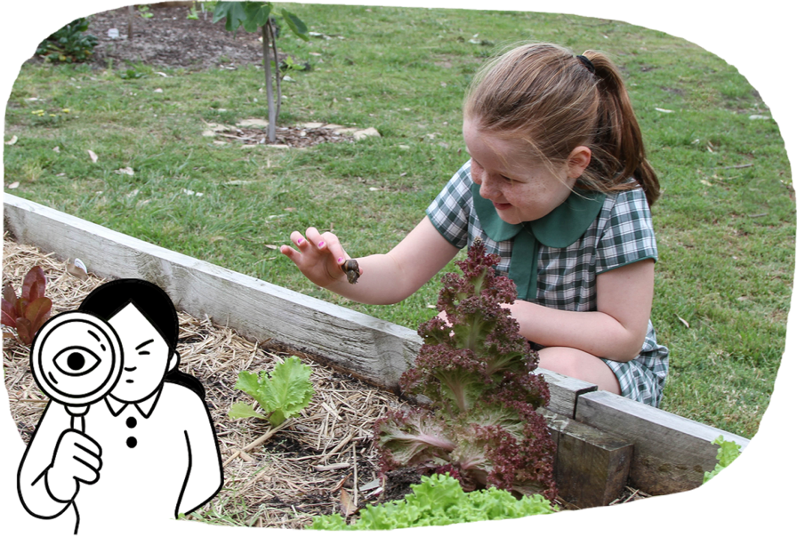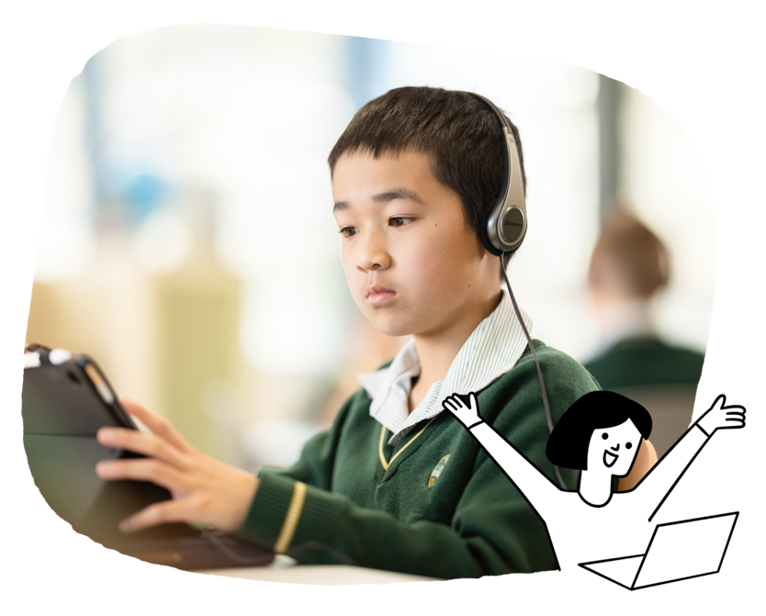

Science

Students learn to investigate by observing and exploring the world around them and by posing and answering questions. They learn to organise their observations, look for patterns and make predictions about their world.

Students learn to:

* investigate living things and the environment
* look for patterns that occur in life cycles of living things
* explore how they can change or combine   
  everyday materials
* examine how sound causes vibration
* investigate daily and seasonal changes to the environment
* recognise Earth as a planet in the solar system.

**The Arts**

Students participate independently or in groups to express and reflect their growing understanding of the world through different art forms. They begin to learn arts technical skills.

Students learn to:

* in Dance, dance alone and with others, being aware of the space and people around them
* in Drama, create fictional situations based on imagination
* in Media Arts, explore how people across cultures and communities experience media arts
* in Music, explore examples of music by First Nations Australians
* in Visual Arts, explore a variety of materials to create and display their art works in informal settings.

**Technologies**

Students learn how digital and other technologies work. They learn how to create solutions with technologies through exploration, design and problem-solving.

Students learn to:

* design and safely make a product
* explore how food and clothing are produced
* explore how food can be prepared for healthy eating
* represent data as pictures, symbols, numbers and words
* understand how data can be stored online
* break down a problem into parts and sequence the steps in finding a solution
* use common digital tools to collaborate, draw, write about or share ideas
* work safely online.

**Languages**

Students build on their learning of a language other than English.

Students learn to:

* use simple words and phrases to interact with others and participate in shared learning experiences
* with support, understand simple phrases and sentences that have familiar vocabulary
* with support, write some words and simple sentences
* gain insights into their own and other cultures, including First Nations Australian cultures.