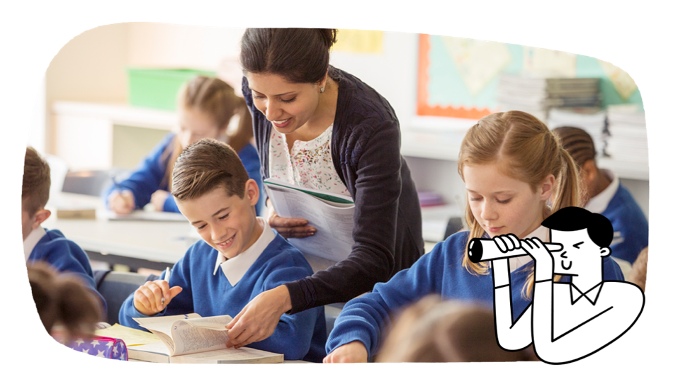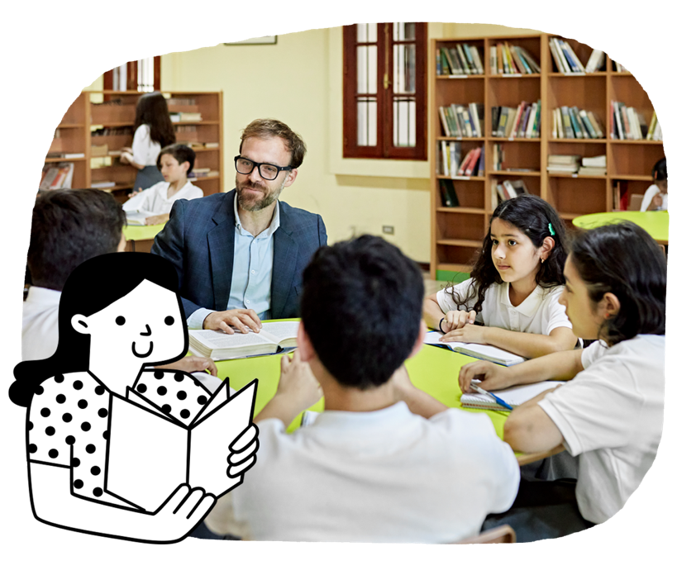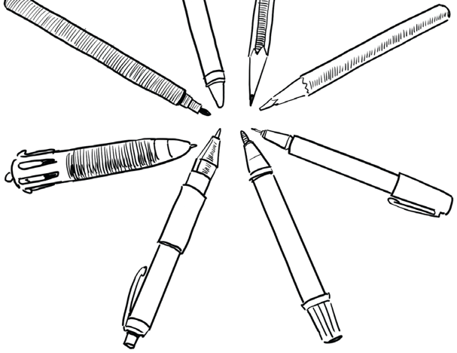

In Years 5 and 6, students learn to take positive actions for their wellbeing. They relate to and communicate well with others. They ask challenging questions and seek answers. Students make informed decisions and act responsibly. The development of digital literacy skills increases across the curriculum at this level.

**English**

Students read and discuss texts for enjoyment and learning. They express their thoughts and opinions about what they have read. They write a wide variety of well-constructed texts such as reviews, reports and narratives. They transfer the literacy skills developed in English to other learning areas.

Students learn to:

* understand how authors organise their texts
* select vocabulary to represent ideas, characters and events
* discuss and compare information in different texts
* use evidence from a text to explain their response to it
* find historical, social and cultural ideas in literature by First Nations Australian, wide-ranging Australian and world authors
* create written and multimodal texts to develop and explain ideas
* write a range of sentences, including complex sentences
* use topic-specific vocabulary
* use accurate spelling and punctuation
* use speaking strategies including questioning, clarifying and rephrasing to contribute to class discussions.

The Australian Curriculum is designed to develop successful learners; confident and creative individuals; and active and informed young people who are ready to take their place in society.

It sets the goals for what all students should learn as they progress through schooling – wherever they live in Australia and whatever school they attend.

There are 8 learning areas, which provide a modern curriculum for every student in Australia.   
The curriculum includes 7 general capabilities intended to help prepare young Australians to learn, live and work in the 21st century.

There are 3 cross-curriculum priorities that also enrich the learning areas.

The Australian Curriculum is used flexibly by schools and teachers, who plan the learning for all their students while taking into account their local school community.

For more information about your child and their educational progress, talk to your school.

**Years 5 and 6**

Information for parents and carers

**The Australian Curriculum**

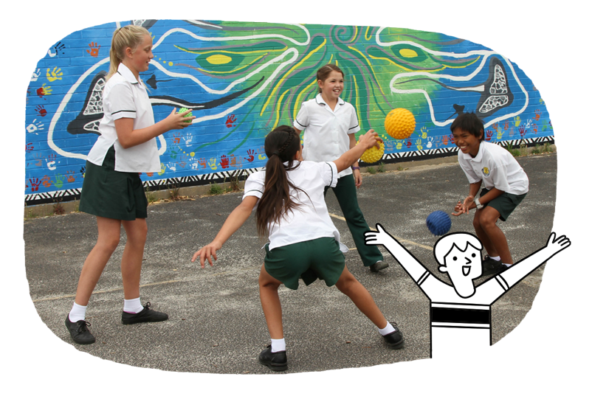

* investigate Australia’s development from colony to nation, including impacts on different groups and the environment, and contributions of significant people and groups, including First Nations Australians
* explore people, events and ideas that led to Australia’s Federation, the Constitution and democratic system of government, and changes after Federation
* explore the influence of people, including First Nations Australians, on the characteristics of a place and the management of Australian environments
* explore geographic diversity and location of places in Asia, and Australia’s interconnections with other countries
* investigate the key values and features of Australia’s democracy, including key institutions and their roles and responsibilities
* explore types of resources and how they satisfy needs and wants
* explore influences on consumer choices and strategies
* investigate people’s participation in the community to achieve civic goals.

**Humanities and Social Sciences**

Students draw on their growing experience of the wider world and use concrete information sources to learn about history, geography, civics and citizenship, and economics and business. Students learn to:

* investigate different sources and types of health information
* develop more specialised skills for games, sports and other physical activities
* identify places where they can get reliable information or help about health, safety and wellbeing
* support fair play and inclusive participation.

**Health and Physical Education**

Students learn about changes and how to manage these transitions. They learn about their unique qualities, how relationships change over time and how to promote health. They develop more complex movement skills. They explore ways they can participate in physical activity and promote safe, equitable and fair participation for all. Students learn to:

* apply skills for coping with changes, including those associated with puberty
* refine skills to establish and manage respectful relationships, including dealing with friendships and valuing diversity
* rehearse how to communicate their intentions   
  effectively and respectfully
* position positive and negative numbers on a number line and use them as coordinates in the Cartesian plane
* solve problems involving addition and subtraction of fractions and decimals
* explain mental strategies and discuss the reasonableness of calculations involving all 4 operations
* apply their mathematical knowledge and skills to model and solve practical problems including financial contexts
* convert between 12- and 24-hour time and interpret timetables
* use algorithms and digital tools to experiment with numbers, describing and explaining emerging patterns
* measure length, perimeter, area, capacity and mass using appropriate metric units
* list outcomes of chance experiments
* conduct repeated chance experiments and simulations using digital tools
* compare and interpret statistical graphs
* pose appropriate questions and conduct statistical investigations.

**Mathematics**

Students extend their knowledge of the key areas of mathematics, particularly fractions, decimals and percentages. They increasingly use mathematical models, pictures and symbols to represent and communicate mathematical ideas and solve practical problems. Students learn to:

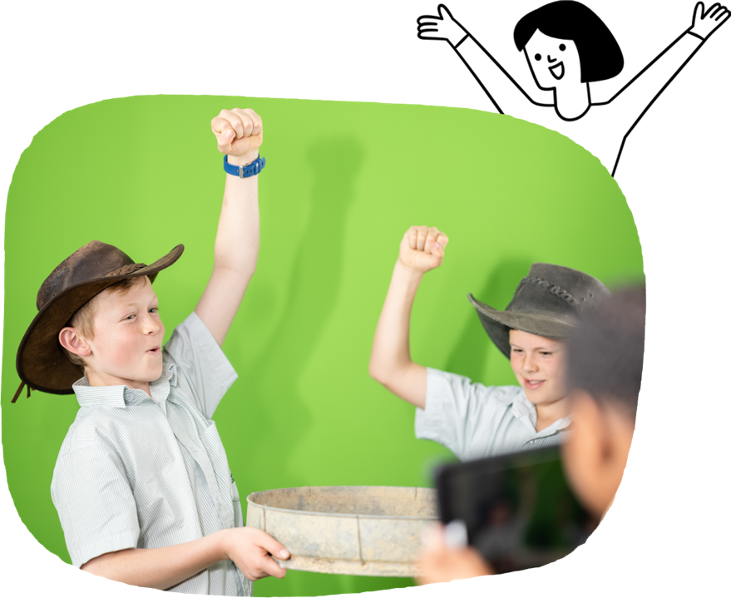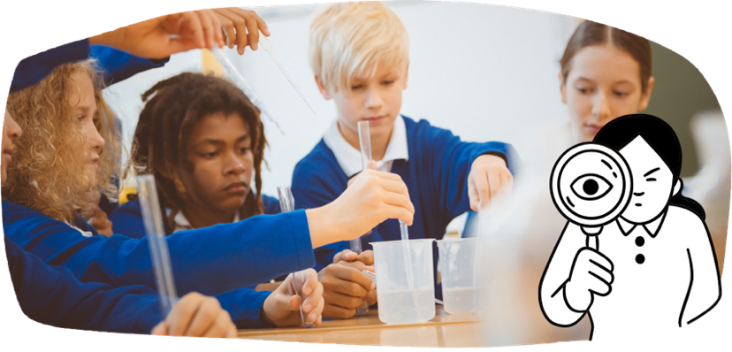

**Languages**

Students continue to build on their learning of a language other than English. Students learn to:

* use the language to communicate and collaborate with peers
* use vocabulary and grammatical resources to comprehend and compose spoken and written texts
* reflect on the relationship between language, culture and identity.

**Technologies**

Students use design processes to produce solutions. They further develop their knowledge and understanding of digital systems and data. They improve their computational thinking. Students learn to:

* use materials or technologies when designing, producing and evaluating solutions
* represent ideas and solutions by using sketches, models and digital tools
* develop plans to complete tasks and projects
* use simple computer algorithms to develop and evaluate digital solutions
* protect their personal safety and digital footprint when engaging online
* find, interpret and manage a range of data, using digital systems.

**The Arts**

Students use subject-specific knowledge and language to describe and create arts works. They communicate ideas, perspectives and meanings in formal and informal settings. Students learn to:

* in Dance, use the elements of dance, such as space and time, to choreograph dances
* in Drama, rehearse and perform plays, using expression to engage an audience
* in Media Arts, explore, plan and produce media arts works such as advertisements
* in Music, rehearse, sing and perform music with rhythm and pitch
* in Visual Arts, explore ways that cultures, including First Nations Australian cultures, are continued and revitalised through visual art practices.

Students learn to:

* investigate adaptations in living things and their interactions with the environment
* add gases to their study of materials and investigate chemical changes
* investigate the solar system and the behaviour of light
* investigate how weathering, erosion, transportation and deposition change Earth’s surface
* deepen their understanding of historical contributions to science
* understand how science influences   
  community decisions.

Science

Students look for patterns and relationships. They recognise the important role of variables in investigations. They develop explanations based on evidence.