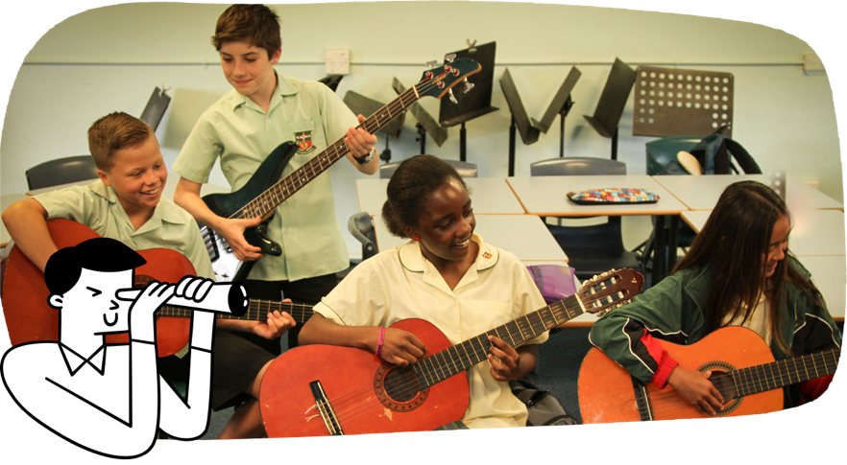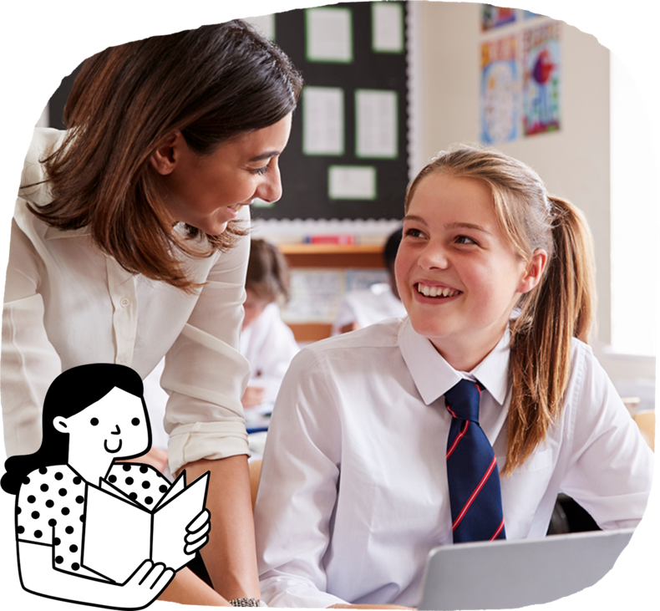

In Year 7 students start high school, which presents new organisational and personal challenges. The Australian Curriculum is taught mostly by subject-specialist teachers. At this age, there is a focus on developing students’ abilities to maintain personal health and wellbeing, and manage personal relationships.

Students learn to:

* read and interpret a range of texts
* compare, analyse and question ideas and information in texts
* select evidence that shows how authors represent their viewpoints in texts
* explore ideas and points of view in literary texts by First Nations Australian, wide-ranging Australian and world authors
* create written and multimodal texts to express ideas with supporting details and evidence
* write well-organised paragraphs to present an argument or convey information
* read digital texts and use a range of digital tools to create texts
* recognise and use a wide range of language features
* use a wide range of technical and literary vocabulary
* create spoken and multimodal texts to express and elaborate on ideas.

**English**

Students read and interpret a wide variety of literature. They create texts to influence their audience.

The Australian Curriculum is designed to develop successful learners; confident and creative individuals; and active and informed young people who are ready to take their place in society.

It sets the goals for what all students should learn as they progress through schooling – wherever they live in Australia and whatever school they attend.

There are 8 learning areas, which provide a modern curriculum for every student in Australia.   
The curriculum includes 7 general capabilities intended to help prepare young Australians to learn, live and work in the 21st century.

There are 3 cross-curriculum priorities that also enrich the learning areas.

The Australian Curriculum is used flexibly by schools and teachers, who plan the learning for all their students while taking into account their local school community.

For more information about your child and their educational progress, talk to your school.

Information for parents and carers

**Years 7 and 8**

**The Australian Curriculum**

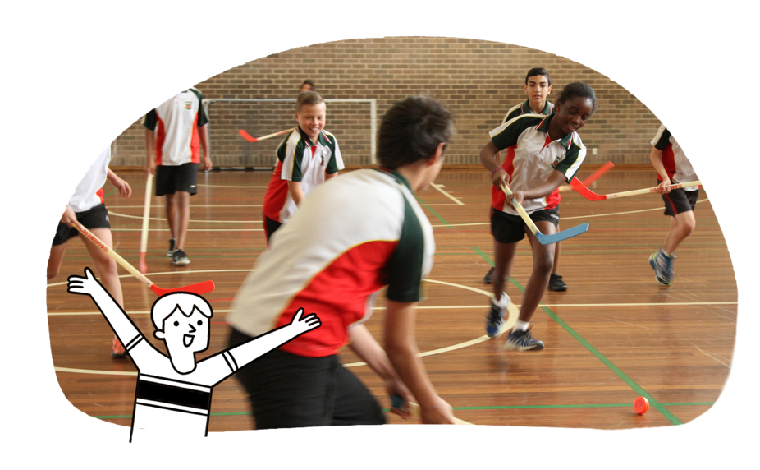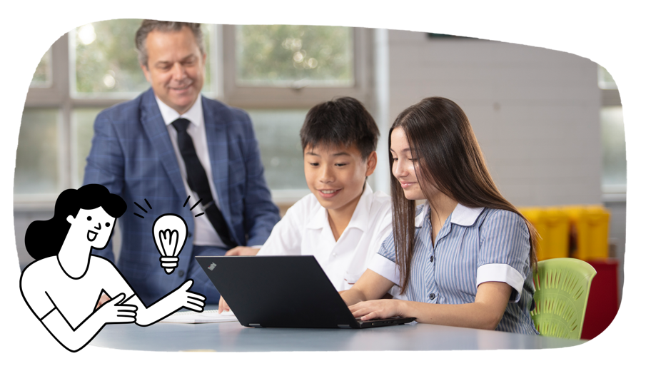

**Health and Physical Education**

Students become more connected to the world around them. Their peers become a key source of motivation and support. Students practise and apply more complex skills and strategies in a range of movement situations. They explore the range of factors that influence the quality of movement performances.

Students learn to:

* examine the influence of values and beliefs on the development of identities
* examine the roles of respect, empathy, power and coercion in developing respectful relationships
* explain and apply skills and strategies to communicate assertively and respectfully when seeking, giving or denying consent
* analyse, refine and transfer movement skills in a variety of movement situations
* investigate the impact of regular participation on health, fitness and wellbeing
* build leadership, collaboration and decision-making skills.

**Humanities and Social Sciences**

Students use inquiry skills to develop historical, geographical, civic, and business and economic knowledge from a local to a global scale.

Students learn to:

* in History, investigate Deep Time history of Australia
* in History, investigate ancient to modern societies around the world, and the legacy of their ideas in today’s world
* in Geography, explore factors and challenges that influence how people access resources and make places liveable
* in Geography, explore links between places, people and environments
* in Geography, explore how changes can be managed sustainably
* in Civics and Citizenship, explore citizenship, laws and the democratic values that promote a cohesive society
* in Economics and Business, understand roles of and relationships between individuals, businesses and entrepreneurs, and Australian markets.

* calculate areas of shapes, including circles and volumes of objects
* apply rates and ratios to practical situations
* interpret statistical graphs
* use Pythagoras’ theorem to solve measurement problems
* use digital tools to conduct repeated chance experiments and simulations
* conduct statistical investigations involving measurement data using digital tools.
* estimate and calculate accurately with positive and negative numbers
* extend known properties of arithmetic to the study of algebra
* develop simple logical geometric arguments
* compare prices of products packaged in different quantities
* represent simple algebraic relationships by graphs
* model and solve real-world problems involving financial contexts

**Mathematics**

Students extend their knowledge of number systems to include irrational numbers. They use proportional thinking and algebra to model practical situations and solve problems. They develop skills in geometric reasoning and consider statistical sampling when conducting statistical investigations.

Students learn to:

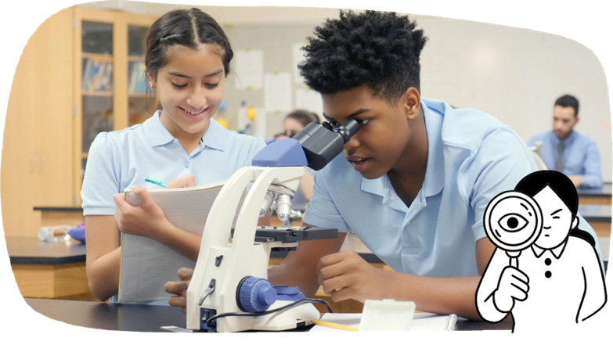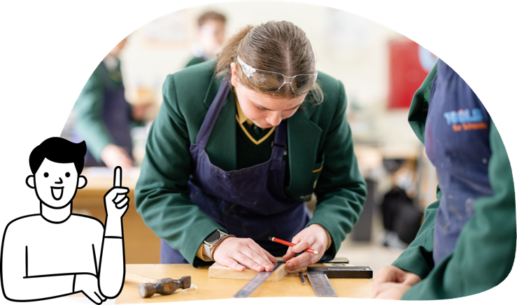

Science

Students develop their understanding of microscopic and atomic structures. They adopt a more sophisticated view of evidence. They begin to calculate changes accurately and compare relative amounts.

Students learn to:

* explore the diversity of life on Earth through a study of ecosystems and cellular systems
* understand Earth as a dynamic system, in which change occurs across a range of timescales
* explore changes in matter at a particle level and link them to physical and chemical changes
* investigate the role of energy in causing change in systems, including the role of energy and forces in the geosphere
* consider ethical and cultural implications of scientific research and development.

**Languages**

Students may further develop communication skills in a language other than English or they may start their learning of a language.

Students learn to:

* use rehearsed and unplanned language to participate in classroom interactions and create spoken, written and multimodal texts
* listen to, read and interpret texts, identifying relationships between texts, contexts, purpose and audience
* use vocabulary and conventions of the language, following modelled examples or independently
* reflect on how language, culture and identity are interconnected.

**Technologies**

Students engage in experiences that develop knowledge and skills through the Technologies subjects.

In Design and Technologies, students learn to:

* understand the work people do in design and technologies occupations and how they contribute to society
* design and produce solutions for a variety of contexts: engineering principles and systems; food and fibre production; food specialisations; materials and technologies specialisations
* select and use appropriate technologies to produce solutions
* plan and communicate how to produce solutions.

In Digital Technologies, students learn to:

* understand the experience a user wants when using hardware and software
* plan and create a solution such as a smart phone app or a chatbot assistant
* develop knowledge and skills for programming
* communicate and collaborate online, demonstrating safe practices
* develop an understanding of cyber security risks and privacy concerns.

**The Arts**

By responding critically and creatively in a variety of art forms, students explore and question their immediate experience and their understanding of the wider world. They knowingly craft arts works to express ideas, tell stories or explore issues.

Students learn to:

* in Dance, choreograph dance sequences to communicate ideas, and rehearse and perform dances
* in Drama, plan and rehearse dramatic performances to communicate ideas expressively
* in Media Arts, investigate the diversity of First Nations Australians’ media arts works
* in Music, improvise, combine and perform a range of music, using elements such as rhythm and pitch
* in Visual Arts, explore how artists create artworks, and plan, create and display visual artworks for an audience.