CASE - Abilities planning questions
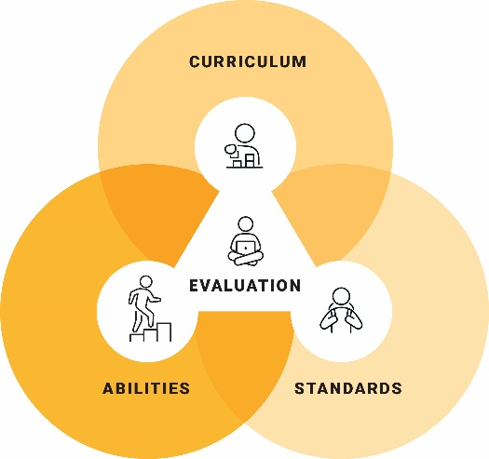
- How will I ensure that students are provided opportunities to engage with adjusted content?
- How will I provide students with access to curriculum content based on their language proficiency?
- How will I use the general capabilities to differentiate students’ learning opportunities?
- How will I provide access to content in ways that connect with all my students?
- How will I engage the students in my class?
- How will I extend and enrich high-achieving students?
- How will I incorporate students’ special interests in the delivery of the content?
- How will I provide opportunities for repeated practice of content and skills?
- How will I use graphic organisers and visual cues to support students’ learning?
- How will I support students’ communication needs for example, through access to braille, first-then boards or augmentative and alternative communication?
- How will I provide access to manipulatives or hands-on materials, especially to support students in understanding concepts?
- How will I provide places in the classroom where students can work quietly and without distraction, as well as places that invite student collaboration?
- How will I access and provide materials that are culturally appropriate?
- How will I use digital tools to support students’ learning?
- How will I monitor students’ engagement and self-regulation levels during learning experiences?

© ACARA 2023

