# CASE - Curriculum planning questions

* 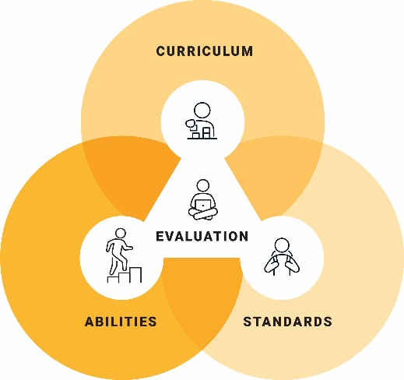How will I use content from the 3 dimensions of the Australian Curriculum to develop meaningful personalised learning goals for students?
* How will I plan rigorous, dignified and meaningful learning experiences, starting with adjustments to content from the Australian Curriculum?
* How will I use knowledge of students’ learning and level of abilities to make adjustments in relation to curriculum?
* How will I use content from the Australian Curriculum to ensure all students have opportunities to progress in their learning?
* How will I support students to explore content from the Australian Curriculum in more depth or breadth?

Access further information about the [Learning areas](https://v9.australiancurriculum.edu.au/), [General capabilities](https://v9.australiancurriculum.edu.au/f-10-curriculum/f-10-curriculum-overview/general-capabilities) and [Cross-curriculum priorities](https://v9.australiancurriculum.edu.au/f-10-curriculum/f-10-curriculum-overview/cross-curriculum-priorities).

[© ACARA 2023](https://www.acara.edu.au/contact-us/copyright)