CASE - Evaluation planning questions
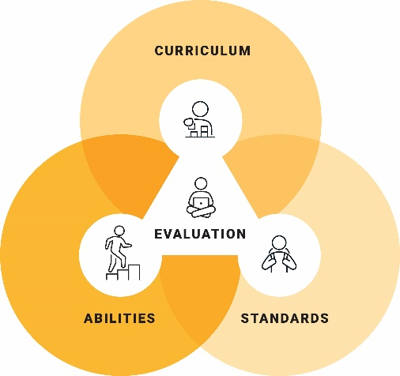
- How will I check if students’ learning is proceeding through the curriculum at a faster or slower rate than had been anticipated in the learning plan?
- How will I use data to analyse and track the effectiveness of adjustments?
- How will I support students in setting and tracking goals?
- How will I review adjustments regularly, seek alternatives or withdraw them where necessary?
- How will I acknowledge the successful learning that has occurred in the unit of work?
- How will I identify the stakeholders required to participate in the evaluation process?
- How will I provide students with opportunities for self-reflection?

© ACARA 2023

