CASE - Standards planning questions
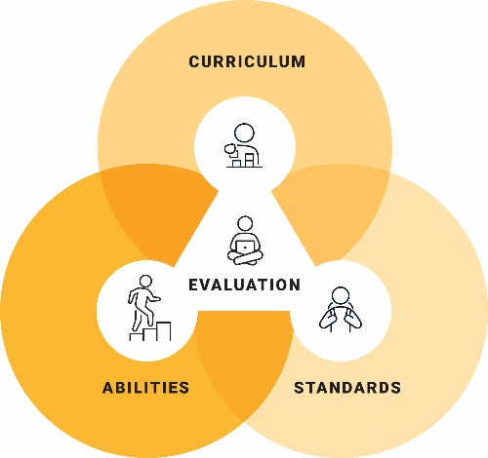
- How will I offer purposeful options for students to show what they know in relation to the achievement standards?
- How will I develop and provide students with authentic assessment tasks suitable for the full range of diverse students?
- How will I develop tasks that allow students to demonstrate the skills, knowledge and/or understandings associated with the achievement standards?
- How will I ensure that students are able to use a variety of modes to demonstrate their knowledge, skills and/or understanding?
- How will I use choice boards to help students decide how they will best represent their learning?
- How will I adjust assessment tasks to address the range of abilities in my class?
- How will I use questioning strategies to engage students in higher-order thinking?
- How will I support students in their planning responses to assessment tasks?
- How will I utilise assistive and augmentative and alternative communication technology to support students?
- How will I use student learning logs and/or exit strategies to track what students have learnt?
- How will I monitor students’ progress?
- How will I design assessment tasks that enable students to demonstrate the full extent and depth of their learning?
- How will I provide timely and meaningful feedback to students?

© ACARA 2023

